VICTORIA CANAL

SHARES NEW SINGLE AND VIDEO
“CHAMOMILE”
LISTEN HERE | WATCH HERE

US HEADLINE TOUR KICKS OFF
MARCH 20 IN BOSTON, MA

Hi-res assets HERE // photo credit: Max Wagner

Praise for Victoria Canal

“Canal’s ascendant career is built on her ability to unflinchingly capture feelings… Her directness about body image and mental health has brought her an audience of people a lot like her.”
– THE NEW YORKER

“perceptive, unflinching songs… as the world wakes up to her many talents.” – THE OBSERVER

“her gentle and ruminative form of songwriting is finally getting the recognition it deserves” – i-D

"a tender blend of goosebump-inducing balladry akin to the kind of cataclysmic intensity of artists like Phoebe Bridgers or Holly Humberstone" – NME

“WELL WELL represents her at her most vulnerable and her most brave” – GAY TIMES

MARCH 8, 2024 - Singer songwriter and multi-instrumentalist Victoria Canal has debuted her tender new single and video “Chamomile” via Elektra/Parlophone Records. Following the release of 2023’s WELL WELL EP, the new single is a powerful ode to the comfort and mutual support found in close friendship, in the hard times as well and the good: “I would love to reach the point where I take care of me,” sings Canal in the song’s chorus. The official music video is streaming now on Victoria’s official YouTube channel.

Of “Chamomile,” Victoria shares, “I wrote ‘Chamomile’ about my best friend Lucy. When I’m struggling with my depression, she’s always there for me when I’m going through it. When I’m in that place, I feel this desire to one day be there for her in the same way; so this song was kind of a promise to her and to myself to always try.”

Watch "Chamomile" Music Video Here

The release comes ahead of the start of her headline US tour, which takes place through March and April and sees her play 12 shows including New York’s Mercury Lounge. Victoria also makes a stop at SXSW festival in Austin and will return to the UK in May to play at Brighton’s The Great Escape festival (full tour itinerary below). For ticketing and more information, please visit www.victoriacanal.com. This week Canal was honoured as one of 12 Incredible Women of 2024 in PORTER Magazine’s International Women’s Day celebrations.

2023 was a breakthrough year for Canal, winning the Rising Star award at the prestigious Ivor Novellos, receiving an Attitude Pride Icon Award, releasing her acclaimed EP WELL WELL, supporting Hozier across the UK and Europe, and being named BBC Radio 1’s Future Artist for June and receiving acclaim from The New Yorker, The Observer, The Times, NME and more.

About Victoria Canal:
25 year-old singer, songwriter, producer and actress Victoria Canal makes soul-stirring, emotive pop music. Spanish-American Canal says her international upbringing fostered her love for a nomadic life in music. A proud “third culture kid,” she lived everywhere from Shanghai, Tokyo, Amsterdam, London, and Dubai to Atlanta, New York, and Forth Worth, and is proud of her identity as a queer, disabled, mixed-heritage woman, which fuels much of her activism.

In 2022 Canal released her EP Elegy, which delicately dealt with themes of grief and death, and featured the single ‘swan song’, which Chris Martin of Coldplay hailed as ‘one of the best songs ever written’. She performed 'swan song' on the recent series of Later… with Jools Holland, appearing alongside the likes of Self Esteem and The 1975.

Last year’s EP WELL WELL found Canal turning the lens back on herself to look inwards: grown from heartache and made with unabashed honesty, these songs find the artist at her most vulnerable—and her most courageous. The singles ‘Shape’ and ‘She Walks In’ were the first time she’d shared on the themes of body image and body dysmorphia, pertaining in part to her limb difference, while she describes ‘Company’ as her “sweet gay love song”.

Canal also made her television acting debut in acclaimed Apple TV+ anthology series Little America, starring in the season’s moving episode The Indoor Arm as a Spanish-speaking Salvadorian refugee in the 80s who comes to America to live with her sister.

VICTORIA CANAL 2024 LIVE DATES

March 14 - Austin, TX - SXSW - ThisFiction and Friends Showcase
March 16 - Austin, TX - SXSW - British Embassy Showcase
March 20 - Boston, MA - Red Room at Café 939
March 21 - New York, NY - Mercury Lounge
March 23 - Philadelphia, PA - MilkBoy
March 24 - Baltimore, MD - Metro Gallery
March 25 - Washington, DC - Songbyrd
March 28 - Phoenix, AZ - Valley Bar
March 29 - Tucson, AZ - 191 Toole
March 30 - San Diego, CA - Voodoo Room
April 1 - Los Angeles, CA - Moroccan Lounge
April 2 - San Francisco, CA - Cafe Du Nord
April 5 - Portland, OR - The Mission Theater
April 6 - Seattle, WA - Fremont Abbey
May 16 - Brighton, UK - The Great Escape
Aug 17 - Biddinghuizen, NL - Lowlands Festival

VICTORIA CANAL
“Chamomile”
AVAILABLE NOW
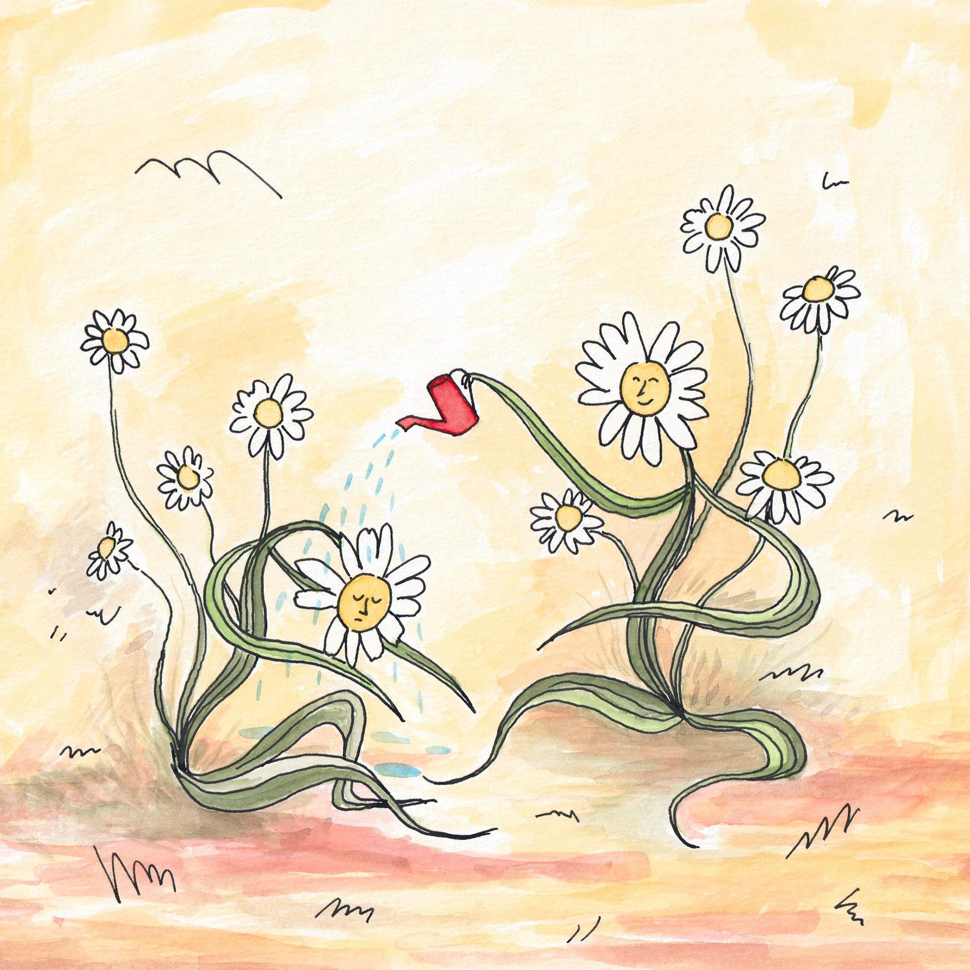

CONNECT WITH VICTORIA CANAL
Instagram | Twitter | TikTok | Facebook | YouTube

For US media inquiries, please contact:
Sarah Goldstein – sarah.goldstein@300elektra.com

