JXDN RETURNS WITH “WHEN THE MUSIC STOPS”

NEW SINGLE & VISUALIZER STREAMING NOW

LISTEN HERE | WATCH HERE

NEW ALBUM ARRIVING SUMMER 2024

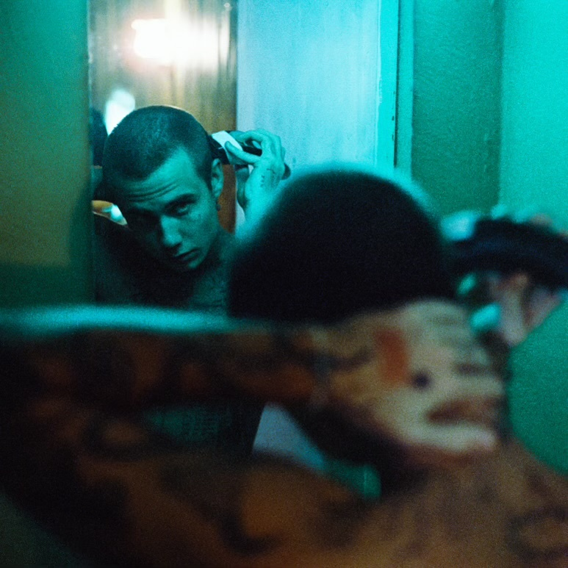
PHOTO CREDIT: HARRISON TOOHEY
FEBRUARY 8, 2024 – LA-based singer-songwriter jxdn has returned with “When The Music Stops,” his first new single of 2024 and the first taste of new music from his widely anticipated sophomore album expected out later this Summer. “When The Music Stops” is co-produced Travis Barker and Brian Lee, and is available today on all streaming platforms via Barker’s DTA Records with an official visualizer available on jxdn’s YouTube channel - watch HERE.

Celebrating his 23rd birthday today, the release marks a significant point of reflection for jxdn who elaborated on the moment sharing, “The music of my life has started playing again. All I can think about is showing everyone what it sounds like.”
“When The Music Stops” follows the release of jxdn’s 2023 singles “Chrome Hearted,” “Elevated Heartbreak,” and his cover of d4vd’s “Romantic Homicide.”

jxdn’s celebrated debut album Tell Me About Tomorrow arrived in 2021 to critical acclaim and has since amassed more than one billion global streams to date. Upon its arrival, the album earned jxdn a #3 Alternative New Artist Albums, #5 Top New Artist Albums, and #11 Digital Albums on the Billboard charts. Furthermore, jxdn was included in Variety’s ‘Power of Young Hollywood’ 2021 Music impact list and Billboard’s ‘21 Under 21’ list for the two consecutive years he was eligible (2020 and 2021), in addition to garnering nominations for both a MTV VMA and MTV EMA in 2021.

“WHEN THE MUSIC STOPS” – SINGLE ARTWORK

ABOUT JXDN:

In 2024 jxdn is letting go of his past and stepping into his future. Up to this point, the breakout star has reached gold status, tallied over one billion streams and counting, collaborated with icons, sold out headline tours, and garnered widespread acclaim. Raised by two pastors, jxdn spent the bulk of his childhood in Texas. Without much money or resources, he retreated into music as an escape. By the time he turned 14, the family relocated to Chattanooga, TN. As a senior in high school, he snuck out to a Juice WRLD concert (his first), and it changed his life. In 2020, he linked up with iconic blink-182 drummer and DTA Records founder Travis Barker who promptly signed him. He served up the gold-certified “ANGELS & DEMONS.” The latter also bulldozed the way for his 2021 full-length debut album, Tell Me About Tomorrow, highlighted by “SO WHAT!,” “BETTER OFF DEAD,” “TONIGHT” [feat. iann dior], and “WANNA BE” [feat. Machine Gun Kelly]. Beyond television performances on ELLEN and Jimmy Kimmel LIVE!, his showstopping MTV Push rendition of “Think About Me” garnered a nomination for “Push Performance of the Year” at the MTV VMAS. Plus, he packed houses on tour coast-to-coast. In between, he endured loss, struggled through mental health, faced addiction, and realized who he was meant to be all along. Armed with wisdom and a deliberate vision for the future, jxdn reintroduces himself on “When The Music Stops” with a new full length album on the horizon in 2024 for DTA Records.

CONNECT WITH JXDN:
WEBSITE / TIKTOK / INSTAGRAM / X / FACEBOOK / YOUTUBE / SPOTIFY / APPLE MUSIC

