DEBUTS NEW SINGLE “MIDDLE OF THE NIGHT”
OFFICIAL VISUALIZER STREAMING NOW
LISTEN HERE | WATCH HERE

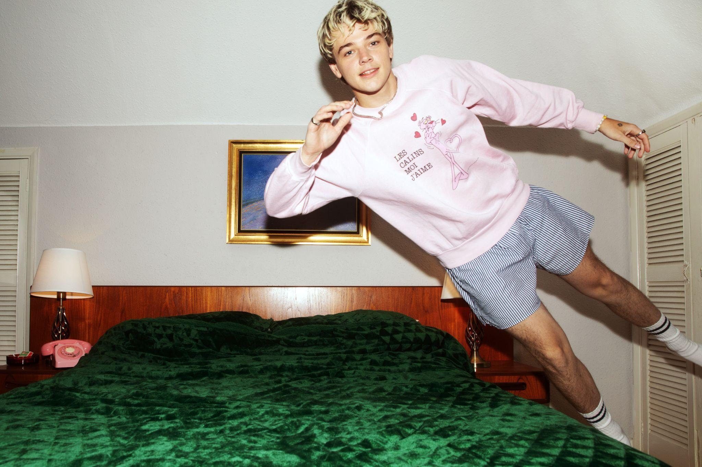
DOWNLOAD PRESS ASSETS HERE

FEBRUARY 16, 2024 - From playing his first-ever UK show at 150-cap venue The Grace in 2020, to selling out 2300-cap O2 Forum Kentish Town, topping the EP charts, completing a co-headline US tour with Alfie Templeman and supporting both Sir Elton John and Sigrid, Thomas Headon has proven himself an undeniable indie-pop force to be reckoned with. Today the London via Melbourne star releases his brand new single, and first of 2024, “Middle of the Night,” after premiering the track on Triple J last night. The breezy earworm arrives alongside an official visualizer, which is streaming on Thomas’s official YouTube channel now.

LISTEN TO “MIDDLE OF THE NIGHT”

“This song to me is the sound I’ve always been trying to achieve, it really blends so many of my influences into one song and feels like a step in the right direction. It’s basically a song about partying non-stop, waking up in the morning and feeling like it is still the night before, your head spinning, the ridiculous plans you make with your friends on nights out that never end up happening and feeling higher and larger than life. I wrote and recorded it with two really great friends (Stephen Barnes & Caroline Pennell) and I think the energy of that really comes through. Anyway I hope people like it, it'll be awkward if they don't.” - Thomas Headon

“Middle of the Night” is the first taste of new music from Thomas since last year’s EP, Six Songs That Thomas Headon Likes And Thinks You Would Like Too, which included the BBC Radio 1-lauded singles “2009 TOYOTA,” “Georgia” and “W4NNA DO.” Having spent the past two years performing a storm of live shows to frenzies of screaming fans at festivals and sold-out tours across the US, Australia and the UK, Thomas shows no signs of slowing down. Following Six Songs release, Thomas spent the rest of the year playing an array of festivals including Barn on the Farm, Standon Calling and Y Not Festival, headed out on his own intimate UK and EU tour - including a show at Camden Assembly which sold-out within 60 seconds of going live - with support from his good friend and rising retro-popstar, Arthur Hill, before hunkering down in the studio to bring all the stories from his recent travels to life in his upcoming new music.

About Thomas Headon:
Thomas Headon was born in London and raised in Melbourne but always dreamt of moving back to the city to pursue music. Arriving in London by himself at the start of 2020, Thomas started to build an incredibly loyal community online, blowing up on TikTok and Instagram with his off-kilter live sessions, tongue-in-cheek charm and remarkable songwriting ability. Learning to write and produce on his own, Thomas had already released two self-written and self-produced EP’s, “The Greatest Hits” and “The Goodbye EP” (including lauded single “UrbanAngel1999” which features on Netflix’s hit series Heartstopper) in 2020 before releasing the Victoria EP which cemented his place as a “proper star” in music - now signed to Warner Records and selling out live dates across the world. Since Victoria’s release, Thomas has earned over 100M streams worldwide and was chosen as one of Amazon Music's Artists to watch and MTV Push's Ones to Watch. One of the first artists to curate Spotify’s Our Generation playlist, Thomas’ blend of playful alternative pop that speaks to the Gen-Z experience has been compared to the likes of the 1975’s Matty Healy (NME), and critically praised by Triple J, who named him a “seriously impressive force in pop music”, as well as BBC Radio 1’s Jack Saunders, Clara Amfo, Greg James & Jordan North.

THOMAS HEADON
“Middle Of The Night”
AVAILABLE NOW

CONNECT WITH THOMAS HEADON
WEBSITE | INSTAGRAM | TIKTOK | TWITTER | YOUTUBE | SPOTIFY | APPLE

For U.S. press inquiries please contact:
Sarah Goldstein / sarah.goldstein@300elektra.com

