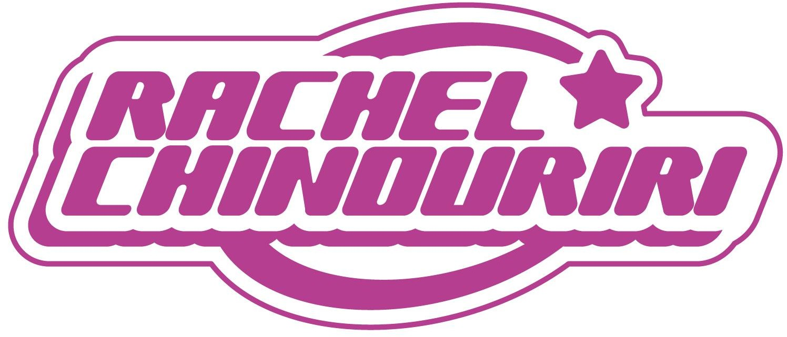

RACHEL CHINOURIRI SHARES NEW SINGLE
“WHAT A DEVASTATING TURN OF EVENTS”
LISTEN HERE
DEBUT ALBUM WHAT A DEVASTATING TURN OF EVENTS

OUT MAY 3RD VIA ELEKTRA

DOWNLOAD PRESS ASSETS HERE
Photo credit: Lauren Harris

“‘What A Devastating Turn of Events’ has allowed Chinouriri to flex her creativity… It’s as though Chinouriri is finally at peace with herself, looking into the future and ready for what’s to come.” - NME

“…one of the warmest, fully enveloping pop introductions in recent memory”
- BILLBOARD

“Chinouriri’s glowing voice and wistful lyrics create a sonically boundless landscape” - CONSEQUENCE

“…honest lyrics and enchanting vocals” – NYLON

“If you’ve ever had a secret crush, obsessed or felt utter despair over someone, Chinouriri’s direct way of discussing love and loss will resonate with you” – THE OBSERVER
“one of Britain’s most compelling and honest rising artists.” - Notion

FEBRUARY 27, 2024 – Alternative indie pop artist Rachel Chinouriri has shared new single “What A Devastating Turn Of Events,” the title track from her forthcoming debut album, arriving May 3rd via Elektra.

Like much of What A Devastating Turn Of Events, the song pulls inspiration from some of the most personal and affecting moments of Chinouriri’s life, reimagining the true story of a death in her family. A tonal shift from the album’s lead singles “Never Need Me” and “The Hills,” “What A Devastating Turn Of Events” builds upon Chinouriri’s penchant for candid, lyrical songwriting.

She shares: “This song is one of my saddest but proudest achievements. It’s personal and based around a true story. It’s the tragic story of a girl who is a similar age to me. I think with every step of her journey, someone somewhere can understand the feelings she felt to some degree. Whether it’s to do with relationships, friendships, neglect, motherhood, depression, rejection, battling internal hatred or suicidal thoughts … I feel like this is something most people can relate to. The decision to take her own life is something many people have contemplated, and her life was almost the perfect storm to create that environment which is heartbreaking. Without the right support or understanding around you, people can feel trapped and it’s sad she ever made this choice. Her story deserves to be told and I hope more people know that this is a feeling that many people have felt and you should always ask for help.”

Listen to "What A Devastating Turn Of Events"

On March 6th, Rachel will play her biggest sold-out headline show to date at London’s KOKO. She then goes on to play a run of sold-out headline dates in the US, taking in debut shows across New York and LA, plus SXSW festival. See below for full list of dates. Chinouriri also recently completed a UK in-store tour, playing intimate shows around the country to share new music from the album with her fans.

What A Devastating Turn Of Events is a culmination of the experiences, challenges and joys of Chinouriri’s life so far, explored through the prism of musical stylings honed through years of experimentation and creation. Ever-eclectic and brutally honest, the album traverses life’s light and shade, the writing and sharing a healing process for Rachel, and she hopes, her listeners.

“Never Need Me” arrived complete with an official music video directed by Jacob Erland and starring Academy Award nominated actress Florence Pugh who features as Rachel’s supportive bestie.

RACHEL CHINOURIRI
What A Devastating Turn Of Events - OUT MAY 3RD
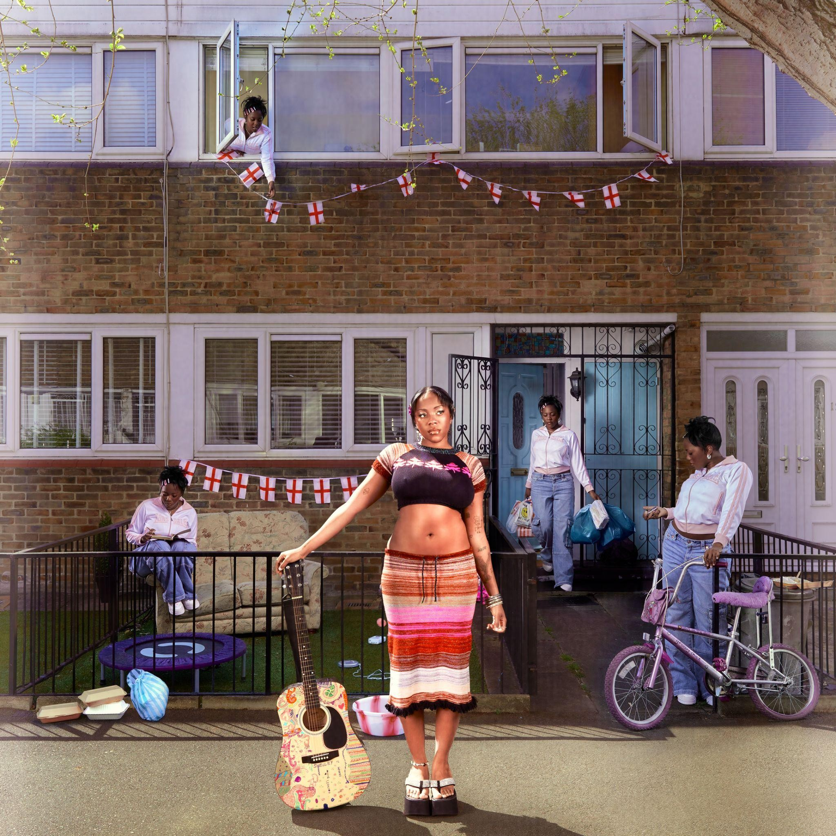
PRESAVE NOW

TRACKLISTING
- Garden Of Eden
- The Hills
- Never Need Me
- My Everything
- All I Ever Asked
- It Is What It Is
- Dumb Bitch Juice
- What A Devastating Turn Of Events
- My Blood
- Robbed
- Cold Call
- I Hate Myself
- Pocket
- So My Darling

On What A Devastating Turn of Events, Rachel Chinouriri is unflinching and mesmerizing as she invites us into her world and the experiences that have shaped her to become the person she is today. Despite facing up to the darkest parts of herself and her life - relationships, loneliness,

regret, abuse, unconditional freedom, self-harm, alcohol abuse and ultimately, death - Rachel asks us to consider the beauty amongst it all too.

The record examines the thoughts that had been swirling around her head: there are more long-standing themes of love, self-deprecation, unworthy exes and finding her boundaries in the album’s first half, but then in the second half, things get heavier.

“It’s a turning point,” she says, “Each song represents how you deal with trauma, but on the second half it’s when you get bad news and your world turns upside down.” This is an album which deals with grief, heartache, hurt, and what she calls the “worst-case scenarios” when these things are left unspoken for too long.

“I’m a lot better now,” she smiles, “And all of these topics don’t hurt me anymore, to a degree, but they shaped me and made me the person I am. When these things happen, you will never be the person you were before then, you adapt; and I think this album reflects that. It’s a healing tool, and I’m hoping people listening to it might feel less alone.”

In the process of learning to collaborate with other writers and producers in the creation of her debut album, Rachel was able to create the sonic world that she’d long been searching for. From soft acoustics to shiny indie pop to roaring scuzz, there’s her mellifluous vocal, the sumptuous harmonies, and even occasional bouts of cheeky, chatty speak-singing à la Kate Nash and Lily Allen, through which she builds upon her penchant for candid, lyrical songwriting.

What A Devastating Turn Of Events’ expansive palette was fleshed out with executive producer Rich Turvey (Blossoms, The Courteeners, The Coral), and co-credits include hip-hop behemoth Kenny Beats, and writers like Aaron “Apob” Paul O’Brien, Glen Roberts, Mary Weitz, and her long-term collaborator Daniel Hylton-Nuamah.

About Rachel Chinouriri
Rachel Chinouriri is one of the UK’s most exciting alternative indie pop talents who made a name for herself as a leading ambassador of captivating and heartfelt songwriting. The London singer songwriter has amassed over 120 million streams to date and has been marked out as a true one to watch by being shortlisted for the BBC’s Sound of 2023 and the Ivor Novello Rising Star Award.

With her 2022 EP Better Off Without Rachel marked a return to her first genre love of indie, balancing the sadness of heartbreak with summery choruses of hope. Rachel also made her COLORS session debut, sharing her vulnerable single ‘Thank You For Nothing’, exploring the topic of alcohol abuse.

The critical success of 2021’s Four° in Winter EP marked out her capabilities as a stylistic amalgamator, praised across the likes of BBC Radio 1, The Guardian, Dazed, NME, and theneedledrop’s Anthony Fantano who named the EP his #1 project of 2021.

Over the past few years Rachel has sold out numerous headline shows, supported the likes of Lewis Capaldi, Sam Fender, Celeste, Tems and Kojey Radical, drawn adoring crowds at festivals including Glastonbury, Latitude, The Great Escape, Boardmasters, Cross The Tracks and more. With a fiercely loyal fanbase by her side, Rachel turns her attention to her debut album: the truest expression of her musical journey to date, she’s ready to share her realest, rawest self.

RACHEL CHINOURIRI

2024 LIVE DATES
Wednesday 6th March - KOKO, London - SOLD OUT
Sunday 10th March - Baby’s All Right, Brooklyn, NY - SOLD OUT
Tuesday 12th March - Baby’s All Right, Brooklyn, NY - SOLD OUT
Thursday 14th March - British Music Embassy showcase @ SXSW, Austin, TX Wednesday 20th March - The Echoplex, Los Angeles, CA - SOLD OUT

Instagram | Facebook | Twitter | TikTok

For US media inquiries, please contact:
Sarah Goldstein – sarah.goldstein@300elektra.com
Sydney Worden – Sydney.worden@300elektra.com

