QUARTERS OF CHANGE RELEASES NEW ALBUM PORTRAITS
STREAM

ALBUM DOCUMENTARY
PORTRAITS OF A NEW YORK CITY ROCK BAND
PREMIERED THIS WEEK AT RENOWNED
FOTOGRAFISKA MUSEUM — WATCH

TAKE TO THE BOXING RING IN OFFICIAL VIDEO FOR
“TIGHTROPE”— WATCH

UPCOMING FESTIVAL PERFORMANCES AT
GOVERNORS BALL AND SHAKY KNEES
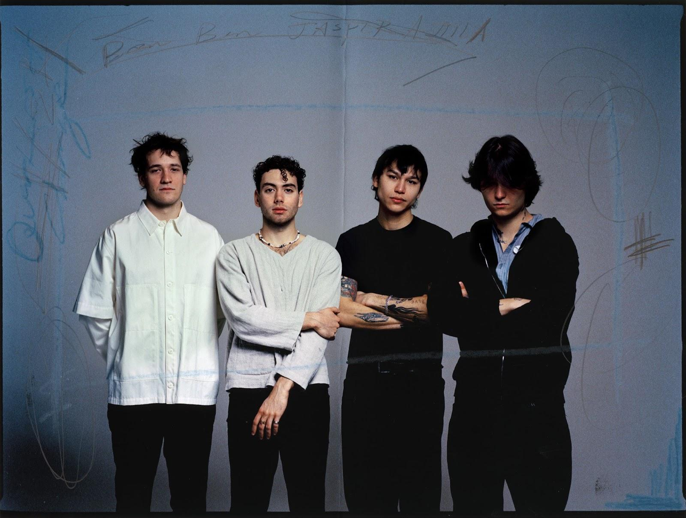
Press photo by Anna Henderson [Download]

“…the depths of the group’s range as musicians. Ben Roter delivers the lyrics with a languid flair that builds to a euphoric crescendo…” - BILLBOARD
“New York's Quarters of Change douse listeners with their aggressively vulnerable storytelling…alluring and bold…” - ONES TO WATCH
“Their best work to date.” - LOCAL WOLVES

One of the fastest rising rock bands coming out of New York City, Quarters of Change, today release their album Portraits via 300 Entertainment. After decamping to Woodstock, NY, for two weeks, the band left with their most collaborative, exposed-nerve writing to date; something with a piece of each of them etched into it. Where their last album Into The Rift was staring into the dark tunnel ahead, Portraits is close to the other side, with the band surfacing for some light — Stream.

“The album is made up of individualized fragments that provide different perspectives and create their own little vignettes,” shares frontman Ben Roter. “I think of each fragment as a portrait, reflecting a separate emotion or moment. Overall, it dives into themes of addiction, isolation and exploration.”

Quarters of Change continued to put themselves to the test by self-producing this body of work back in the Big Apple, joined by a handful of collaborators including GRAMMY® Award winning producers Mikey Freedom Hart (Jon Batiste, Taylor Swift, Bleachers, Lana Del Rey) and Dave Tozer (John Legend, JAY-Z), in addition to fellow artist Charlie Burg and producer Brandon Shoop.

“We tried to preserve the beauty of what a performance by a band should be,” Roter explains. “When you hear the album, I hope you can tell we’re real humans playing instruments, and it’s honest.”

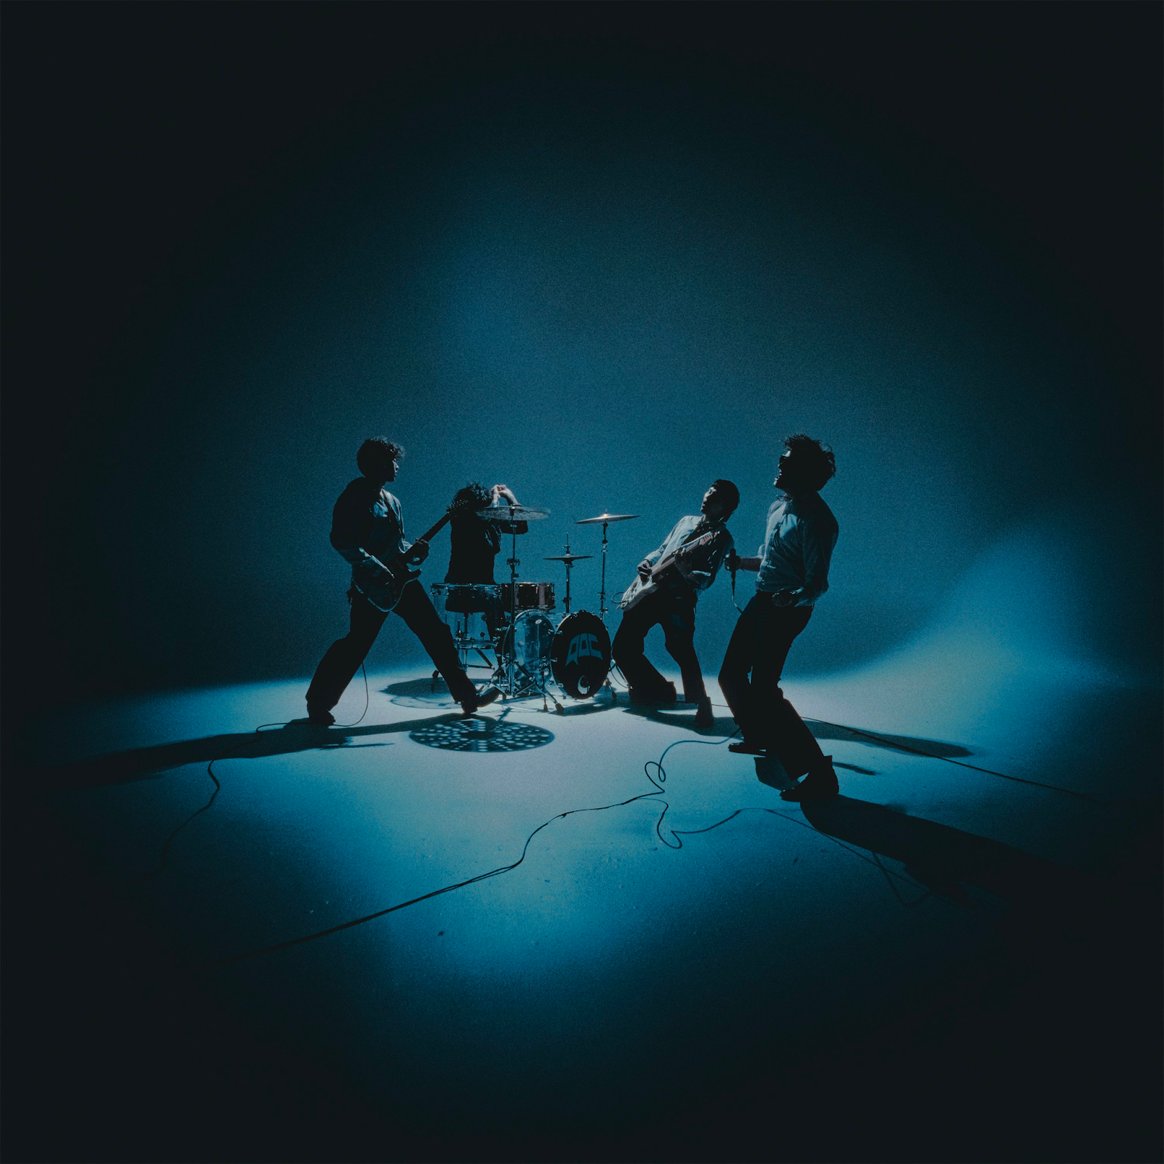
Portraits album artwork [Download]

PORTRAITS TRACKLIST
“What I Wanted”
“Depression II”
“Heaven Bound”
“Turn It Away”
“Tightrope”
“Cherry Tree”
“Do or Die”
“Time Before Mourning”
“Hollywood Baby”
“Illogical Decisions”
“Keep My Blood”

Earlier this week, the band hosted an album release event at Fotografiska Museum in New York with fans, their team, and everyone else who helped bring Portraits to life. At the party, the band premiered their album documentary, Portraits of a New York City Rock Band. Directed by longtime creative collaborator Amyas Ryan, the documentary shows the behind the scenes of the 14 days in the woods writing, 47 shows, 26 states, 3 festivals, and 10,000 miles that led to this album — Watch.

Also arriving today is the official video for “Tightrope.” Directed by Oliver Pearson across Manhattan and Brooklyn, Quarters of Change don’t pull their punches in this blow-by-blow cut. Training in the streets and taking it to the ring, the visual matches the song’s intensity and combativeness — Watch.

In the coming months, Quarters of Change will continue rolling out more content from Portraits. They’ll be joining the festival lineups of Governors Ball and Shaky Knees, with more to be announced soon.

In the tailend of last year, Quarters of Change sold out their headline tour while releasing singles from their latest album. In December, the band played to a sold out NYC crowd at their Webster Hall homecoming show. Live performance videos can be watched here of “Heaven Bound” and “What I Wanted.” At their Albany arena show, the Jonas Brothers brought Quarters of Change out to perform “T Love,” introducing the band to a whole new, ravenous fanbase.

"We’ve been labeled many different ways, but in the end, ‘Portraits’ is a picture of where Quarters of Change is right now. What started at a cabin in Woodstock, NY, ultimately brought us to clubs, arenas and beyond. Each song is a portrait, and together it’s our sophomore album,” concludes Roter.
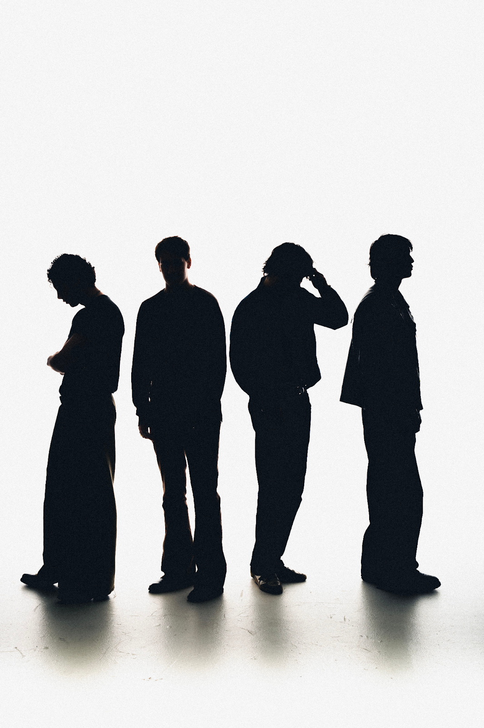
Press photo by Max Durante [Download]

ABOUT QUARTERS OF CHANGE
Anchored by a mutual predisposition for unpredictability, Quarters of Change fuse together a signature hybrid of nineties-style alternative hooks, crunchy space rock soundscapes, and strutting seventies grooves. After piling up millions of streams, selling out shows, and inciting critical applause, the New York City quartet — Ben Acker (guitar, bass, synths), Attila Anrather (drums), Jasper Harris (guitars, bass, synths), and Ben Roter (vocals, guitar)— are working their way toward the 2024 release of their album Portraits.

Leaning on an unspoken musical language of their own, forged by years of cutting their teeth together, sneaking into shows they were once too young to play and practicing in the basement of their old high school, Quarters of Change very clearly have a lifelong bond that has created their own breed of alternative rock with stadium scope.

Initially gaining traction with a handful of independent EPs as the fan favorite “Kiwi” reeled in over 10 million streams, they continued to hone this signature style on their 2022 full-length debut, Into The Rift. Highlighted by fan-favorite tracks “T Love,” “Jaded,” and “Dead,” they made enamored notable fans out of Joe Jonas, Lewis Capaldi, Chad Smith, and Fred Durst, to name a few.

Quarters of Change simultaneously emerged as a live force, supporting Bad Suns and selling out their first-ever US headline tour. The Aquarian hailed them as “reviving alt rock,” and Sheesh professed, “Quarters of Change has mastered the New York rock resurgence in a way that is resonating with even the best of the best.” In 2023 the band made their SXSW debut, sold out a headline tour run that ended with a momentous performance at Austin City Limits, and began rolling out the singles from the newest body of work. Doubling down on amplifying the energy, and turning up the distortion, Quarters of Change have quietly emerged as a phenomenon, and maintain this momentum with the release of their new album Portraits, available everywhere now.

###

For more information on Quarters of Change, please visit:
Instagram | Twitter | TikTok | YouTube | Spotify | Apple Music | Website

For Quarters of Change press materials and inquiries, please contact:
Collin Citron | Collin.Citron@300elektra.com
Destiny Dominguez | Destiny.Dominguez@300elektra.com

