GAMES WE PLAY RETURNS WITH HEARTFELT NEW SINGLE
“GIRL SHAPED CRATER”
LISTEN HERE | WATCH MUSIC VIDEO HERE

DEBUT ALBUM LIFE’S GOING GREAT AVAILABLE MARCH 1 VIA FUELED BY RAMEN/DCD2
PRE-ORDER/PRE-SAVE HERE

U.S. HEADLINE TOUR AND FALL OUT BOY SUPPORT DATES KICK OFF MARCH 15
TICKETS AVAILABLE HERE

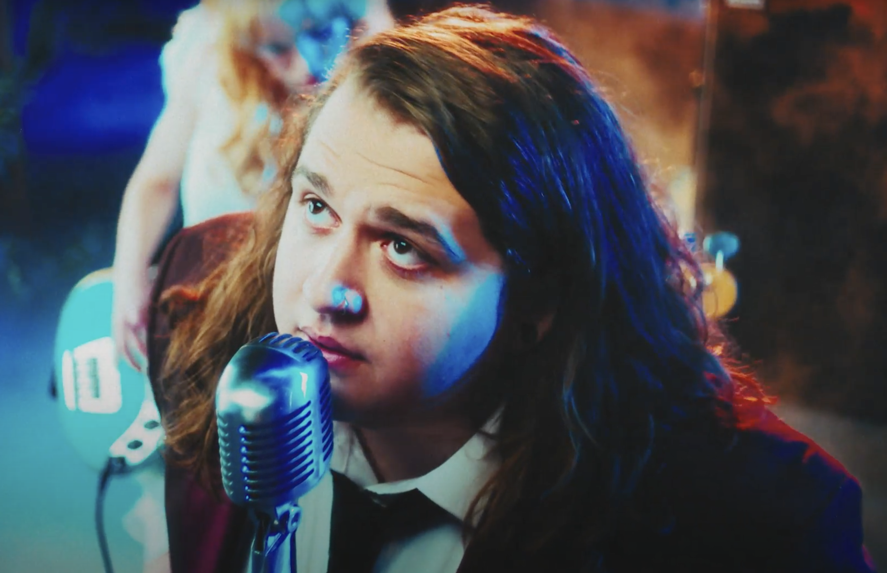

DOWNLOAD HI-RES PRESS ASSETS HERE

“2024 Artist To Watch” GRAMMY.com
“The one-man pop-punk powerhouse Games We Play produces nothing but feel-good pop-punk anthems” Alternative Press
“Big, catchy hooks and lyrics that are equal parts spiteful and playful” Consequence

“Emotionally self-aware lyrics, big heavy riffs and a brilliantly fun attitude” Rock Sound

“Radiating pop-punk-esque melodies that provide a mesmerizing atmosphere paired with glowing crisp vocals” New Noise

“Games We Play is going to be massive. Just a talented musician who has it all — catchy music, fun lyrics and an amazing stage presence.” LOUDWIRE

January 19, 2024 - Singer, songwriter, multi-instrumentalist, producer, and pop-punk provocateur Games We Play (a.k.a Emmyn Calleiro) returns with his new heartfelt single “Girl Shaped Crater” out today via Fueled By Ramen / DCD2. It is available on all streaming platforms HERE. The song is accompanied by a captivating music video—now streaming on the official Fueled By Ramen YouTube Channel HERE. Additionally, he has revealed his anxiously awaited full-length debut album, Life’s Going Great, will now arrive on March 1, 2024. The album is available for pre-order/pre-save HERE.

Games We Play previewed “Girl Shaped Crater” on social media by posting candid videos from the driver’s seat of his car and in the backyard, generating anticipation among his devout fan base in the process. This morning, he candidly introduced the single with a highly personal TikTok video. In the clip, he dedicates the tune to his wife Dani. On the track, breezy acoustic guitar glides through soft strings while his spacey croon practically hovers on the hook, “There’s a girl-shaped creator in the earth, that’s never leaving no, right where you fell.” Directed by Jared Asher Harris (Hozier, Flo Rida, Joywave) the music video proves equally engaging as Emmyn, donning a dapper suit, pulls up to a Victorian house where he proceeds to serenade a girl Romeo & Juliet-style flanked by an all-female band of angels.

About “Girl Shaped Crater,” Emmyn explains, “It’s about the most amazing person in the world who doesn’t see herself as you do. This girl is irreplaceable, and it’s like she came from another planet. There’s a hole in the earth, since she arrived so fast and crashed so hard.”

Games We Play set the stage for Life’s Going Great with the hyper catchy “All My Untalented Friends (Ooo La La),” the emotionally charged “too young,” and the vulnerable earworm “Pretty Boy.” Beyond gathering over 1 million total streams and counting, Rock Sound hailed “too young.” as “wistful,” while Substream Magazine also praised it as “vulnerable.” Melodic Magazine noted, “In “Life’s Going Great,” Calleiro paints a vivid picture of his experiences over the past year, encapsulating both his fulfilled aspirations and the formidable challenges he faced.”
Get ready for a whole lot more from Games We Play soon.
In 2022, Games We Play released his major label debut EP Get A Job, followed by the official video for the wildly chantable title track “Get A Job.” Inspired by the legendary “What The Fuck Is Up Denny’s?” clip, the video was filmed at Emmyn’s first-ever Los Angeles show at America’s beloved diner Denny’s in Hollywood, CA. The epic performance sees Emmyn start a mosh pit in the middle of the restaurant and features Fall Out Boy bassist/Emmyn’s DCD2 Records label boss Pete Wentz crowd surfing. Watch the video on Fueled By Ramen’s official YouTube channel HERE.

The Get A Job EP was introduced with viral breakout single “I Hope You’re Happy” and anthemic track “St. Girlfriend.” In May of last year, Games We Play announced his Fueled By Ramen/DCD2 Records signing in an exclusive interview with Consequence. Watch how Games We Play signed featuring DCD2 Records Founder and Fall Out Boy bassist and visionary Pete Wentz HERE. To herald the announcement, Games We Play unveiled an official music video for his viral breakout single “I Hope You’re Happy”. Watch it on Fueled By Ramen’s official YouTube channel HERE. In the clip, Emmyn’s contagious enthusiasm, bold personality, and hilarious sense of humor come to life on screen as the magnetic pop-punk refrain resounds with chantable turn-of-the-century bliss.

Games We Play - Life’s Going Great
DOWNLOAD HI-RES ALBUM ART HERE
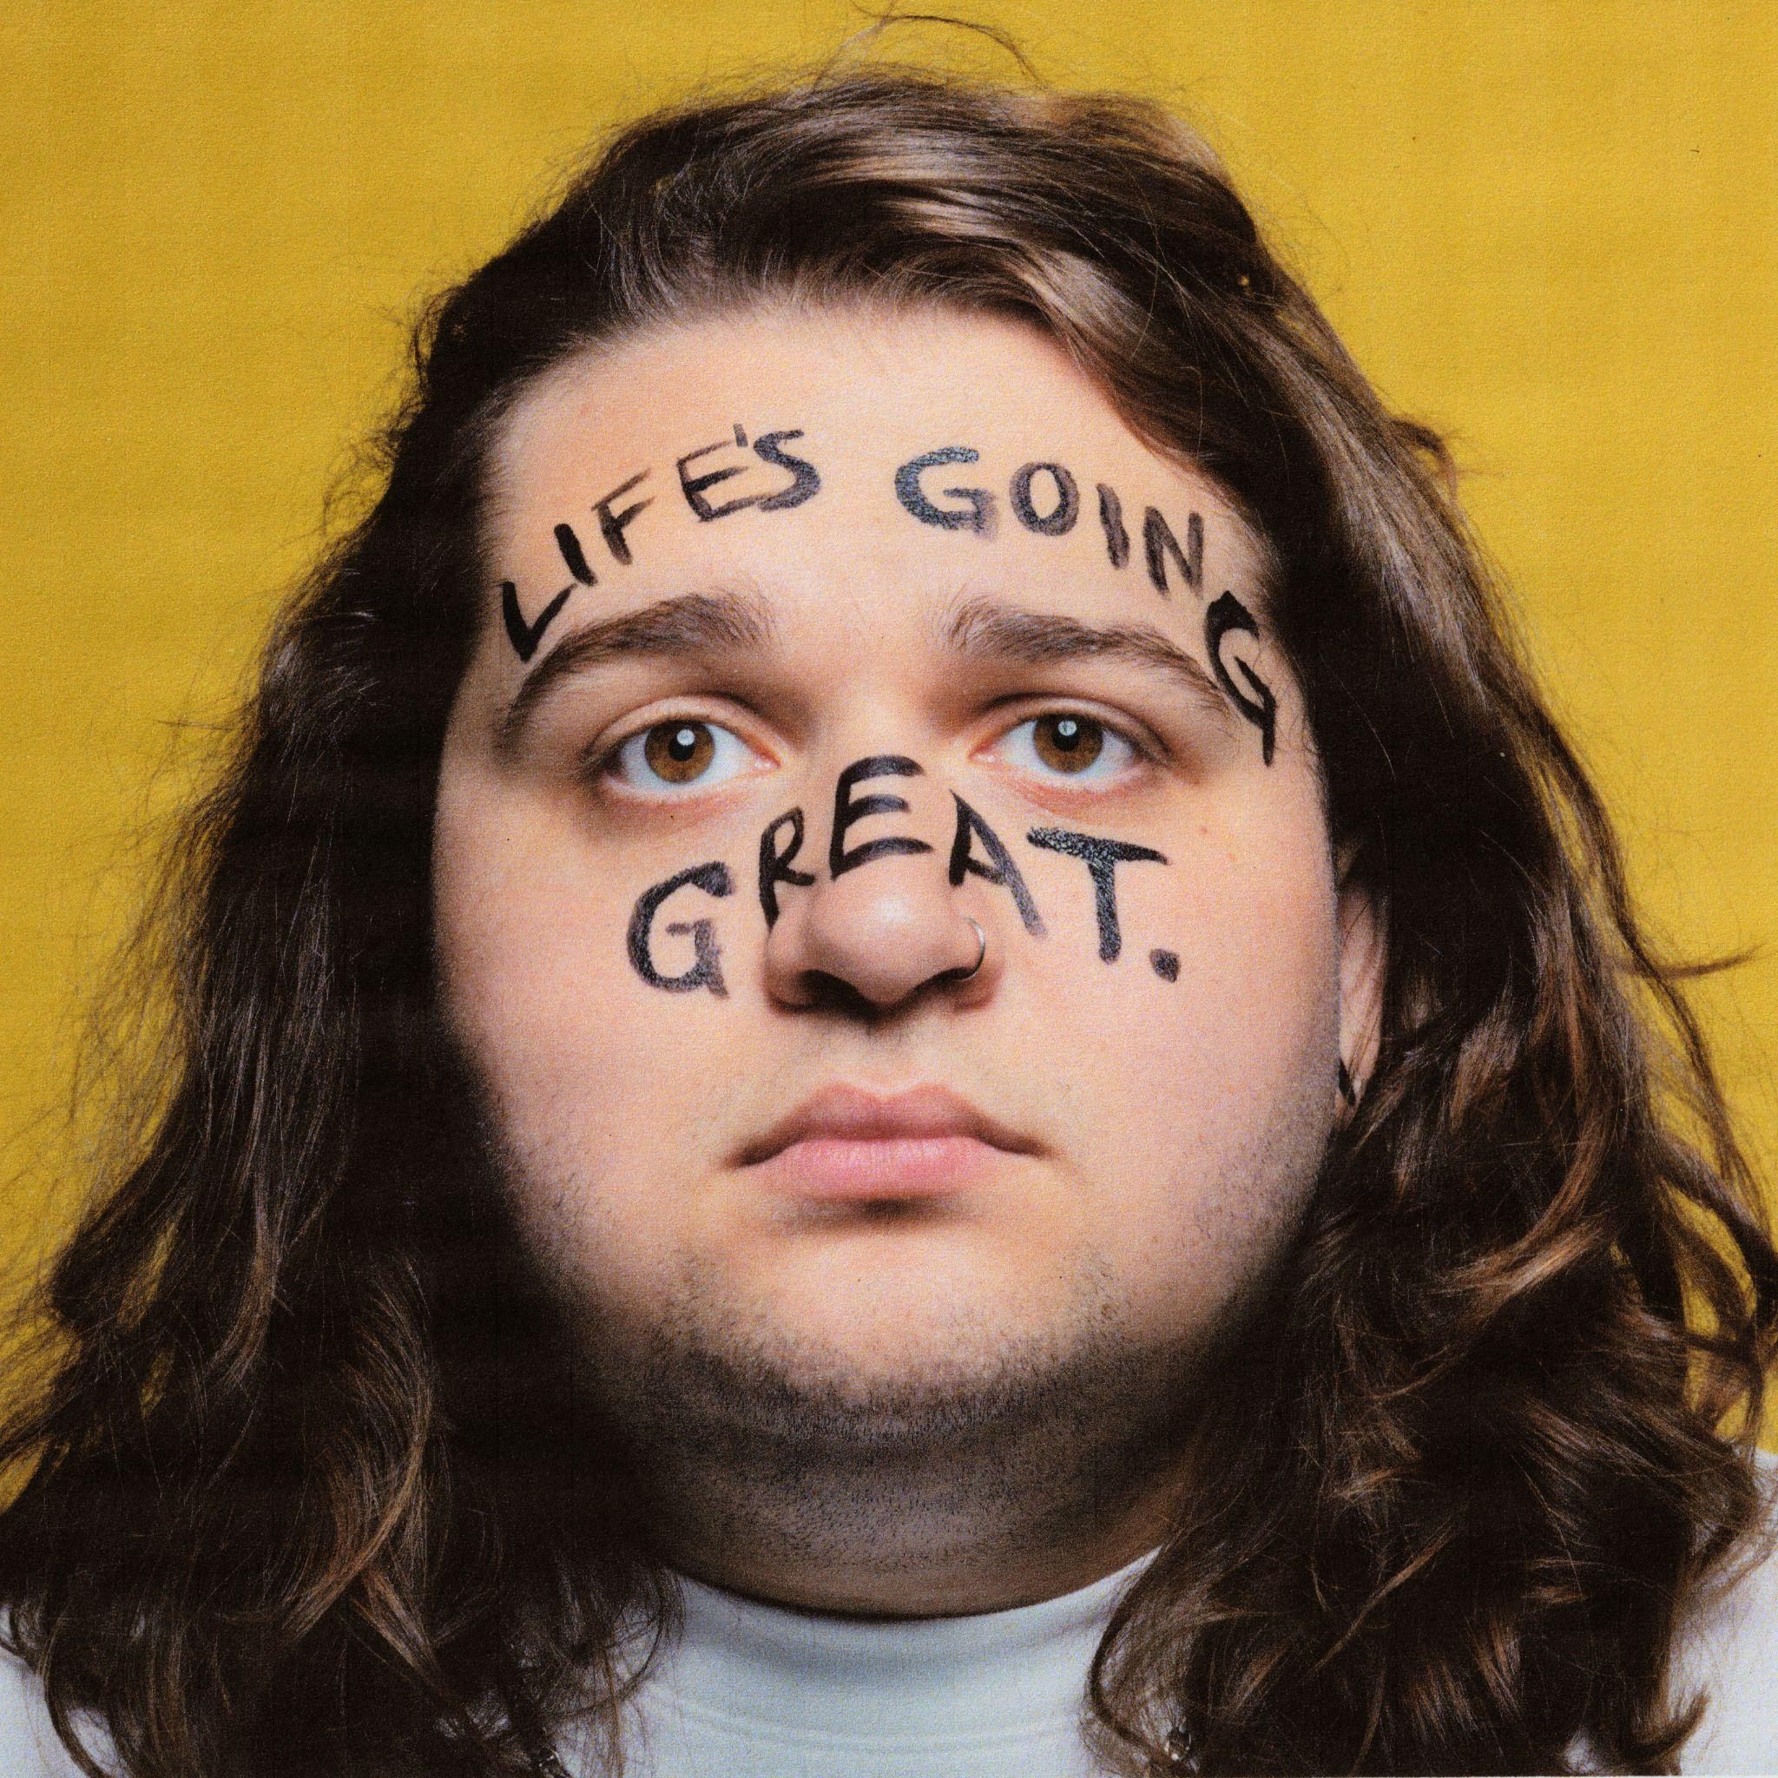

Life’s Going Great Album Track List
1. The End
2. Typical Me
3. Girl Shaped Crater
4. Oh So Blue
5. Petty Enemy
6. Interlude (ft. Pete Wentz)
7. too young.
8. So Bad
9. Pretty Boy
10. Round & Round
11. Interlude (ft. My Mom)
12. Naked
13. She’s The Girl
14. All My Untalented Friends (Ooo La La)
15. Life’s Going Great

Games We Play Tour Dates
Life’s Going Great Tour
^ Supporting FOB, The Maine
*Headline Show

March 15, 2024 - Orlando, FL - Amway Center ^
March 16, 2024 - Jacksonville, FL - VyStar Veterans Memorial Arena ^
March 19, 2024 - Raleigh, NC - PNC Arena ^
March 20, 2024 - Baltimore, MD - CFG Bank Arena ^
March 22, 2024 - New York, NY - Madison Square Garden ^
March 24, 2024, Albany, NY - MVP Arena ^
March 26, 2024 - Grand Rapids, MI - Van Andel Arena ^
March 27, 2024 - Detroit, MI - Shelter *
March 29, 2024 - Chicago, IL - Cobra Lounge *
March 30, 2024 - Minneapolis, MN - 7th Street Entry *
April 2, 2024 - Denver, CO - Meow Wolf *
April 3, 2024 - Salt Lake City, UT - Kilby Court *
April 5, 2024 - Vancouver, BC - Wise Hall *
April 6, 2024 - Seattle, WA - Barboza *
April 7, 2024 - Portland, OR - Mission Theatre *
April 9, 2024 - Los Angeles, CA - El Cid *
April 10, 2024 - Phoenix, AZ - Valley Bar *
April 13, 2024 - Austin, TX - Empire Control Room *
April 14, 2024 - Dallas, TX - HOB- Cambridge Room *
April 16, 2024 - St. Louis, MO - Old Rockhouse *
April 17, 2024 - Nashville, TN - Eastside Bowl *
April 19, 2024 - Orlando, FL - The Social *
April 20, 2024 - Atlanta, GA - Purgatory The Masquerade *
April 23, 2024 - New York, NY - Gramercy Theatre *
April 24, 2024 - Washington, DC - The Atlantis *
April 25, 2024 - Philadelphia, PA - The Church *
April 27, 2024 - Toronto, ON - Velvet Underground *
April 28, 2024 - Columbus, OH - A&R Bar *
May 1, 2024 - Boston, MA - Brighton Music Hall *

ABOUT GAMES WE PLAY:
Games We Play a.k.a. Emmyn Calleiro brings pop punk back to the people. You could think of him as the pop punk everyman—kinda like Springsteen if he was weaned on blink-182. He writes about breakups, awkwardness, growing up, and living his dream with wide-eyed enthusiasm through the perspective of a seasoned pro. For as sharp as his hooks are, he’s also gleefully self-effacing (which makes him even more likable!). Moreover, he’ll play a Denny’s with just as much bombast and bravado as he would an arena (and he’s actually done both!). The Florida-born singer, songwriter, multi-instrumentalist, and producer relocated to Nashville in his teens and served up the independent Senior Year EP in 2018. Simultaneously, his sense of humor, relatability, and sharp songcraft endeared him to a rabid fan base on TikTok as “I Hope You’re Happy” caught fire. He wound up signing to Fueled By Ramen/DCD2 Records and dropped his major label debut EP, Get A Job, in 2022. Beyond reeling in tens of millions of streams, he incited the applause of Consequence, Alternative Press, Loudwire, Rock Sound, The Honey Pop, and more. Renowned for his live energy, he notably toured alongside everyone from All Time Low, The Band CAMINO, and State Champs to YUNGBLUD and Fall Out Boy. Now, he’s serving up a batch of undeniable and unforgettable anthems on his full-length debut, Life’s Going Great, introduced by “All My Untalented Friends (Ooo La La)” and “too young.” Get ready to sing along to Games We Play.
Connect with Games We Play:
Instagram |X | Facebook | YouTube | TikTok

Press contacts:
Collin Citron / Collin.Citron@300elektra.com
Sydney Worden / Sydney.Worden@300elektra.com

