PRATEEK KUHAD SHARES ACOUSTIC VERSION OF “Co2”
FROM ACCLAIMED ALBUM THE WAY THAT LOVERS DO
LISTEN HERE

NEW EP MULAQAT ARRIVING NOVEMBER 28 VIA ELEKTRA

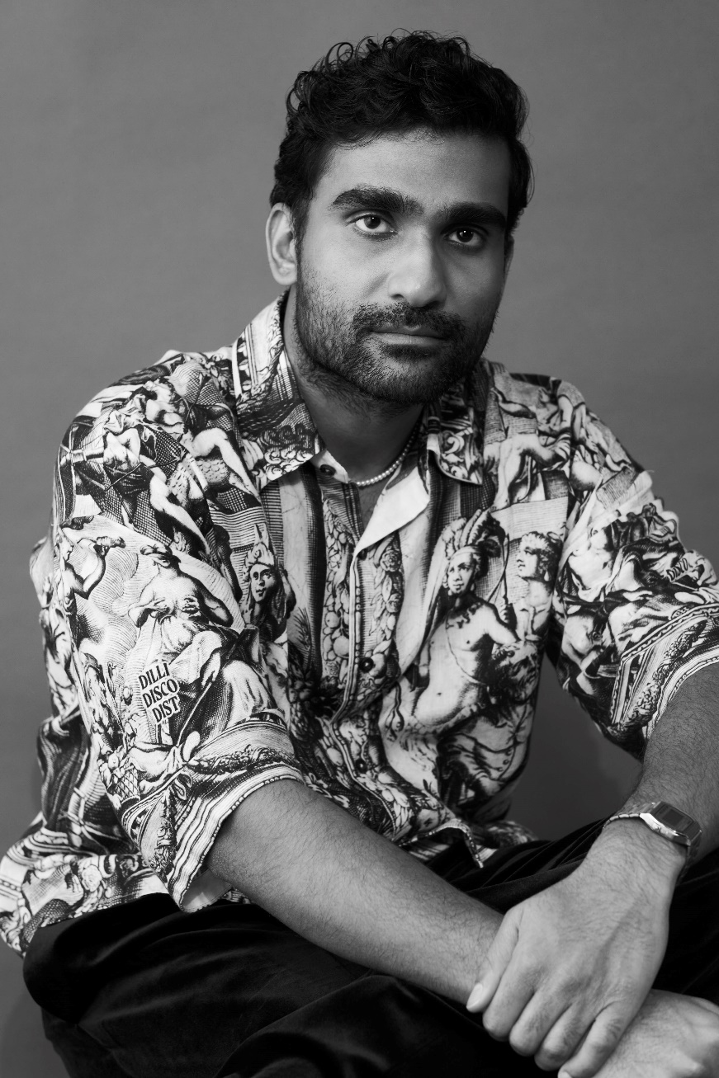
NOVEMBER 14, 2023 – Critically acclaimed singer-songwriter Prateek Kuhad has shared an acoustic version of “Co2” from his acclaimed album The Way That Lovers Do. A fan-favorite since the album’s 2022 release, “Co2 (Acoustic)” [LINK] strips back the original production for an intimate performance that focuses on Kuhad’s stunning vocals and guitar. The track is available now via Elektra [LINK].
Earlier this month, Prateek shared “O Piya” the second single from his upcoming Hindi EP Mulaqat. The release followed the EP’s title track, which was shared alongside an official music video starring famed Indian actress Tara Sutaria. The video is streaming now on Kuhad’s official YouTube channel, with the Mulaqat EP set for arrival on November 28th via Elektra.
In the spring, Kuhad shared a deluxe version of his latest album The Way That Lovers Do, which included an alternate version of “Bloom” featuring guest vocals from Indian-American R&B standout Raveena. The deluxe arrived on the heels of a breakout stretch for Kuhad that's seen him grace the cover of India's Rolling Stone, earn praise from Barack Obama on his famous year-end lists and play to bigger audiences than ever across continents – including his debut at Los Angeles' hallowed Walt Disney Concert Hall next year.
Despite all these accolades, Kuhad's road to global acclaim was never an inevitable one - first giving songwriting a try while an international student at NYU after finding his love of artists like Elliott Smith, Laura Marling and Fleet Foxes. Discovering a natural gift for the craft after dusting off his acoustic (he was kicked out of lessons during an earlier attempt to learn the instrument), Kuhad's intimate heart-on-your-sleeve lyricism - in both English and Hindi - has turned heads around the world. Some other major moments include Kuhad becoming one of the most streamed domestic artists as Spotify launched in India, earning an "Artist To Watch" designation from NPR at his first SXSW, and seeing his music placed in pivotal scenes of top TV shows like Ted Lasso.
(Single art below)

Prateek Kuhad
“Co2 (Acoustic)”
AVAILABLE NOW [LINK]

CONNECT WITH PRATEEK KUHAD
www.prateekkuhad.com
YOUTUBE
INSTAGRAM
FACEBOOK
TWITTER

CONTACT:
Sarah Goldstein
SarahGoldstein@elektra.com

