MEET ME @ THE ALTAR ANNOUNCE
THE “SAY IT TO MY FACE” TOUR
NORTH AMERICAN HEADLINE RUN KICKS OFF JANUARY 19

PAST // PRESENT // FUTURE (DELUXE) OUT NOW
LISTEN HERE

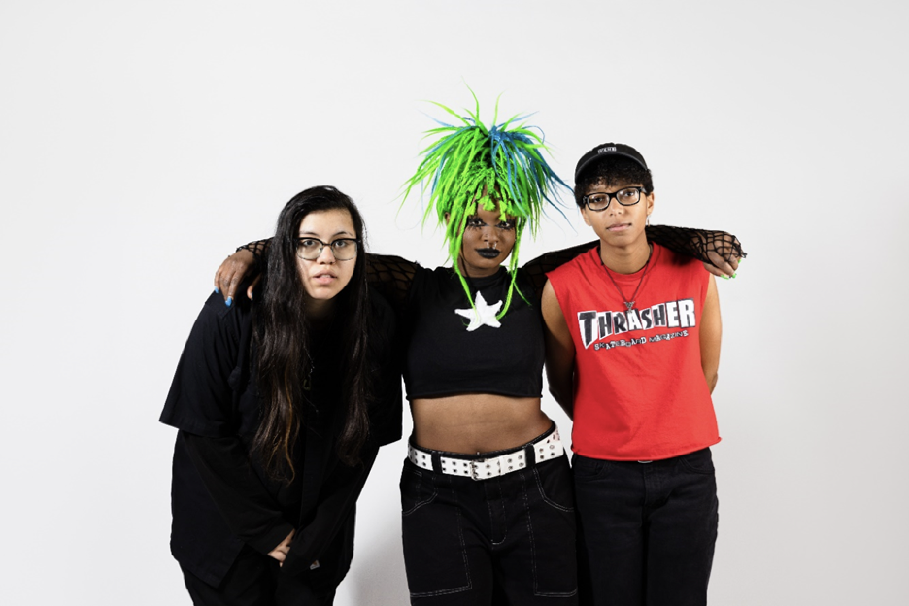

DOWNLOAD PRESS ASSETS HERE
Photo credit: LA Rodgers
“They are on the brink of … huge stardom” – NPR
“Meet Me @ The Altar are jump-starting a new era for pop punk”” – Rolling Stone
“Some of the most promising, exciting pop-punk in recent memory” – Stereogum
“Meet Me @ The Altar shine as voices of their generation” – UPROXX
“…a powerful statement from a band that is beginning to make their mark” – Them
OCTOBER 3, 2023 – Critically acclaimed rock trio Meet Me @ The Altar have announced the “Say It To My Face” tour. The North American headline run kicks off January 19 in Orlando, FL and wraps up February 21 in Nashville, TN, hitting NYC’s Irving Plaza on January 25 and The Roxy in LA on February 15 (full itinerary below). Support will be provided by Honey Revenge, John Harvey, and Elliot Lee. Presale begins today at 12pm ET, with general on-sale beginning Friday, October 6 at 10am local time. For up-to-date ticketing information, please visit www.meetmeatthealtar.com.
Last week, the trio shared Past // Present // Future (Deluxe), an extended version of their debut album which arrived earlier this year. The release was accompanied by an official music video for new track “Changes,” which is streaming now on the Fueled By Ramen official YouTube channel. Past // Present // Future (Deluxe) is available now via Fueled By Ramen. The album is available on hot pink and sky-blue vinyl through the band’s merch store HERE.
The deluxe record was heralded by new singles “Strangers,” and “Give It Up,” in addition to their long-awaited cover of “Take Me Away” from the iconic 2000s movie, Freaky Friday. The tracks arrived to praise from Rolling Stone, Stereogum, Consequence, UPROXX, Alternative Press, and more. UPROXX hailed “Strangers” as “lively and catchy,” while Stereogum attested, “…[it’s] as punchy and catchy as you’d hope, with riffs that verge on metallic and hooks that edge up to bubblegum pop.” Guitar World celebrated the single as “another gem from one of punk’s most talented up-and-coming groups.”

Past // Present // Future was originally released in March and arrived to widespread critical praise. The album was named one of the “Best Albums of 2023 So Far” by Billboard and Alternative Press. NPR lauded the record’s “…punchy rhythm section and a momentum that reaches out a hand to yank potential friends into the fun” and noted, “[Edith Victoria] … soars through powerful hook after hook with seeming ease.” “Meet Me @ The Altar shine as voices of their generation,” hailed UPROXX, while SPIN praised the album’s “…memorable lyrics and infectious jams.” Them commended the “earworm-filled LP,” Consequence applauded its “…high-energy percussion, undeniably fun guitar hooks … [and] vibrant vocal abilities,” and Alternative Press celebrated the debut’s “unending optimism.”
Calling upon iconic producer John Fields (Jonas Brothers, P!NK, Miley Cyrus, Demi Lovato), the album sheds any notion of sonic limitations and was heralded by singles “Say It (To My Face)” (which also soundtracked a national ad campaign for Taco Bell), “Kool,” and “TMI.” The group made their late-night television debut on The Late Show with Stephen Colbert, playing a walloping rendition of “Say It (To My Face),” and followed up with a dynamic performance of “Kool” on The Kelly Clarkson Show, marking their daytime performance debut. Meet Me @ The Altar recently discussed the album at length with the Zach Sang Show.
Meet Me @ The Altar just wrapped a North American tour supporting 5 Seconds of Summer that saw them perform at historic venues including Los Angeles’s Kia Forum and New York City’s Madison Square Garden. Earlier this summer the band wrapped their second North American headline tour in support of Past // Present // Future. The run saw them perform to sold-out crowds across the US and make appearances at numerous festivals and Pride events. Meet Me @ The Altar has previously supported MUNA, Green Day, jxdn, KennyHoopla, and more on tour, and performed at festivals including Lollapalooza, Riot Fest, and When We Were Young. Last Weekend, the band performed at All Things Go festival in Washington D.C. Additionally, frontwoman Edith Victoria participated in the festival's creator summit, speaking as a panelist on the “Inspiring Action Through Music” which was moderated by U.S. Representative Maxwell Frost.

MEET ME @ THE ALTAR
“SAY IT TO MY FACE” TOUR DATES
All dates featuring support from Honey Revenge, John Harvie, and Elliot Lee
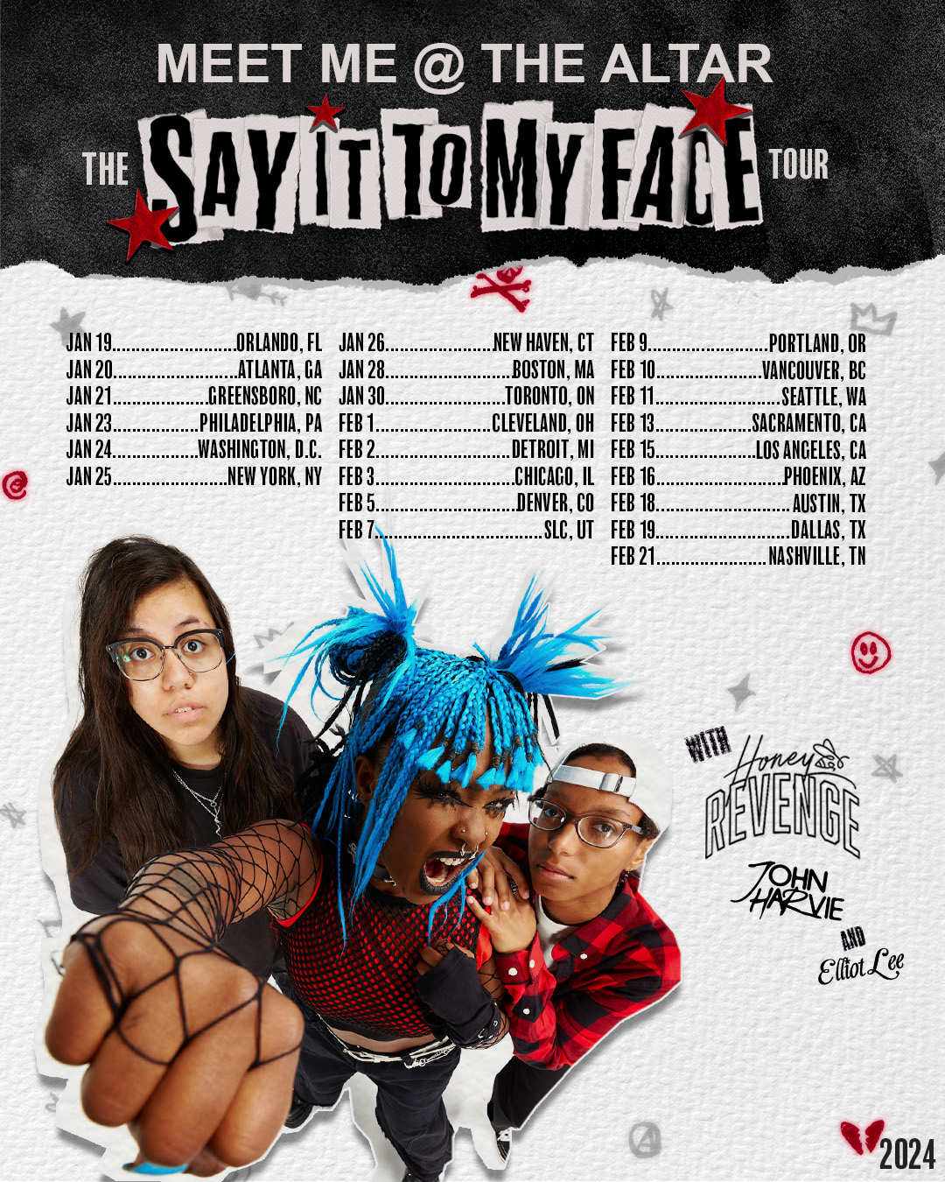

January 19, 2024 - Orlando, FL - The Abbey
January 20, 2024 - Atlanta, GA - Hell @ The Masquerade
January 21, 2024 - Greensboro, NC - Hangar 1819
January 23, 2024 - Philadelphia, PA - Theatre of Living Arts
January 24, 2024 - Washington, D.C. - 9:30 Club
January 25, 2024 - New York, NY - Irving Plaza
January 26, 2024 - New Haven, CT - Toad’s Place
January 28, 2024 - Boston, MA - Paradise Rock
January 30, 2024 - Toronto, ON - The Axis Club
February 01, 2024 - Cleveland, OH - Mahall’s
February 02, 2023 - Detroit, MI - The Shelter
February 03, 2024 - Chicago, IL - House of Blues Chicago
February 05, 2024 - Denver, CO - Marquis Theater
February 07, 2024 - Salt Lake City, UT - Soundwell
February 09, 2024 - Portland, OR - Hawthorne Theater
February 10, 2024 - Vancouver, BC - Rio Theatre
February 11, 2024 - Seattle, WA - Neumos
February 13, 2024 - Sacramento, CA - Goldfield Roseville
February 15, 2024 - Los Angeles, CA - The Regent
February 16, 2024 - Phoenix, AZ - Rebel Lounge
February 18, 2024 - Austin, TX - Antone’s
February 19, 2024 - Dallas, TX - Gilley’s
February 21, 2024 - Nashville, TN - Basement East

ABOUT MEET ME @ THE ALTAR:
Meet Me @ The Altar is an all women of color rock trio that met on YouTube through their shared love of Paramore and Twenty One Pilots, and formed while spread across three states. In 2021, the group released their major label debut Model Citizen EP, which arrived to widespread acclaim from The New York Times, The FADER, NPR Music, Rolling Stone, Teen Vogue, and more. Since the EP’s release, the band has toured supporting Green Day, MUNA, and jxdn, and appeared at festivals including Lollapalooza, Riot Fest, and When We Were Young. Now, Meet Me @ The Altar is ready to stake their claim in rock history with their debut album Past // Present // Future, out now via Fueled By Ramen.

# # #
CONNECT WITH MEET ME @ THE ALTAR
MeetMeAtTheAltar.com
Facebook
Instagram
Twitter
YouTube

Press Contacts:
Collin Citron / collin.citron@300elektra.com
Sarah Goldstein / sarah.goldstein@300elektra.com

