**HANNAH GRAE DROPS HALLOWEEN INSPIRED TRACK**

**‘*WHO DUNNIT*?’**

**LISTEN** [**HERE**](https://hannahgrae.lnk.to/whodunnit)

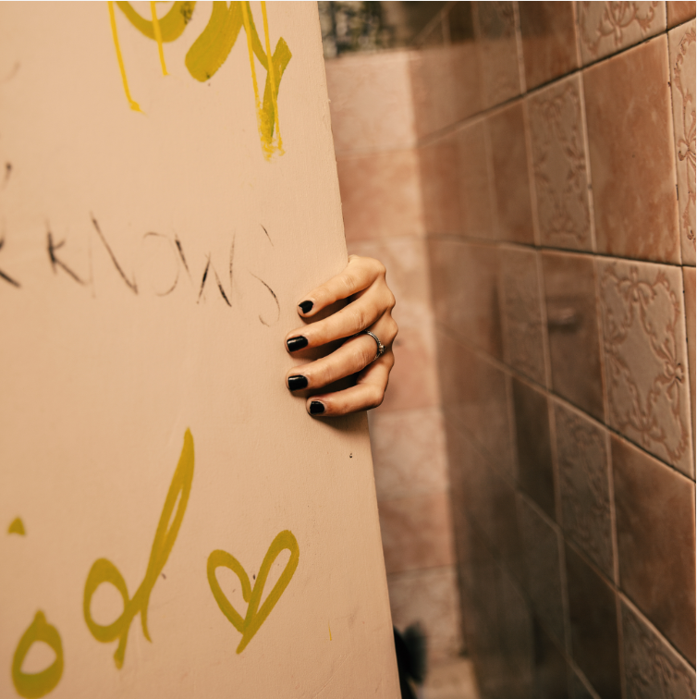

**DOWNLOAD ARTWORK** [**HERE**](https://www.dropbox.com/scl/fo/d4ru2vqqz9rl0cb3bwvse/h?rlkey=9511apq9s4uss58msxd5aeqcm&dl=0)

**OCTOBER 27, 2023 –** Today, 21-year-old self-taught musician Hannah Grae has dropped exciting fan track ‘*Who Dunnit?’*, from her upcoming sophomore mini-album. Listen [HERE](https://hannahgrae.lnk.to/whodunnit). Just in time for Halloween, the track sees Hannah admit to committing a crime that no one suspects her of. ‘*Who Dunnit?*’ is laced with Hannah’s signature pop punk sound, showcasing her impressive vocal ability seen throughout her growing discography.

Speaking of the new song, Hannah says: *“’Who Dunnit?’ was an experiment for me. I wanted to write something without putting any pressure on it sounding a certain way. I didn’t want to think about it being a single or playable for radio. I literally just wanted to write the most ridiculous song possible. The initial main reference for it was actually ‘Heart of Glass’ by Blondie, which is so funny in retrospect.*

*The concept is about people not taking me seriously. As a 5ft, baby faced, big mouthed pocket rocket, I often feel intimidated and overlooked. This song is a statement against that. I listen to it whenever I need to feel empowered and strong. I honestly can’t remember writing it and I can’t quite believe I did. I listen back, and every time, I’m surprised. I hope those who listen to it feel as epic as I do when I listen, and I hope it soundtracks their Halloween.”*

The rising star celebrated the release of ‘*Who Dunnit?*’ last night with an exclusive Halloween-themed event for fans in London.

Recently Hannah Grae released [*'It Could've Been You'*](https://youtu.be/wtf8HzxQoPY?si=W-qS3um0p-iMxYwj)*,* which has proven popular within her fanbase and beyond after the teaser video hit over 3 million views on TikTok in a matter of days. Before [*'It Could've Been You'*](https://youtu.be/wtf8HzxQoPY?si=W-qS3um0p-iMxYwj)came [*'Screw Loose'*](https://hannahgrae.lnk.to/ScrewLoose)*,* a hard hitting track which kicked off a new era for Hannah after she released her first body of work [*Hell Is A Teenage Girl*](https://hannahgrae.lnk.to/HIATG) in April.

This year, Hannah impressed festival crowds across the UK and Europe with performances at **2000Trees Festival**, Brighton’s**The Great Escape, Neighbourhood Weekender, Liverpool Sound City, Focus Wales,** **Standon Calling Festival,**Paris’**Rock En Seine,**Budapest’s**Sziget Festival**, Madrid’s**Mad Cool Festival**, Belgium’s **Pukkelpop Festival, Reading & Leeds Festival,**and **All Points East** to name a few.

Named an artist to watch by **Rolling Stone UK**, as well as being listed as one of **NME**’s 100 essential emerging artists for 2023, Hannah began captivating online audiences with her rewrites of popular songs and covers posted from her garden shed, resulting in over 150k subscribers to her YouTube channel and 272k followers on TikTok. Merging nostalgic elements of **No Doubt, Alanis Morrisette,** and **The Bangles** and modern storytelling lyrics inspired by the likes of **Phoebe Bridgers, Paramore,** and **Taylor Swift**– Hannah’s self-taught musical education seats her firmly in the lineage of cross-genre women making musical waves.

**DOWNLOAD PRESS PHOTO**[**HERE**](https://www.dropbox.com/scl/fo/d4ru2vqqz9rl0cb3bwvse/h?rlkey=9511apq9s4uss58msxd5aeqcm&dl=0)

-

**Follow Hannah Grae on socials**:

Instagram: @[hannahgrae](https://www.instagram.com/hannahgrae/)

Twitter: [@HannahGraeMusic](https://twitter.com/HannahGraeMusic)

YouTube: [hannah grae](https://www.youtube.com/c/hannahgrae)

TikTok: [@hannahgrae](https://www.tiktok.com/@hannahgrae)

*For Hannah Grae press enquiries:*

[*Evie.Ranscombe@edge-ent.com*](mailto:Evie.Ranscombe@edge-ent.com)