TONES AND I RETURNS WITH NEW SINGLE “THE GREATEST”

LISTEN HERE

MORE NEW MUSIC COMING SOON

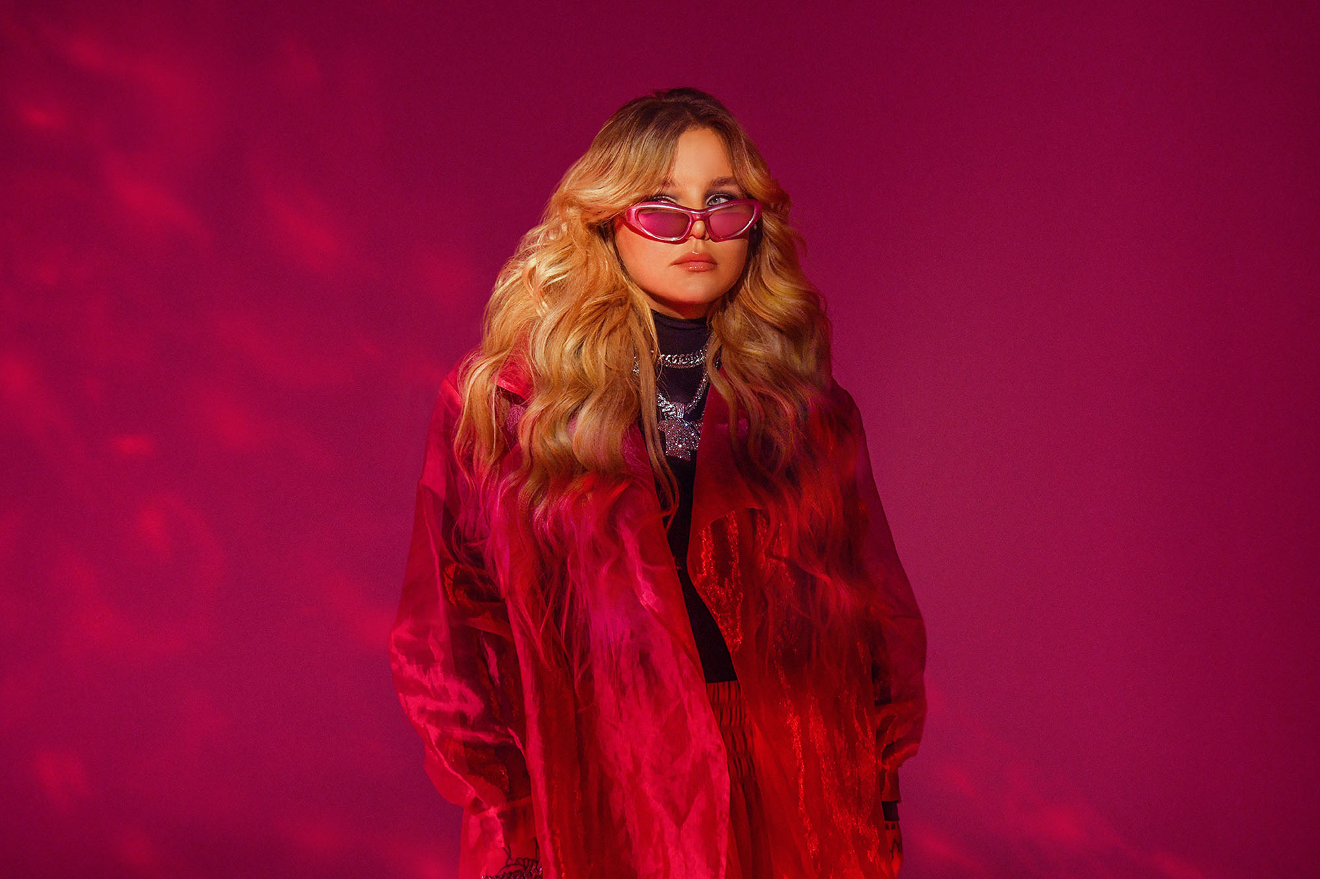
PHOTO CREDIT: GIULIA MCGAURAN

AUGUST 4, 2023 – Global superstar and multi- platinum award-winning songwriter Tones And I has unveiled a new standalone single entitled “The Greatest” (see single art below), which is available today on all streaming platforms and joined by an official music video directed Nick Kozakis, Liam Kelly, and Tones And I – watch it HERE.

Regarding the song, Tones And I stated, “'The Greatest' encapsulates the power of strong women. When writing the track, I wanted to create something that would make females feel empowered and courageous. I'm proud to be a woman, and I'm constantly inspired by them.”

On the track, cinematic strings dissolve into a punchy beat as Tones And I’s vocals rise from intimate verses towards a chantable chorus punctuated by a proclamation, “I will be the greatest.” The song layers eloquent orchestration over glitchy production and rich piano as her uplifting vocals meet this ebb and flow with power and passion. Be on the lookout for an equally emotional and arresting music video to accompany “The Greatest.”

Tones And I recently announced a groundbreaking partnership with Football Australia and the CommBank Matildas. The collaboration will see Football Australia and Tones And I collaborate on promotional opportunities across digital and broadcast assets and in an exciting first with “The Greatest” being used as the ultimate anthem to support the CommBank Matildas and inspire their global fan base over coming weeks and months. Furthermore, Tones And I is also featured on the recently released track "BRING IT ON [Official FIFA Walkout Anthem]," alongside Bia and Diarra Sylla, and produced by RedOne (Lady Gaga, Britney Spears, Nicki Minaj, Justin Bieber) serves as the official walk-out song for all FIFA matches, commencing with the Women’s World Cup in Australia. It will also serve as the official walk out music for every FIFA match until 2030.

The two new tracks land on the heels of Tones And I’s other 2023 single “I Am Free,” which has gathered millions of streams on DSPs alongside a recently released ‘Piano Version.’ It also heralds more new music to come from Tones And I very soon.

“I Am Free” followed Tones And I’s single “I Made It” – composed for the Netflix original film True Spirit - her 2022 single “Charlie” and her feature on Macklemore’s “Chant.” The pair debuted the collaboration on Good Morning America with an electrifying performance in New York City’s Central Park. Furthermore, Tones And I also recently wrapped up a run of dates supporting Macklemore on his UK and Europe spring headline tour.

Released in 2021, Tones And I’s debut album Welcome To The Madhouse landed at #1 on Australia’s ARIA Albums Chart continuing an incredible string of successes for Tones And I. The record details an intimately honest and vivid journey from busking in Byron Bay to international stardom to saying goodbye to her best friend. Tones And I weaves it all together into a moving and magnetic 14-track collection written entirely by the Australian artist with her co-producing every song.

Tones And I exploded in to pop culture’s consciousness with her global smash “Dance Monkey,” which is featured on her debut EP The Kids Are Coming. “Dance Monkey” is the most Shazamed single of all time, the most streamed song ever by a female artist on Spotify, and has earned 6x platinum certification from the RIAA in the US as well as multi-platinum or diamond certification in sixteen other countries.

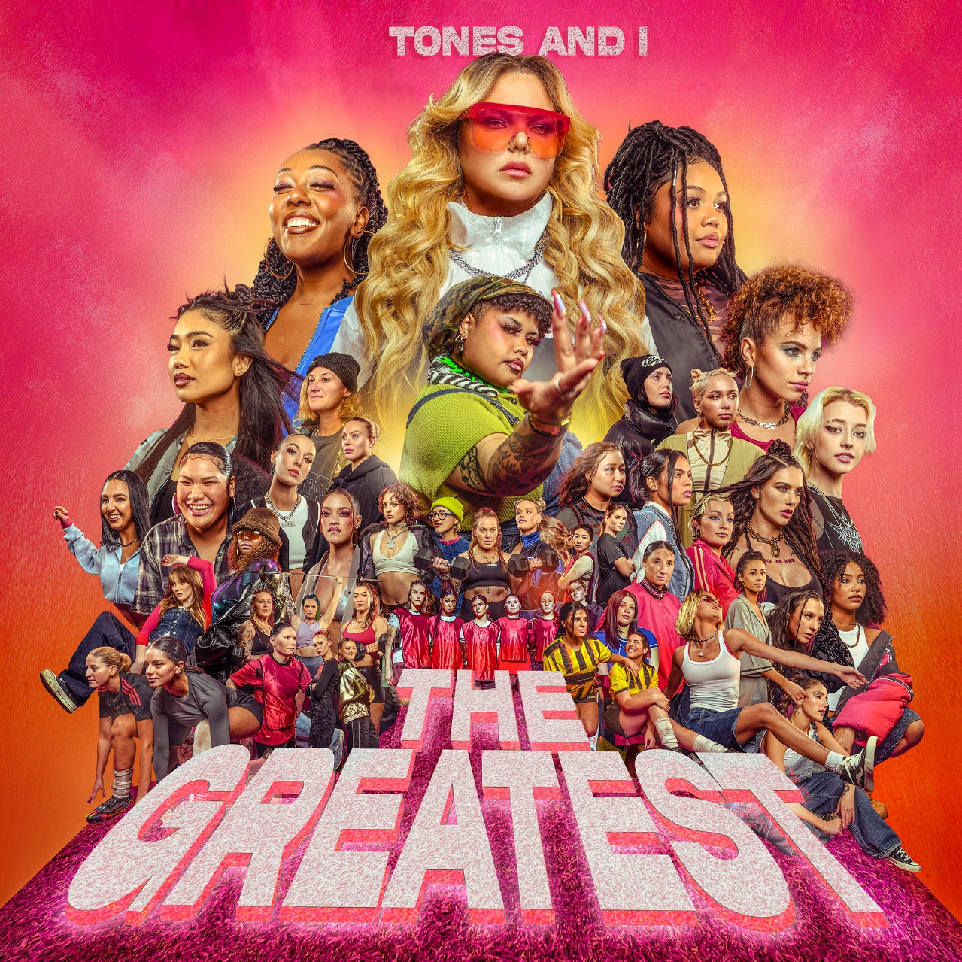

FOR MORE INFORMATION ON TONES AND I:
FACEBOOK / TWITTER / INSTAGRAM / YOUTUBE / SPOTIFY / APPLE MUSIC / AMAZON MUSIC

CONTACT FOR TONES AND I:

Glenn Fukushima
Glenn.Fukushima@300Elektra.com

Ross Anderson
Ross.Anderson@300Elektra.com

