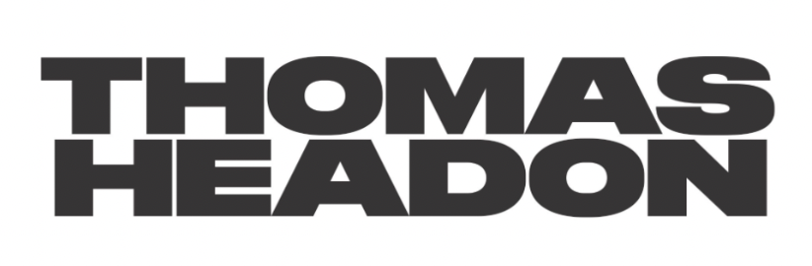
RELEASES BRAND NEW PROJECT
SIX SONGS THAT THOMAS HEADON LIKES AND THINKS YOU WOULD LIKE TOO

WITH LEAD SINGLE AND BBC RADIO 1’S HOTTEST RECORD IN THE WORLD
“W4NNA DO”

NORTH AMERICAN TOUR DATES SUPPORTING HALF ALIVE
KICK OFF THIS SEPTEMBER
DOWNLOAD PRESS ASSETS HERE

“The competition best start taking lessons – Thomas Headon is starting to run away with the game.” - Dork, 5*

“a British pop star on the rise” – V Magazine

“fast rising star” – DIY

“bubbling new bedroom pop” - Clash

“…innate talent for songwriting” – Ones To Watch

JUNE 30, 2023 – Having claimed the highest charting UK EP of 2022 with his debut EP Victoria, Thomas Headon has proven himself an undeniable indie-pop force. Playing his first-ever UK show at 150-cap venue The Grace in 2020, to selling out 2300-cap O2 Forum Kentish Town last year, completing a co-headline tour with good friend Alfie Templeman and supporting both Sir Elton John and Sigrid, the London via Melbourne rising star today releases his highly anticipated project, six songs that thomas headon likes and thinks that you would like too.

LISTEN TO SIX SONGS THAT THOMAS HEADON LIKES
AND THINKS YOU WOULD LIKE TOO HERE

This latest project sees Thomas take fans on a captivating journey through his vibrant alt-pop world. With abundant variety, the project skillfully blends auto-tuned sonics in the euphoric single “2009 TOYOTA” with nostalgic guitar strums destined to become the soundtrack of summer evenings in “not saying goodbye :(.” Throughout the project, Thomas showcases his evolved lyricism, offering fresh perspectives in the empathetic “i loved a boy” and off-beat wordplay in the BBC Radio-playlisted hit “Georgia.” On the other end of the sonic spectrum is the angsty, upbeat anthem “wet tongue,” while the lead single “W4NNA DO” - which BBC Radio 1’s Clara Amfo made her Hottest Record earlier this week - bursts with an infectious, catchy melody, exemplifying Headon's prowess in crafting pop-bangers. On Clara’s show, Thomas said of the track: “It’s a bit chaotic. We put a line about oat milk in the beginning very last minute, that was fun. It’s kind of about doing stupid things for other people because you’re in love with them.”

LISTEN TO "W4NNA DO" HERE

“I’ve always written songs without a purpose, they’ve always just been a documentation of how I’m feeling at the time and then I’ve managed to put them into EP’s as a shared feeling or moment. These six songs are the first time that I’ve put together a collection of songs without a shared feeling, and more so just six songs that I fucking love, made for the my audience and hope they love too. I wrote these with some of my favorite people from all around the world and I’m so excited that everybody can finally have them, especially after I’ve been teasing them for months.” - Thomas Headon

Having spent the past two years performing a storm of live shows to frenzies of screaming fans at festivals and sold-out tours across the US, Australia and the UK, tonight Thomas sets off on his intimate UK tour, 6 shows by thomas headon, to celebrate the release of the new project. This September, Headon will support half•alive’s “Conditions of a Punk” North American tour (tour itinerary below).

Thomas Headon was born in London and raised in Melbourne but always dreamt of moving back to the city to pursue music. Thomas’ mum told him he had a year to get a “proper job” otherwise he would have to return home. Arriving in London at the start of 2020, Thomas started to build an incredibly loyal community online, blowing up on TikTok and Instagram with his off-kilter live sessions, tongue-in-cheek charm and remarkable songwriting ability. Learning to write and produce on his own, Thomas had already released two self-written and self-produced EP’s, The Greatest Hits and The Goodbye EP (including lauded single “UrbanAngel1999” which features on Netflix’s hit series Heartstopper) in 2020 before releasing the Victoria EP which cemented his place as a “proper star” in music - now signed to Warner Records and selling out live dates across the world.

Since Victoria’s release, Thomas has earned over 100M streams worldwide and was chosen as one of Amazon Music's Artists to watch for 2022 and MTV Push's Ones to Watch for 2022. One of the first artists to curate Spotify’s Our Generation playlist, Thomas’ blend of playful alternative pop that speaks to the Gen-Z experience has been compared to the likes of the 1975’s Matty Healy (NME), and critically praised by Triple J, who named him a “seriously impressive force in pop music”, as well as BBC Radio 1’s Jack Saunders, Clara Amfo, Greg James & Jordan North.

THOMAS HEADON
2023 NORTH AMERICAN TOUR DATES
All dates supporting half•alive

SEPTEMBER
18 Cleveland, OH House of Blues
19 Cincinnati, OH Bogart's
21 Detroit, MI Saint Andrew's Hall
22 Indianapolis, IN Old National Centre
23 Louisville, KY Mercury Ballroom
25 Saint Louis, MO The Pageant
27 Chattanooga, TN The Signal
28 Raleigh, NC The Ritz
29 Asheville, NC The Orange Peel
2 Orlando, FL House of Blues Orlando

OCTOBER
3 Athens, GA Georgia Theatre
4 Birmingham, AL Iron City
12 Las Vegas, NV Brooklyn Bowl Las Vegas
13 Albuquerque, NM Revel Entertainment Center
15 San Diego, CA The Observatory North Park
17 San Francisco, CA The Fillmore

THOMAS HEADON
SIX SONGS THAT THOMAS HEADON LIKES AND THINKS YOU WOULD LIKE TOO
AVAILABLE NOW
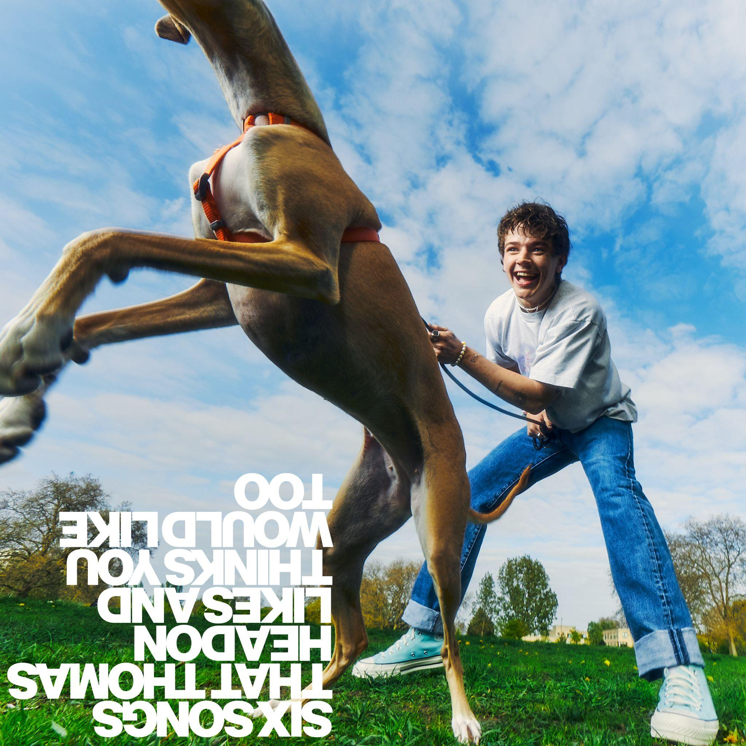
TRACKLISTING:
- 2009 TOYOTA
- Georgia
- W4NNA DO
- i loved a boy
- not saying goodbye :(
- wet tongue

CONNECT WITH THOMAS HEADON
WEBSITE | INSTAGRAM | TIKTOK | TWITTER | YOUTUBE | SPOTIFY | APPLE

For US media inquiries, please contact:
Sarah Goldstein
sarahgoldstein@elektra.com

