THE FRONT BOTTOMS RELEASE NEW ALBUM
YOU ARE WHO YOU HANG OUT WITH

LISTEN HERE

PERFORMING SPECIAL RED ROCKS ALBUM RELEASE SHOW TONIGHT

“YOU ARE WHO YOU HANG OUT WITH TOUR” UNDERWAY

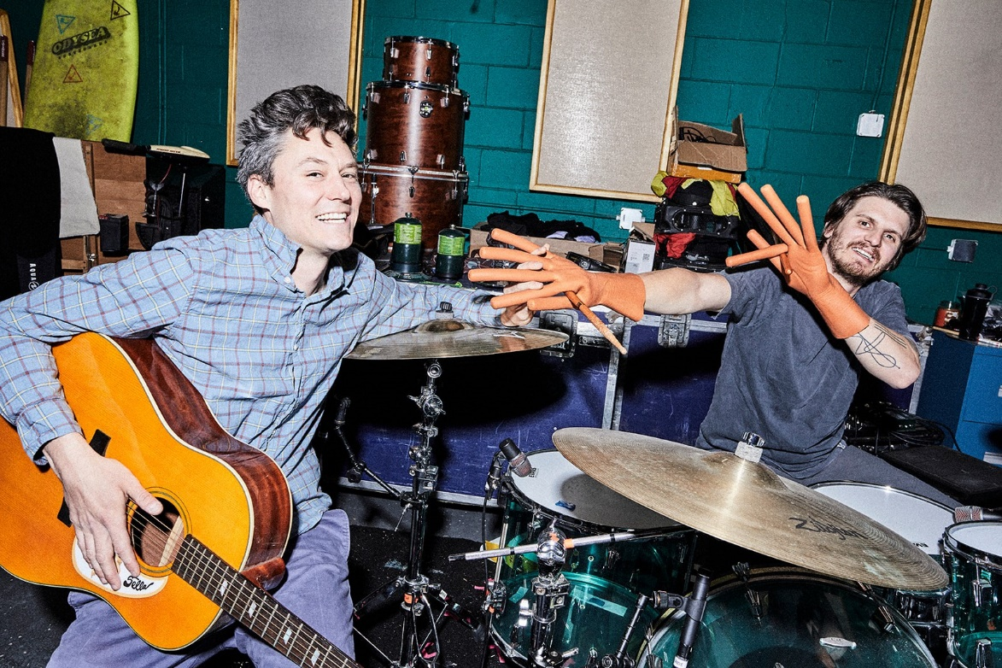
PHOTO CREDIT: JIMMY FONTAINE

AUGUST 4, 2023 – Fueled By Ramen band The Front Bottoms have released their eagerly awaited new album You Are Who You Hang Out With.

Recorded in multi-week spurts with producer Mike Sapone, both in The Front Bottoms’ New Jersey studio and Ghost Hit Recording in Massachusetts, You Are Who You Hang Out With features the singles “Emotional,” “Punching Bag” and “Outlook” [Album Art / Track Listing Below].

Brooklyn Vegan hailed “Outlook” as “a crunchy, catchy, power pop-punk song with that distinct Front Bottoms flair,” while UPROXX attested that “‘Emotional’ shows a new direction, forward-looking and ambitious.” “[It’s] all of the best parts of the Front Bottoms’ aesthetic” raved PASTE, and Consequence urged “there’s plenty more classic Front Bottoms to come.”

For New Jersey’s The Front Bottoms, working on new music has always been therapeutic, but on their new album You Are Who You Hang Out With, having complete and utter fun took top priority for the duo of Brian Sella and Mat Uychich. It’s this carefree and laid-back mindset that colored the sessions for You Are Who You Hang Out With. Armed with the duo’s signature anthemic melodies, take-no-prisoners lyrics and tight musical interplay, every spin of the album is a chance to peek behind the curtain at two friends having one hell of a time doing what they do best. “Oh yeah, it had to be fun for us,” says Uychich of the freewheeling, oft-emotional sessions that resulted in You Are You Who Hang Out With. “Also, we said numerous times that we needed to make it sound like The Front Bottoms.” To hear Sella tell it, things had to feel comfortable for he and Uychich. Because, sure, they could get self-serious about their craft. But The Front Bottoms have never been that band. “So we had to keep it natural,” Sella says of the process that resulted in a stunning 10-track album full of explosive hooks and even harder-hitting melodies “Don’t force anything and just let the songs develop the way they develop. That’s just the way it’s meant to be.”

Earlier this week The Front Bottoms kicked off Part 1 of their “You Are Who You Hang Out With Tour” featuring special guests Kevin Devine & The Goddamn Band, and tonight they’ll perform a special album release show at Colorado’s legendary Red Rocks Amphitheatre happening. Part 2 of the tour (9/15 – 10/1) will feature support from Vundabar and see the band performing two-night stands at Boston’s Roadrunner and Philadelphia’s Franklin Music Hall. Part 3 (10/20 – 11/11) kicks off on the west coast with Slothrust supporting, and includes stops at Austin’s ACL Live, Nashville’s Marathon Music Works, and concludes with two performances at New York City’s Terminal 5 [admat / tour itinerary below]. Additional special guests for select dates will be announced in the coming weeks. For tickets and more information, visit www.thefrontbottoms.com.

Last year, The Front Bottoms released the Theresa EP, which features the singles “More Than It Hurts You” and “Hello World.” The five song collection serves as the third installment of the band’s popular Grandma EP series and features new recordings of never before released fan favorite songs. In addition, The Front Bottoms shared the standalone singles “Lover Boy” and “Voodoo Magic,” the latter of which the band enlisted Matt Skiba of Alkaline Trio to play guitar on.

[Album Art / Track Listing / Tour Admat / Itinerary Below]

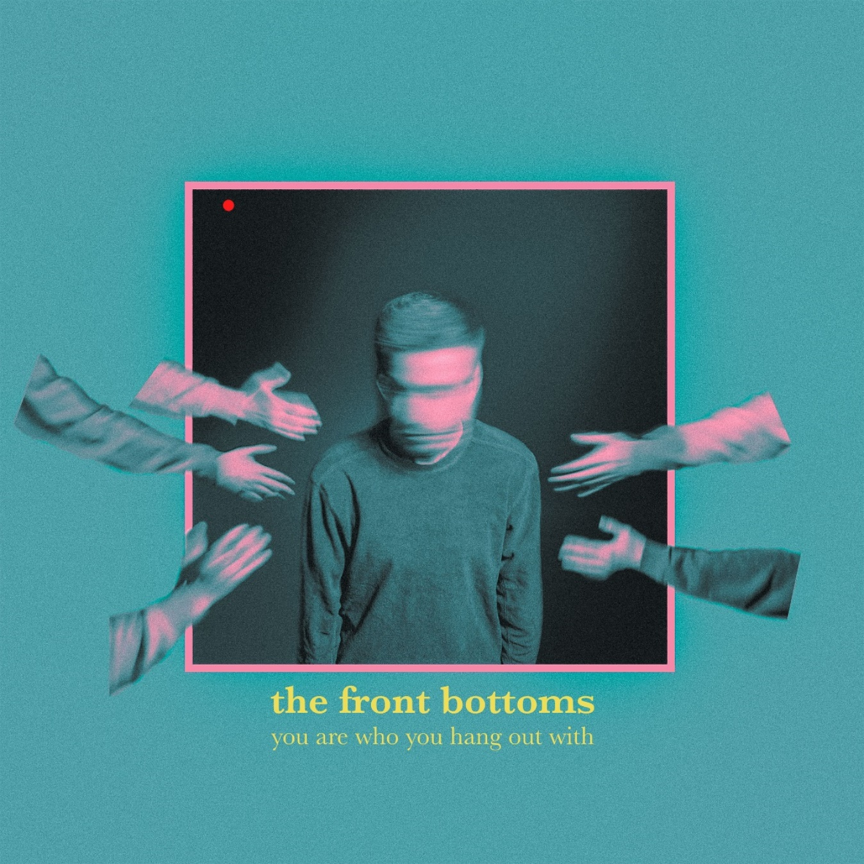
Album Art by Ryan Draybuck

- Emotional
- Outlook
- Punching Bag
- Clear Path
- Not Joking
- Paris
- Fake Gold
- Brick
- Batman
- Finding Your Way Home

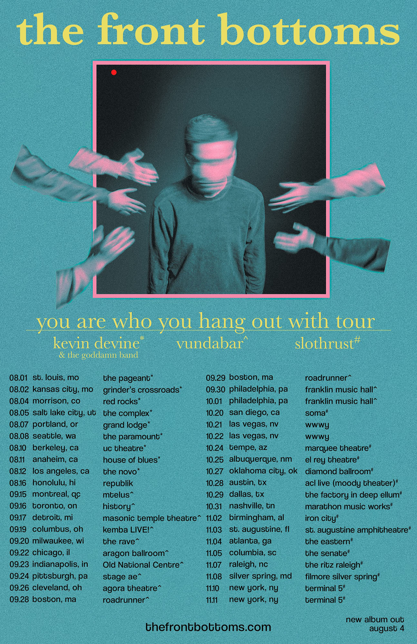

THE FRONT BOTTOMS 2023 LIVE DATES
8/5 – 8/16: YOU ARE WHO YOU HANG OUT WITH TOUR – PART 1 WITH SPECIAL GUESTS KEVIN DEVINE & THE GODDAMN BAND
9/15 – 10/1: YOU ARE WHO YOU HANG OUT WITH TOUR – PART 2 WITH SPECIAL GUESTS VUNDABAR
10/20 – 11/11: YOU ARE WHO YOU HANG OUT WITH TOUR – PART 3 WITH SPECIAL GUESTS SLOTHRUST

8/4 Morrison, CO Red Rocks Amphitheatre*
8/5 Salt Lake City, UT The Complex
8/7 Portland, OR Grand Lodge
8/8 Seattle, WA The Paramount
8/10 Berkley, CA UC Theatre
8/11 Anaheim, CA House of Blues
8/12 Los Angeles, CA The NoVo
8/16 Honolulu, HI republik^
9/15 Montreal, QC MTelus
9/16 Toronto, ON HISTORY
9/17 Detroit, MI Masonic Temple Theatre
9/19 Columbus, OH KEMBA LIVE!
9/20 Milwaukee WI The Rave
9/22 Chicago, IL Aragon Ballroom
9/23 Indianapolis, IN Old National Centre
9/24 Pittsburgh, PA Stage AE
9/26 Cleveland, OH Agora Theatre
9/28 Boston, MA Roadrunner
9/29 Boston, MA Roadrunner
9/30 Philadelphia, PA Franklin Music Hall
10/1 Philadelphia, PA Franklin Music Hall
10/20 San Diego, CA SOMA
10/21 Las Vegas, NV When We Were Young - Las Vegas Festival Grounds #
10/22 Las Vegas, NV When We Were Young - Las Vegas Festival Grounds #
10/24 Tempe, AZ Marquee Theatre
10/25 Albuquerque, NM El Rey Theatre
10/27 Oklahoma City, OK Diamond Ballroom
10/28 Austin, TX ACL Live (Moody Theater)
10/29 Dallas, TX The Factory Deep Ellum
10/31 Nashville, TN Marathon Music Works
11/2 Birmingham, AL Iron City
11/3 St. Augustine, FL St. Augustine Amphitheatre
11/4 Atlanta, GA The Eastern
11/5 Columbia, SC The Senate
11/7 Raleigh, NC The Ritz Raleigh
11/8 Silver Spring, MD Filmore Silver Spring
11/10 New York, NY Terminal 5
11/11 New York, NY Terminal 5

# Festival Date
* Album Release Show with Say Anything
^ No Kevin Devine

CONNECT WITH THE FRONT BOTTOMS:
WWW.THEFRONTBOTTOMS.COM
FACEBOOK
INSTAGRAM
TWITTER
WWW.FUELEDBYRAMEN.COM

FOR MORE INFORMATION, CONTACT:
ROSS.ANDERSON@300ELEKTRA.COM
SYDNEY.WORDEN@300ELEKTRA.COM

