FOR IMMEDIATE RELEASE

JUNE 30, 2023

**BENDIGO FLETCHER RELEASE NEW SINGLE “UNCLE MICK’S FIREWORKS EXTRAVAGANZA”**

**LISTEN** [**HERE**](https://bendigofletcher.lnk.to/fireworks)**| WATCH**[**HERE**](https://youtu.be/q-I87-0fQIg)

**SUPPORTING THE BACKSEAT LOVERS NEXT MONTH, SUPPORTING**

**THE BROOK & THE BLUFF THIS FALL**

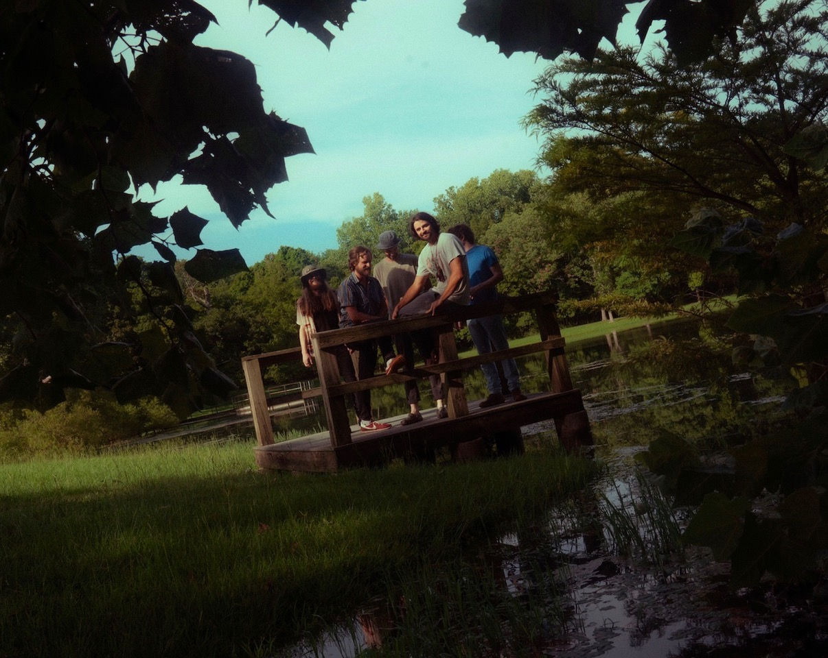

*Photo credit: Aubrey Denis*

Louisville, KY’s **Bendigo Fletcher** have unveiled a brand new single entitled **“**[**Uncle Mick’s Fireworks Extravaganza**](https://youtu.be/q-I87-0fQIg).**”** The standalone track is available to stream and download beginning today[HERE](https://bendigofletcher.lnk.to/fireworks)via Elektra. Just in time for the Fourth of July, the song captures the energy and summer spirit of a rowdy annual family barbecue.

“*I should start by mentioning that I do have an Uncle Mick, and he does put on an epic fireworks show around the Fourth of July. I’ll be at his house in Rasselas, PA this weekend*,” shares Bendigo Fletcher frontman Ryan Anderson. “*I had the pleasure of attending one of these parties as a kid, and the magic of those memories led me to write a heroic experience of this special place. We wanted to capture that sparkly feeling of watching fireworks and hanging out with family in the summer time. It was fun to bring that spirit into the studio and to make something uninhibited and a little over the top.*”

Bendigo Fletcher originally wrote and recorded “Uncle Mick’s Fireworks Extravaganza” during the sessions for their acclaimed 2022 *Wingding* EP. Longtime collaborator and original Wilco/Uncle Tupelo drummer Ken Coomer served as producer, while Tchad Blake (Fiona Apple, The Black Keys) mixed. On the song, warm piano sets the stage for the action to follow, as glassy harmonies give way to delicate strumming. Fuzzed-out guitars erupt into the falsetto-inflicted refrain *“This is Uncle Mick’s fireworks extravaganza”* atop a frenetic solo at the track’s apex.

Returning to the road next month, Bendigo Fletcher will support The Backseat Lovers for a string of dates, beginning July 21 in Kansas City, and concluding August 2 in Portland, ME. In the fall, they will join The Brook & The Bluff for a 7-week North American run. It begins on September 18 in Phoenix, AZ, visits major markets coast-to-coast, and concludes on November 11 in Austin, TX. Check out the full  itinerary below, and visit [BendigoFletcher.com](https://www.bendigofletcher.com/?frontpage=true) for tickets. As a powerhouse live presence, Bendigo Fletcher has previously toured supporting Caamp, Mt. Joy, Rainbow Kitten Surprise, Shakey Graves, Madison Cunningham, and more.

In 2022, Bendigo Fletcher released their four track [*Wingding* EP](https://bendigofletcher.lnk.to/wingding). Thus far, it has amassed millions of streams and earned critical acclaim. [*MUD*](https://www.themudmag.com/post/bendigo-fletcher-band-interview-photos) professed, *“Bendigo Fletcher is a beauty of a band, masterfully crafting stories and depicting what it is to be wonderfully human with folk-rock spectacularly infused with psychedelic twang.”* The EP also earned praise from *Consequence,* *The Bluegrass Situation*, *Entertainment Tonight*, and more. Watch the band perform the EP’s lead single “Pterodactyl” live from La La Land Studios [HERE](https://www.youtube.com/watch?v=A7lXxZxafJ4).

*Wingding* followed Bendigo Fletcher’s 2021 debut album [*Fits Of Laughter*](https://bendigofletcher.lnk.to/fitsoflaughter). Highlighted by singles “[Sugar In The Creek](https://www.youtube.com/watch?v=kP9RJnmniDU)” and “[Evergreen](https://youtu.be/anSo2V8XADE)”, the album is available [HERE](https://bendigofletcher.lnk.to/fitsoflaughter) via Elektra. Beyond amassing millions of streams, the album earned widespread critical acclaim. *FLOOD Magazine* hailed it as  *“Somewhere between the post-Woodstock folk scene of the ‘70s and that decade’s burgeoning hard rock movement*,*”* and *Music Connection* dubbed it, *“Alt-rock, country-flecked folk-rock soaked in LSD*.*” American Songwriter* noted it as *“Denser psych-rock with some remaining elements of Bendigo Fletcher’s drifting folk-Americana roots*”, and *Atwood Magazine* praised “*Fits Of Laughter soars with charming passion.”*

**BENDIGO FLETCHER - “UNCLE MICK’S FIREWORKS EXTRAVAGANZA”**

**LISTEN** [**HERE**](https://bendigofletcher.lnk.to/fireworks)



**Bendigo Fletcher Tour Dates**

**Supporting The Backseat Lovers**

July 21, 2023 - Kansas City, MO - Grinders KC

July 22, 2023 - Chesterfield, MO - The Factory

July 23, 2023 - Columbus, OH - KEMBA Live!

July 25, 2023 - Detroit, MI - The Masonic Temple Theatre

July 26, 2023 - Pittsburgh, PA - Stage AE

July 27, 2023 - Burlington, VT - Burlington Waterfront Park

August 01, 2023 - Asbury Park, NJ - Stone Pony Summerstage

August 02, 2023 - Portland, ME - Thompson’s Point

**Supporting flipturn**

August 12, 2023 - Memphis, TN - Growlers

**Supporting The Brook & The Bluff**

September 18, 2023 - Phoenix, AZ - Crescent Ballroom

September 20, 2023 - Solana Beach, CA - Belly Up

September 21, 2023 - Los Angeles, CA - The Fonda

September 23, 2023 - San Francisco, CA - The Independent

September 25, 2023 - Portland, OR - Wonder Ballroom

September 26, 2023 - Seattle, WA - Neumos

September 27, 2023 - Vancouver, BC - Biltmore Cabaret

September 30, 2023 - Salt Lake City, UT - Complex

October 01, 2023 - Denver, CO - Ogden

October 03, 2023 - Minneapolis, MN - Fine Line

October 05, 2023 - St. Louis, MO - Delmar Hall

October 06, 2023 - Indianapolis, IN - HiFi Annex

October 07, 2023 - Cleveland, OH - Beachland Ballroom

October 08, 2023 - Cincinnati, OH - Bogarts

October 10, 2023 - Columbus, OH - Newport

October 11, 2023 - Chicago, IL - Thalia Hall

October 13, 2023 - Detroit, MI - The Shelter

October 14, 2023 - Toronto, ON - Velvet Underground

October 15, 2023 - Montreal, QC - Petit Campus

October 17, 2023 - Hamden, CT - Space Ballroom

October 19, 2023 - Philadelphia, PA - TLA

October 20, 2023 - New York, NY - Webster Hall

October 21, 2023 - Washington, DC - 9:30 Club

October 22, 2023 - Boston, MA - Royale

October 26, 2023 - Raleigh, NC - Lincoln Theater

October 27, 2023 - Charlotte, NC - Underground

October 28, 2023 - Atlanta, GA - Eastern

November 02, 2023 - Birmingham, AL - Avondale Brewery

November 03, 2023 - Nashville, TN - Brooklyn Bowl

November 04, 2023 - Nashville, TN - Brooklyn Bowl

November 05, 2023 - Knoxville, TN - Mill & Mine

November 08, 2023 - New Orleans, LA - Tolouse

November 09, 2023 - Houston, TX - House of Blues

November 10, 2023 - Dallas, TX - The Studio at The Factory

November 11, 2023 - Austin, TX - Scoot Inn

Bendigo Fletcher is: Ryan Anderson (lead vocals, guitar, banjo) - Andrew Shupert (backing vocals, lead guitar) - Evan Wagner (backing vocals, keys, guitar, auxiliary percussion) - Conner Powell (bass) - Chris Weis (drums).

[BendigoFletcher.com](https://nam04.safelinks.protection.outlook.com/?url=http%2525253A%2525252F%2525252Fbendigofletcher.com%2525252F&data=04%2525257C01%2525257CSydneyWorden%25252540elektra.com%2525257C496651e9ae1c4829030008d95e5ab6bc%2525257C8367939002ec4ba1ad3d69da3fdd637e%2525257C0%2525257C0%2525257C637644565979480132%2525257CUnknown%2525257CTWFpbGZsb3d8eyJWIjoiMC4wLjAwMDAiLCJQIjoiV2luMzIiLCJBTiI6Ik1haWwiLCJXVCI6Mn0%2525253D%2525257C1000&sdata=DwnjXSoisNE7dEIwJsn0Ol9pXmx3ckFc4n%2525252BMPRTyboc%2525253D&reserved=0)

[Facebook](https://nam04.safelinks.protection.outlook.com/?url=https%2525253A%2525252F%2525252Fwww.facebook.com%2525252Fbendigofletcher%2525252F&data=04%2525257C01%2525257CSydneyWorden%25252540elektra.com%2525257C496651e9ae1c4829030008d95e5ab6bc%2525257C8367939002ec4ba1ad3d69da3fdd637e%2525257C0%2525257C0%2525257C637644565979490127%2525257CUnknown%2525257CTWFpbGZsb3d8eyJWIjoiMC4wLjAwMDAiLCJQIjoiV2luMzIiLCJBTiI6Ik1haWwiLCJXVCI6Mn0%2525253D%2525257C1000&sdata=NXO3zPwFKZPGOypH4vElUmn%2525252BvEY4oQvxFgbugfmiZYo%2525253D&reserved=0) | [Instagram](https://nam04.safelinks.protection.outlook.com/?url=https%2525253A%2525252F%2525252Fwww.instagram.com%2525252Fbendigofletcher%2525252F%2525253Fhl%2525253Den&data=04%2525257C01%2525257CSydneyWorden%25252540elektra.com%2525257C496651e9ae1c4829030008d95e5ab6bc%2525257C8367939002ec4ba1ad3d69da3fdd637e%2525257C0%2525257C0%2525257C637644565979490127%2525257CUnknown%2525257CTWFpbGZsb3d8eyJWIjoiMC4wLjAwMDAiLCJQIjoiV2luMzIiLCJBTiI6Ik1haWwiLCJXVCI6Mn0%2525253D%2525257C1000&sdata=ZPbgTr7oOdLZKpc9nJeWq8%2525252FlxhP7q8X%2525252FdCkY%2525252BY35bvQ%2525253D&reserved=0) | [Twitter](https://nam04.safelinks.protection.outlook.com/?url=https%2525253A%2525252F%2525252Ftwitter.com%2525252Fbendigofletcher%2525253Flang%2525253Den&data=04%2525257C01%2525257CSydneyWorden%25252540elektra.com%2525257C496651e9ae1c4829030008d95e5ab6bc%2525257C8367939002ec4ba1ad3d69da3fdd637e%2525257C0%2525257C0%2525257C637644565979490127%2525257CUnknown%2525257CTWFpbGZsb3d8eyJWIjoiMC4wLjAwMDAiLCJQIjoiV2luMzIiLCJBTiI6Ik1haWwiLCJXVCI6Mn0%2525253D%2525257C1000&sdata=kJRRkKaOhgjDEezX5MFmnHCsNVdAnsYapraqslfWeZI%2525253D&reserved=0) | [YouTube](https://nam04.safelinks.protection.outlook.com/?url=https%2525253A%2525252F%2525252Fwww.youtube.com%2525252Fchannel%2525252FUCqWvWwv7K8kq3PZnygVG1BA&data=04%2525257C01%2525257CSydneyWorden%25252540elektra.com%2525257C496651e9ae1c4829030008d95e5ab6bc%2525257C8367939002ec4ba1ad3d69da3fdd637e%2525257C0%2525257C0%2525257C637644565979500120%2525257CUnknown%2525257CTWFpbGZsb3d8eyJWIjoiMC4wLjAwMDAiLCJQIjoiV2luMzIiLCJBTiI6Ik1haWwiLCJXVCI6Mn0%2525253D%2525257C1000&sdata=je%2525252BQcsx%2525252FcO5DWK8iMgiiY1CecLP7inplAOftW9IWaqo%2525253D&reserved=0)

**Bendigo Fletcher press contact:**

Collin Citron | [collin.citron@300elektra.com](mailto:collin.citron@300elektra.com)