FOR IMMEDIATE RELEASE

JANUARY 06, 2023

**FITZ AND THE TANTRUMS UNVEIL “MONEYMAKER” (PHANTOGRAM REMIX)**

**LISTEN**[**HERE**](https://fitz.lnk.to/PHmoneymaker)

**NEW ALBUM** [***LET YOURSELF FREE***](https://fitz.lnk.to/letyourselffree)**AVAILABLE NOW**

***LET YOURSELF FREE TOUR* KICKS OFF JANUARY 21**

**TICKETS AVAILABLE** [**HERE**](https://www.fitzandthetantrums.com/tour)

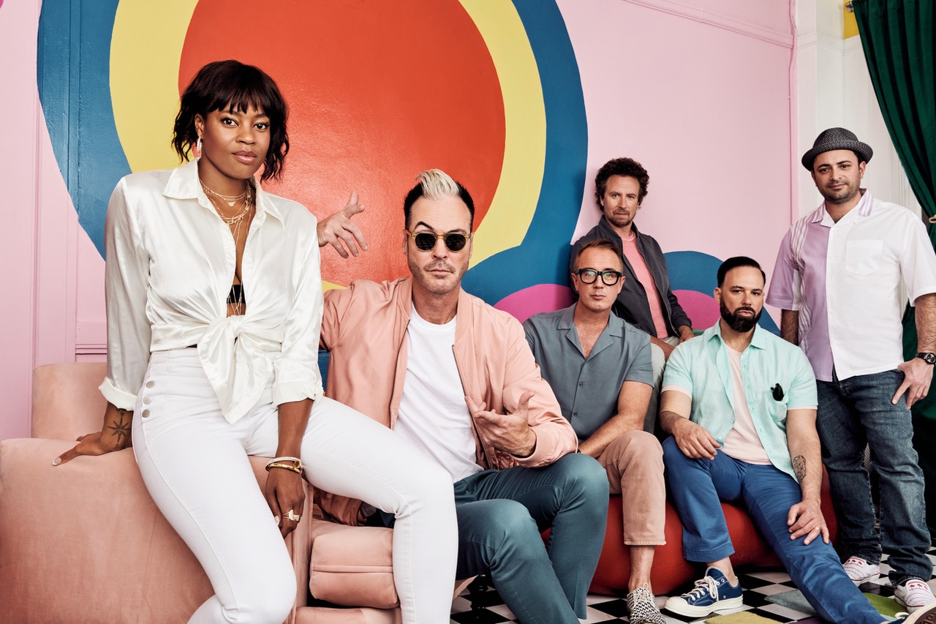

*Photo credit: Lindsey Byrnes*

Multi-Platinum band **Fitz and The Tantrums** have unveiled an official remix of their current single “Moneymaker” from New York duo **Phantogram**. **“Moneymaker” (Phantogram Remix)** is available to stream and download beginning today [HERE](https://fitz.lnk.to/PHmoneymaker). Watch a visualizer for the track on the band’s official YouTube channel [HERE](https://youtube.com/watch?v=_IsinGsS28g&feature=shares).

“[Moneymaker](https://youtube.com/watch?v=yfQkiWSVptc&feature=shares)” is the current single off Fitz and The Tantrums’ brand new studio album ***Let Yourself Free***, which was released in November. The 12-track collection is available to stream and download now [HERE](http://fitz.lnk.to/letyourselffree) via Elektra Entertainment. *Let Yourself Free* arrived to widespread praise *Rolling Stone, E! News, Entertainment Tonight*, and more.

Fitz and The Tantrums rang in the new year with a trio of high-profile television performances in support of the album. In just four short days, the band appeared at the *2022 Orange Bowl* halftime show*,* [*Dick Clark’s New Year’s Rockin’ Eve with Ryan Seacrest 2023*](https://www.facebook.com/watch/?v=1854652998214289&ref=sharing)*,* and the opening spectacular of the [*2023 Rose Parade*](https://youtube.com/watch?v=jW8cCMM_2FM&feature=shares&t=131). Surrounding the release of *Let Yourself Free*, the band also delivered unforgettable performances of the album’s tracks on [*Good Morning America*](https://www.goodmorningamerica.com/video/embed/88135685)*,* [*The Kelly Clarkson Show*](https://www.youtube.com/watch?v=mQS6paiUDcI&feature=youtu.be), *Macy’s Thanksgiving Day Parade 2022*, and [*Live with Kelly and Ryan*](https://kellyandryan.com/video/fitz-and-the-tantrums-moneymaker/)*.*

Later this month, Fitz and The Tantrums will embark on their *Let Yourself Free Tour* of North America. The 17-city trek will kick off on January 21 in Portland, OR, visit major markets across the US, and wrap on February 16 in Ft. Lauderdale, FL. Special guest BabyJake will provide support. Tickets for all dates are on sale now. A complete list of upcoming live dates and ticket information can be found [HERE](https://www.fitzandthetantrums.com/tour).

*Let Yourself Free* follows Fitz and The Tantrums’ 2019 album *All the Feels*, which featured the top 10 hit “I Just Wanna Shine” and was supported by national television appearances on *Jimmy Kimmel LIVE!*, *Good Morning America*, and *Live with Kelly and Ryan*.  In 2021, Fitz and The Tantrums’ frontman Michael “Fitz” Fitzpatrick released his first-ever solo album *Head Up High* under the moniker FITZ.  FITZ performed the album’s infectious title track on *The Ellen DeGeneres Show*, *The Late Late Show with James Corden*, and *Good Morning America*.

**Let Yourself Free Tour Dates**

January 21st, 2023 - Portland, OR - Roseland Theater

January 22nd, 2023 - Seattle, WA - The Showbox

January 24th, 2023 - Sacramento, CA - Ace of Spades

January 25th, 2023 - San Francisco, CA - The Regency Ballroom

January 27th, 2023 - Los Angeles, CA - The Belasco

January 28th, 2023 - Phoenix, AZ - Talking Stick Resort

January 31st, 2023 - Omaha, NE - The Admiral

February 2nd, 2023 - Chicago, IL - The Vic Theater

February 3rd, 2023 - Madison, WI - The Sylvee

February 4th, 2023 - Detroit, MI - Saint Andrew’s Hall

February 6th, 2023 - Washington, DC - 9:30 Club

February 8th, 2023 - New York, NY - Webster Hall

February 10th, 2023 - Boston, MA - Big Night Live

February 11th 2023 - Philadelphia, PA - Union Transfer

February 13th, 2023 - Atlanta, GA - Buckhead Theatre

February 14th, 2023 - Nashville, TN - Brooklyn Bowl Nashville

February 16th, 2023 - Ft. Lauderdale, FL - Culture Room

**FITZ AND THE TANTRUMS - “MONEYMAKER” (PHANTOGRAM REMIX)**

**LISTEN** [**HERE**](https://fitz.lnk.to/PHmoneymaker)

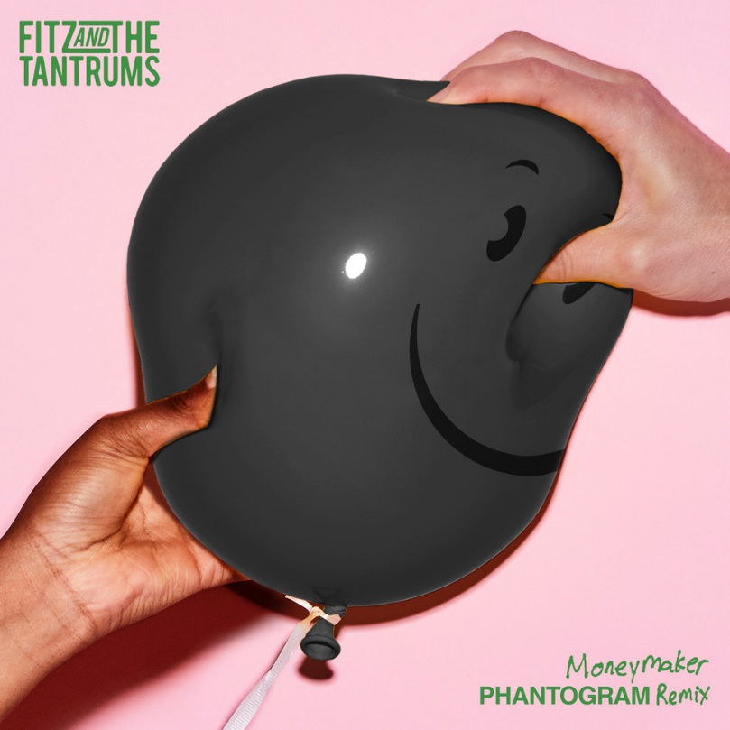

**ABOUT FITZ AND THE TANTRUMS:**

Multi-platinum artists Fitz and The Tantrums have energized popular music and culture with a series of unshakable, undeniable, and ubiquitous anthems and albums. Since 2008, the Los Angeles collective have magnified the scope of pop with a dash of indie, a dose of soul, and a whole lot of dancefloor-ready bounce. Their catalog spans fan favorite records such as Pickin’ up the Pieces [2010], More Than Just A Dream [2013], the gold-certified Fitz and The Tantrums [2016], and All the Feels [2019]. Along the way, they’ve impressively tallied just shy of 4 billion streams and counting powered by enduring hits such as the triple-platinum “HandClap,” platinum “Out of My League” and “The Walker,” and gold “Moneygrabber.” As an inescapable presence, their music has notably coursed through the mainstream conversation, soundtracking films on NETFLIX and campaigns for CVS Wellness, Sunchips, Sofi, Xfinity, Walmart, Norwegian Cruise Line, Lays, and Wells Fargo, to name a few. Beyond standout performances everywhere from Coachella and Bonaroo to numerous late-night television shows, they’ve consistently sold out some of the most iconic venues in the world, including The Forum and Red Rocks Amphitheatre. Not to mention, they’ve incited the applause from Rolling Stone, Billboard, People, and more. In 2021, Fitz and The Tantrums frontman Michael “Fitz” Fitzpatrick released his first-ever solo album Head Up High under the moniker FITZ. Meanwhile, co-lead vocalist Noelle Scaggs founded Diversify The Stage to help foster more diverse, inclusive, equitable, and accessible concerts, events, and touring workforces for historically marginalized and underrepresented communities. Fitz and The Tantrums once again leap forward with their bold, bright, and buoyant new album *Let Yourself Free.*

Fitz and The Tantrums are:  Michael “Fitz” Fitzpatrick (vocals), Noelle Scaggs (vocals), James King (saxophone, flute), Jeremy Ruzumna (keyboards), Joseph Karnes (bass), and John Wicks (drums, percussion).

<https://www.fitzandthetantrums.com/>

[Facebook](https://www.facebook.com/fitzandthetantrums) | [Instagram](https://www.instagram.com/fitzandthetantrums/) | [Twitter](https://twitter.com/FitzAndTantrums) | [YouTube](https://www.youtube.com/channel/UCey2z8VZ7Mc0R1M5QiBU4EA) | [TikTok](https://www.tiktok.com/@fitzandthetantrums?lang=en)

**ABOUT PHANTOGRAM:**

Lauded as an experimental and alternative band and one that’s never been married to a particular genre, Phantogram – comprised of lifelong friends Josh Carter and Sarah Barthel – have continued to change the zeitgeist for almost a decade by consistently challenging it with their signature blend of hard-hitting beats, guitar driven dark psychedelia and electronic pop. Since the arrival of 2010’s debut release, Eyelid Movies, the duo has amassed over a billion streams, achieved one platinum-certified single, two gold-certified singles, collaborated with legends such as Tom Morello, Billy Corgan, The Flaming Lips and Miley Cyrus, partnered with Big Boi of Outkast to form supergroup Big Grams, headlined sold out shows worldwide, become a festival staple and toured with artists including Arcade Fire, The xx, Muse, M83, alt-J and more.

With major campaigns for Apple TV+, Peloton and Apple Watch, and additional placement in multiple TV shows, the band’s reach has never been so wide.

<https://www.phantogram.com/>

[Facebook](https://www.facebook.com/Phantogram) | [Instagram](https://www.instagram.com/phantogram/) | [Twitter](https://twitter.com/Phantogram) | [YouTube](https://www.youtube.com/c/phantogrammusic)

# # #

**FITZ AND THE TANTRUMS PRESS CONTACTS:**

Glenn Fukushima (National)

[Glenn.Fukushima@300elektra.com](mailto:Glenn.Fukushima@300elektra.com)

Collin Citron (National)

[Collin.Citron@300elektra.com](mailto:Collin.Citron@300elektra.com)

Sydney Worden (Tour/Online)

[Sydney.Worden@300elektra.com](mailto:Sydney.Worden@300elektra.com)