WHITE REAPER RELEASE NEW ALBUM ASKING FOR A RIDE

“PAGES” GOES TOP 15 AT ALTERNATIVE RADIO

2023 NORTH AMERICAN HEADLINE TOUR BEGINS FEBRUARY 7TH
WITH SPECIAL GUESTS NARROW HEAD, MILITARIE GUN,
TAIPEI HOUSTON, MAMALARKY & SOUL BLIND

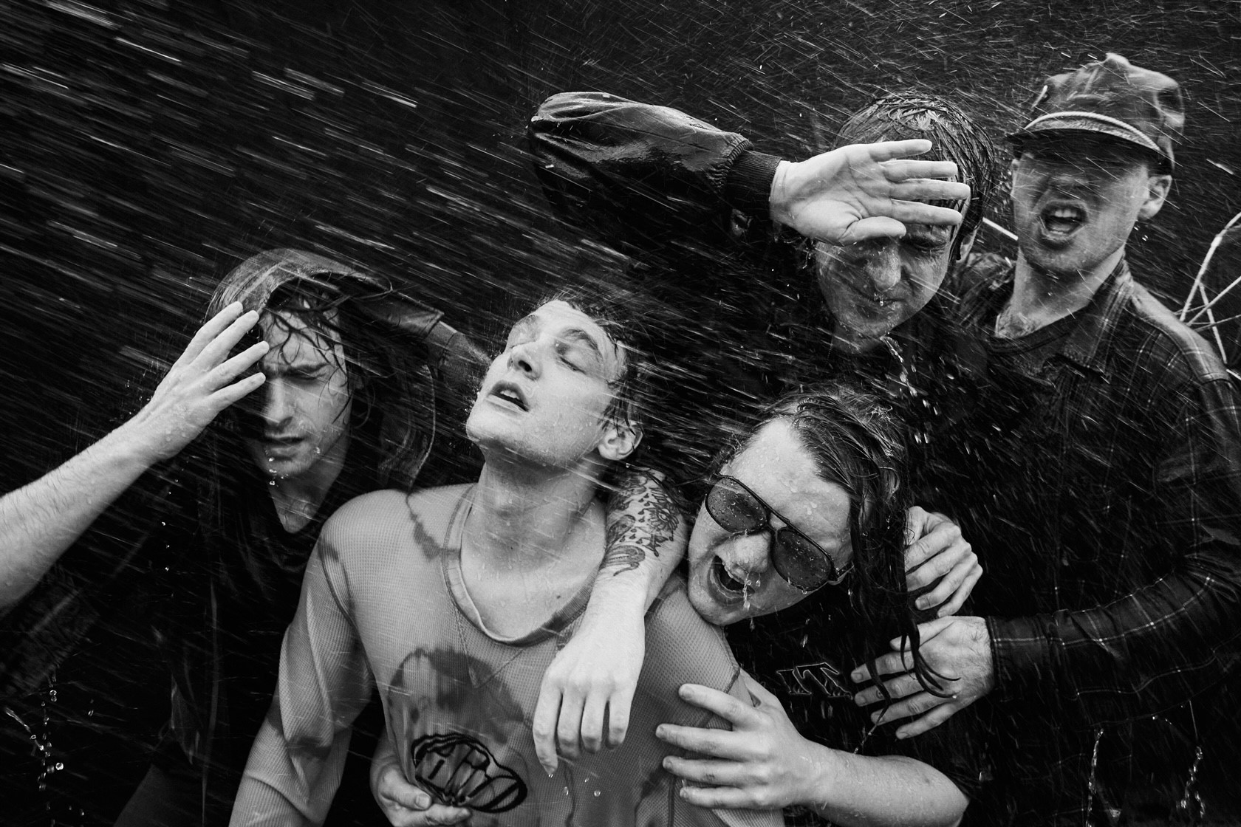
PHOTO CREDIT: JIMMY FONTAINE

JANUARY 27, 2023 – White Reaper have released their widely anticipated new album Asking for a Ride, which is available today on all streaming platforms.

“It could be White Reaper’s best album. It’s entirely possible that the album is flat-out-great, maybe even a classic of its form,” declared UPROXX, while Treble attested “The journey to reclaim rock as an outlet for ballistic fun may very well start here.” Stereogum praised White Reaper’s “ideal balance of pop accessibility and rocking-the-fuck-out abandon,” and +rcmndlisten affirmed “They’re everything a rock band should be this day in age, and for that, they deserve the title of world’s best.”

Asking for a Ride is led by the single “Pages” - Top 15 at Alternative radio this week - which Rolling Stone picked as one of their “Songs You Need to Know.” Additional album standouts include “Pink Slip” and
“Fog Machine,” the latter of which is joined by a Max Moore directed music video – watch it HERE.

Recorded and largely self-produced in Nashville with the help of close friend and engineer Jeremy Ferguson, Asking for a Ride finds the Louisville band taking a more direct and in-your-face approach, prioritizing the collection’s raw energy and its ability to translate live through ripping and nervy compositions. It’s White Reaper at their most exciting - dialing up the chrome-plated riffs and monster hooks – a welcome reminder of just how much fun rock music can be.

Up next, White Reaper will hit the road for their 2023 North American “Asking for a Ride” headline tour. The upcoming trek will feature special guests Narrow Head, Militarie Gun, Taipei Houston, Mamalarky, and Soul Blind on select dates, and will kick off February 7th [tour itinerary below]. The forthcoming dates will see White Reaper’s long awaited return to touring after having spent years living on the road, headlining and supporting some of their idols – Pearl Jam, Weezer, and The Killers – while making festival appearances at Lollapalooza, Austin City Limits and more. For tickets and more information on White Reaper’s upcoming tour dates, visit www.whitereaperusa.com.

Comprised of Tony Esposito (guitar / vocals), Ryan Hater (keyboards), Sam Wilkerson (bass), Nick Wilkerson (drums), and Hunter Thompson (guitar), Asking for a Ride follows White Reaper’s 2019 album You Deserve Love, which marked a new career peak for the Louisville band. The collection was led by the number one alternative radio hit, “Might Be Right,” which the band later made their network TV debut performing on ABC’s Jimmy Kimmel LIVE!. A collection of smart, sharply-written songs of doubt, dislocation, and elusive and often complicated love, The New York Times observed, “The Kentucky quintet White Reaper blends the winking gravitas of ‘70s arena rock with garage-y power pop… enjoy the trip back,” while GQ applauded the release as “the perfect companion for all your nice weather fun.” Equal parts glam and grit, You Deserve Love found the band expanding on the songcraft laid down on 2017’s critically acclaimed The World’s Best American Band, which landed on Noisey’s “100 Best Albums of 2017” and Pitchfork’s “20 Best Rock Albums of 2017,” earning an 8.0 album score.

[ Album Art / Tracklisting / Tour Itinerary Below]

ASKING FOR A RIDE
ALBUM ARTWORK + TRACKLIST

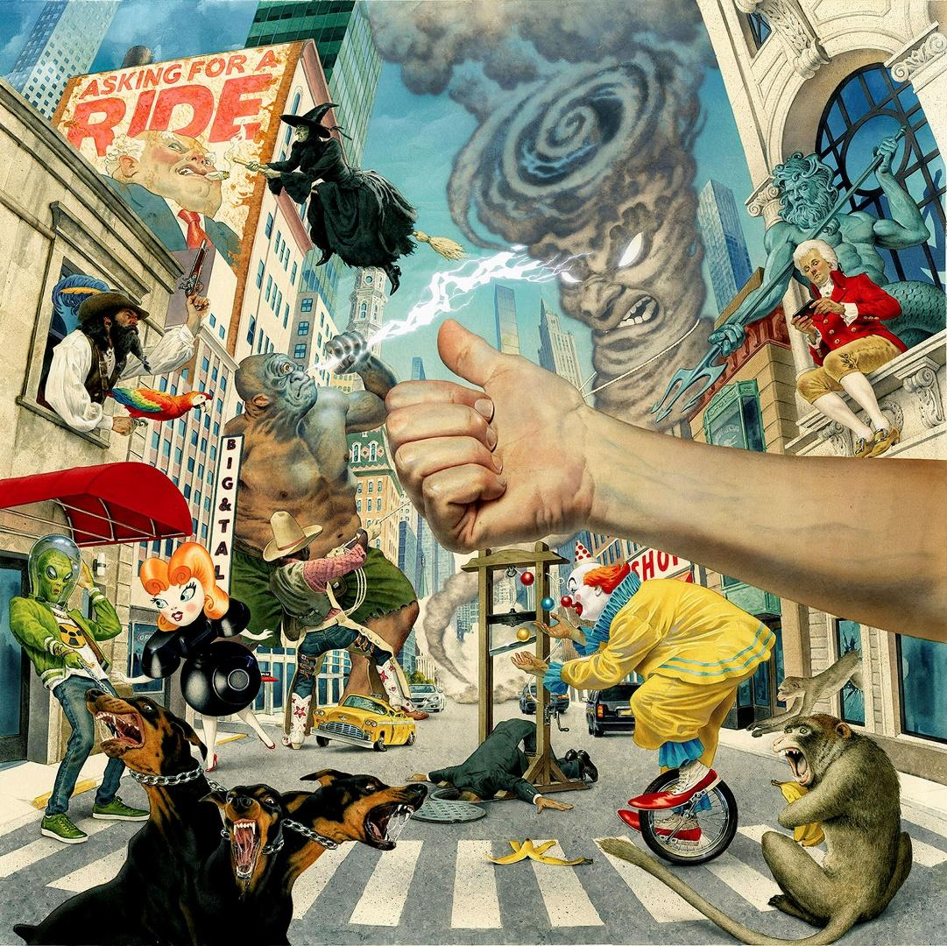
ARTWORK BY MARK STUTZMAN

- Asking for a Ride
- Bozo
- Fog Machine
- Getting into Trouble w/ the Boss
- Funny Farm
- Pink Slip
- Heaven or Not
- Crawlspace
- Thorn
- Pages

WHITE REAPER NORTH AMERICAN HEADLINE TOUR 2023
WITH SPECIAL GUESTS NARROW HEAD, MILITARIE GUN,
TAIPEI HOUSTON, MAMALARKY, & SOUL BLIND ON SELECT DATES

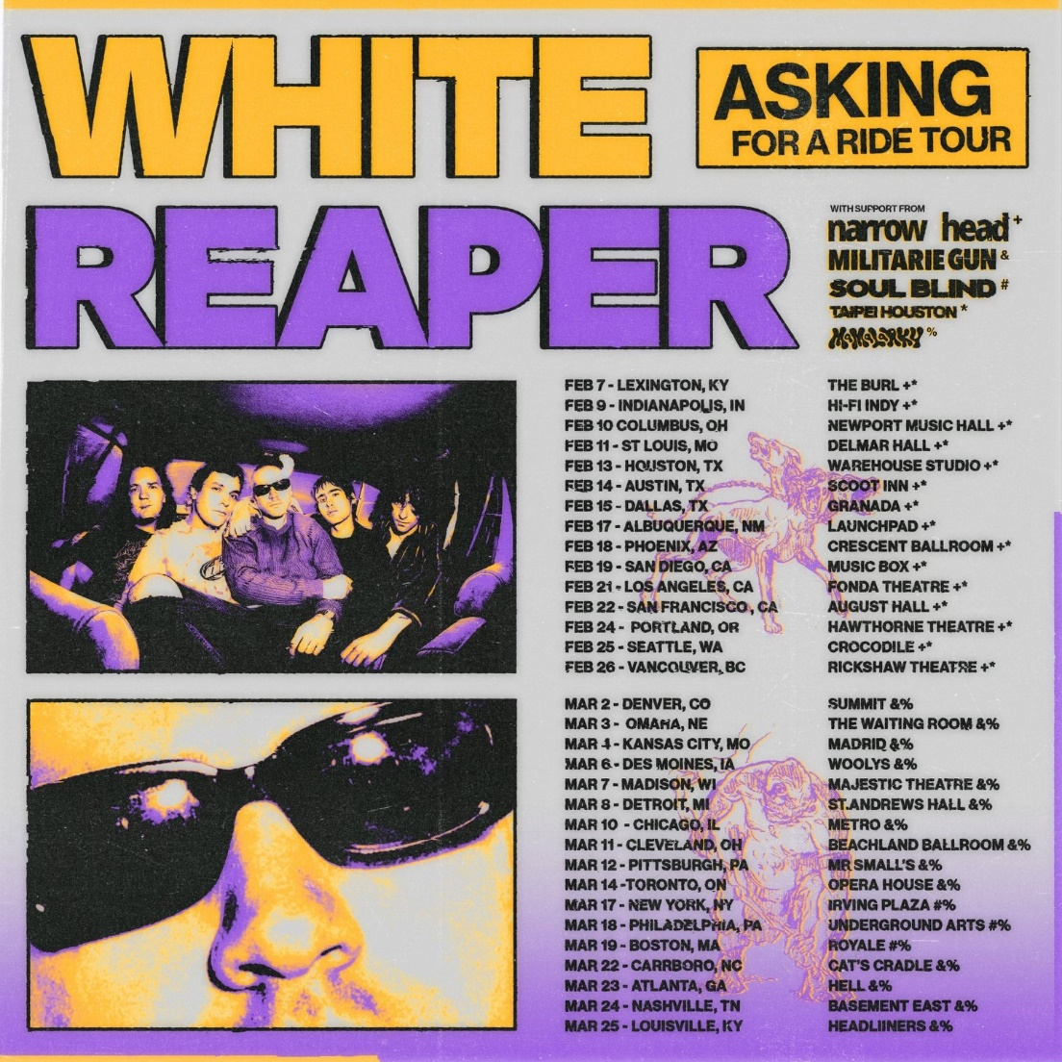

February 7 - Lexington, KY - The Burl +#
February 9 - Indianapolis, IN - HI-FI Indy +#
February 10 - Columbus, OH - Newport Music Hall +#
February 11 - St Louis, MO - Delmar Hall +#
February 13 - Houston, TX - Warehouse Studio +#
February 14 - Austin, TX - Scoot Inn +#
February 15 - Dallas, TX - Granada +#
February 17 - Albuquerque, NM - Launchpad +#
February 18 - Phoenix, AZ - Crescent Ballroom +#
February 19 - San Diego, CA - Music Box +#
February 21 - Los Angeles, CA - Fonda Theatre +#
February 22 - San Francisco, CA - August Hall +#
February 24 - Portland, OR - Hawthorne Theatre +#
February 25 - Seattle, WA - Crocodile +#
February 26 - Vancouver, BC - Rickshaw Theatre +#
March 2 - Denver, CO - Summit *&
March 3 - Omaha, NE - The Waiting Room *&
March 4 - Kansas City, MO - Madrid *&
March 6 - Des Moines, IA - Woolys *&
March 7 - Madison, WI - Majestic Theatre *&
March 8 - Detroit, MI - St. Andrews Hall *&
March 10 - Chicago, IL - Metro *&
March 11 - Cleveland, OH - Beachland Ballroom *&
March 12 - Pittsburgh, PA - Mr Smalls *&
March 14 - Toronto, ON - Opera House *&
March 17 - New York, NY - Irving Plaza &x
March 18 - Philadelphia, PA - Underground Arts &x
March 19 - Boston, MA - Royale &x
March 22 - Carrboro, NC - Cat's Cradle *&
March 23 - Atlanta, GA - Hell *&
March 24 - Nashville, TN - Basement East *&
March 25 - Louisville, KY - Headliners *&

+ Narrow Head
# Taipei Houston
* Militarie Gun
& Mamalarky
x Soul Blind

Connect with White Reaper:
WEBSITE / FACEBOOK / TWITTER / INSTAGRAM / YOUTUBE / SPOTIFY / APPLE MUSIC
Contact:
GLENN FUKUSHIMA / ROSS ANDERSON / COLLIN CITRON

