BRITTNEY SPENCER ANNOUNCES DEBUT ALBUM ‘MY STUPID LIFE’ DUE FRIDAY, JANUARY 19 VIA ELEKTRA

Pre-save ‘My Stupid Life’ here

Performing this morning on NBC’s TODAY Show at 9 AM ET

“Bigger Than The Song” – the album’s lead single and Spencer’s tribute to her favorite artists – is out everywhere now. Listen here

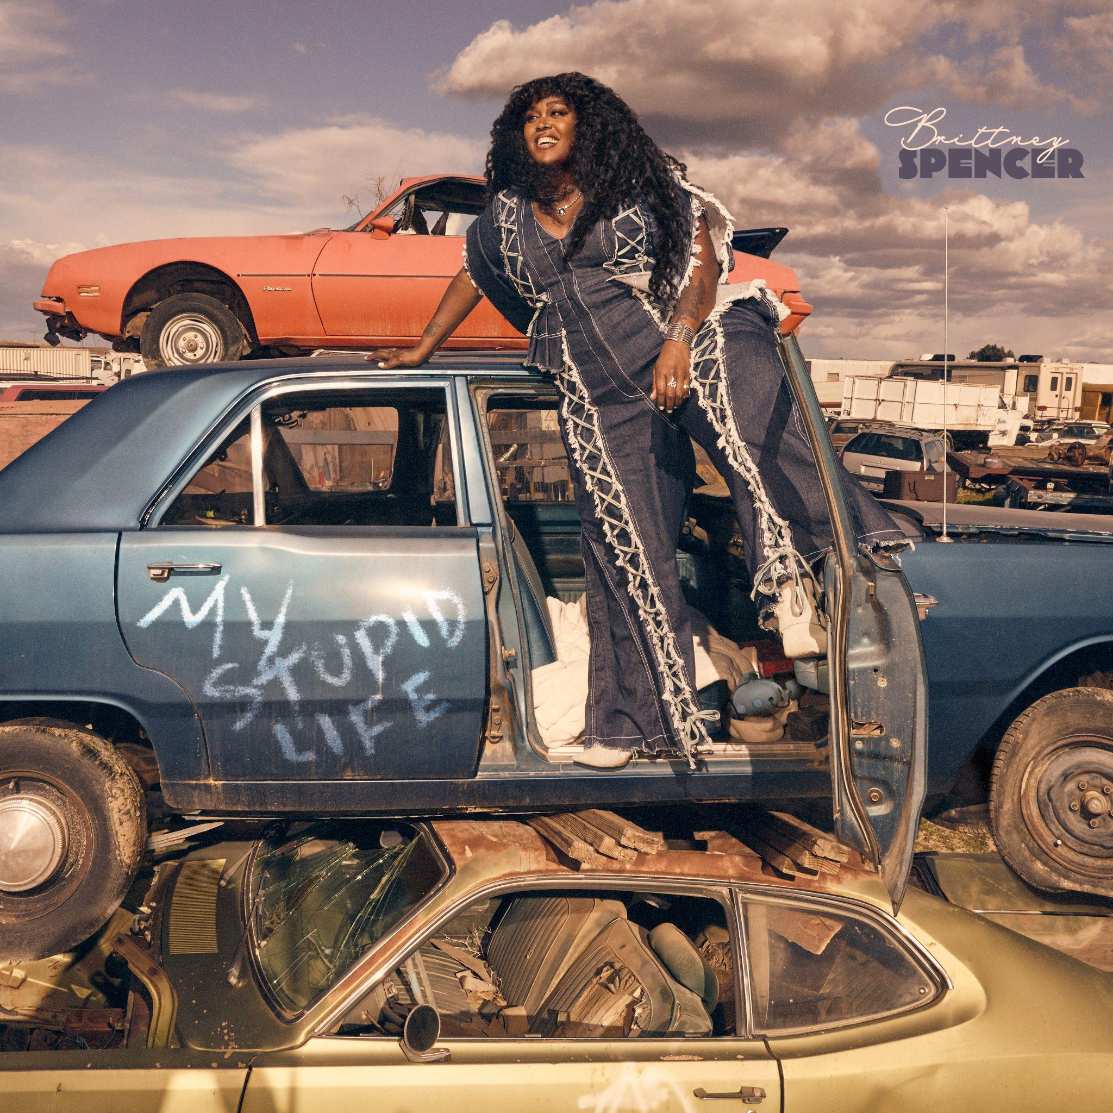

Today (9.29), “Nashville’s new star” (CBS This Morning) Brittney Spencer announces her highly-anticipated debut album, My Stupid Life, out January 19th via Elektra. The first track, “Bigger Than The Song,” showcases Spencer’s ability to excel on the fringe of genre periphery with her honest and free-spirited songwriting, and it’ll be performed on NBC’s TODAY Show this morning in the 9 AM ET hour.

The album’s 13 tracks are a culmination of her experience during her time trying to “make it” in Music City, discovering herself in the process. The Baltimore native moved to Nashville ten years ago, and this album is Spencer’s commitment to be unapologetically herself. Recorded at Sound Emporium Studios and Blackbird Studio in Nashville, the album is produced by GRAMMY award-winning Daniel Tashian (Kacey Musgraves, Little Big Town, Brett Eldredge), with the exception of two tracks, Marcus “MarcLo” Lomax (Monsters & Strangerz, Maren

Morris, Justin Bieber, Kelsea Ballerini), who produced the lead single — “Bigger Than The Song” — and Romil Hemnani (BROCKHAMPTON), who produced “New To This Town.”

“This feels like a long time coming,” says Spencer. “It took me three years from the time I released my first EP Compassion to now to release my first album. These songs serve as my introduction to country music and I wanted to give them all the time and care that they (and my fans) deserve. I wrote a lot of songs from the back corners of my mind because I wanted to take a good, deeper look at myself and create something true to who and where I am at this time in my life. The more I put the pen to my feelings and thoughts, the more I realize I’ve heard similar sentiments throughout my life. Through making this album, I’ve learned we’re not alone in our heads, and I hope this album hugs the tiny, loud parts of our overthinking brains that sometimes need it most.”

The project features award-winning collaborators including Grace Potter, Maren Morris, Abbey Cone & Sarah Buxton, plus guitar contributions by Jason Isbell.

Today, Spencer shares the album’s first preview, “Bigger Than The Song.” Produced by Lomax, the track is Spencer’s tribute to artists who curated the soundtrack to her life – Reba McEntire, Aretha Franklin, Alanis Morissette, Janet Jackson, Dolly Parton, Beyonce, Britney Spears, and more. Written by Spencer, Jennifer Anne Wayne (Runaway June) and Tofer Brown (Little Big Town, Elle King, Jason Mraz), the song is a celebration of the simple joys of good music and the impact a great song can have on someone’s life.

CMT and BET will air the song’s official music video (also out today) on the Viacom Times Square Billboard.

Watch the “Bigger Than A Song” official video here Listen to “Bigger Than A Song” here
Pre-save My Stupid Life here

Spencer’s debut album announcement follows her 2022 EP if i ever get there: a day at blackbird studio, which landed her on NPR’s “Best of 2022” and Paper Magazine’s “Best Country Songs of 2022.” Next month, Spencer will make her Austin City Limits TV debut, plus her debut at ACL Fest. She’s set to play Stagecoach in 2024 and was the only country artist featured in Rolling Stone’s “Music's Future 25” – read her full feature here.

Spencer is represented by Activist Artists Management, UTA, and Shore Fire Media.

My Stupid Life Tracklist:
- “New To This Town” (Brittney Spencer)+
- “I Got Time” (Spencer, Jessica Cayne, Nate Campany, Emily Reid)
- “Night In (Phone Call)”

- “Night In” (Spencer, Cayne, Summer Overstreet)
- “Bigger Than The Song” (Spencer, Jennifer Anne Wayne, Tofer Brown)*
- “My First Rodeo” (Spencer, Cayne, Sean Douglas, Zach Skelton)
- “The Last Time” (Spencer, Sean McConnell, Sarah Buxton)
- “Deeper” (Spencer, Tayla Parx, Gustav Landell)
- “First Car Feeling” (Spencer, Cayne, Kat Higgins)
- “Desperate” (Spencer, Emily Falvey, Mikey Reeves)
- “If You Say So” (Spencer)
- “My Stupid Life” (Spencer, James Brock Human, McConnell)
- “Reaching Out” (Spencer, Joe Kirkland)

My Stupid Life Credits:
Produced by: Daniel Tashian
Select songs produced by: Marcus “MarcLo” Lomax*, Romil Hemnani+ Mixed by: Dave Clauss, Manny Marroquin, Jonathan Low, Jason Agel Mastered by: Greg Calbi
Engineered by: Gena Johnson, Konrad Snyder, Marcus “MarcLo” Lomax, Garry Purohit Background vocals: Grace Potter (“Reaching Out”), Maren Morris (“Night In”), Abbey Cone (“The Last Time,” “Desperate” ) & Sarah Buxton (“I Got Time,” “My First Rodeo,” “The Last Time,” “Deeper,” “Desperate,” “If You Say So”)
Featured instrumentalist: Jason Isbell (“First Car Feeling,” “Reaching Out”)

About Brittney Spencer:
As a Baltimore native, Brittney Spencer is known for her free spirit and standout ability to mold life, truth, and wild imagination into songs. She has earned praise by The New York Times, Rolling Stone, Vanity Fair, and others, and she’s appeared on CBS Mornings with Anthony Mason, as well as performed on NBC's Today Show, The Late Show (After Dark), the CMA Awards, ACM Awards and more. Spencer was featured as part of Victoria’s Secret Global “UNDEFINABLE” campaign, and she appeared in Amazon’s “For Love & Country” Documentary. Deemed a “one to watch” by PEOPLE Magazine, Spencer has shared stages with Jason Isbell, The Highwomen, Willie Nelson, Reba, Bobby Weir, and Maren Morris to name a few. She’s also performed the National Anthem at The 148th Kentucky Derby, the Preakness in 2022 alongside Megan Thee Stallion and Lauryn Hill, and the 2023 NFL Draft. As an outspoken advocate for her community and the planet, Brittney is an active supporter of many causes, including Habitat for Humanity, the Women's March, CARE, and more.

Follow Brittney Spencer:
Website: https://www.brittneyspencer.com/
Instagram: https://www.instagram.com/brittneyspencer/ Twitter: https://twitter.com/BrittNicx
Facebook: https://www.facebook.com/brittneyspencermusic TikTok: https://www.tiktok.com/@brittney.spencer
YouTube: https://www.youtube.com/@BrittneySpencer

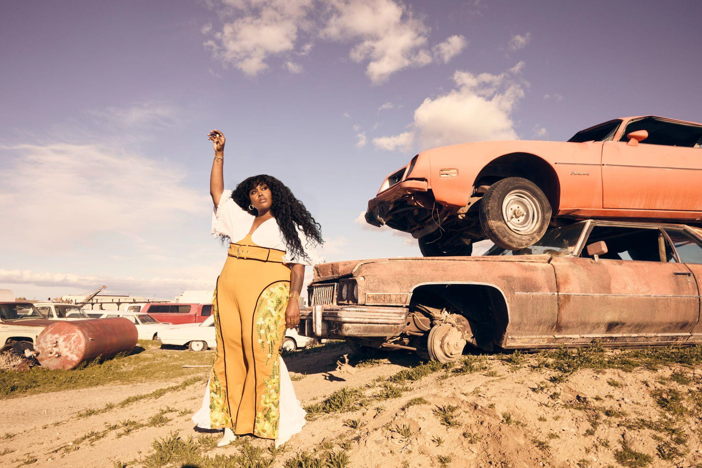

Photo credit: Jimmy Fontaine

###

