WHITE REAPER RELEASE COVER OF THE SOUND’S
“I CAN’T ESCAPE MYSELF” TODAY

LISTEN HERE

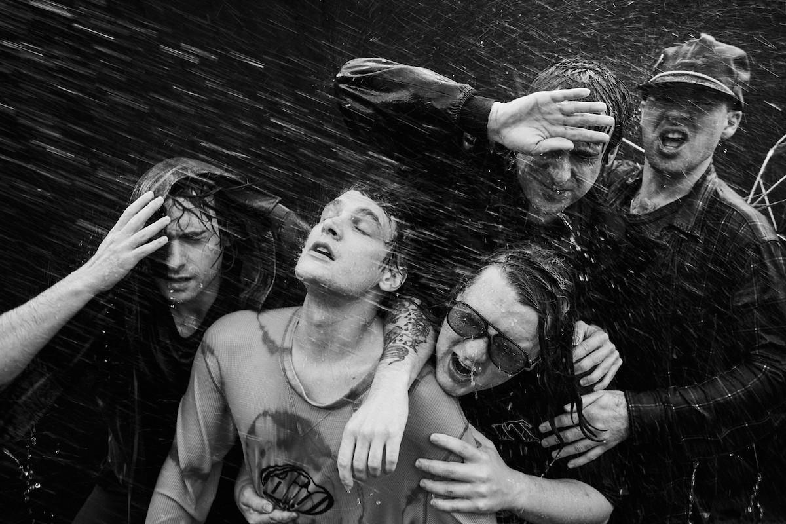

PHOTO CREDIT: JIMMY FONTAINE

MARCH 01, 2024 – Louisville, KY’s White Reaper have surprised fans with a brand new cover of The Sound’s “I Can’t Escape Myself.” The song is available on all streaming platforms beginning today HERE via Elektra. The original track notably served as the opener to the English post-punk band’s acclaimed 1980 full-length debut LP, Jeopardy.

“We wanted to put something out and we didn’t have an album yet so we covered a song that we love. We’ve done this before and we’ll probably do it again. The Sound is a really great band and you should check them out if you’re unfamiliar.” shares White Reaper frontman Tony Esposito. “The sounds we made sound so much like The Sound, you’re gonna have trouble differentiating our sounds from The Sound’s sounds,” adds guitarist Hunter Thompson.

“I Can’t Escape Myself” marks the first new music from White Reaper since the release of their 2023 studio album Asking for a Ride. The LP arrived to a flurry of critical acclaim. “It could be White Reaper’s best album. It’s entirely possible that the album is flat-out-great, maybe even a classic of its form,” declared Uproxx. Stereogum praised the band’s “Ideal balance of pop accessibility and rocking-the-fuck-out abandon.” Alternative Press raved, “The songs on Asking For a Ride are fast, unadulterated, and nasty in the best way, with wild guitars and themes of youthfulness.” Pitchfork lauded, “At its simplest and most carefree, it’s a blast,” and +rcmndedlisten affirmed “They’re everything a rock band should be this day in age, and for that, they deserve the title of world’s best.” Asking for a Ride is available HERE via Elektra.

White Reaper supported the release of the album with their massive Asking for a Ride Tour of North America. Last summer, the band joined Weezer and Spoon on their Indie Rock Roadtrip, and supported select dates on Blink 182’s monumental North American headline tour. White Reaper also made appearances at festivals including Riot Fest and Oceans Calling Music Festival.

Be on the lookout for more from White Reaper soon.

WHITE REAPER - “I CAN’T ESCAPE MYSELF”
LISTEN HERE

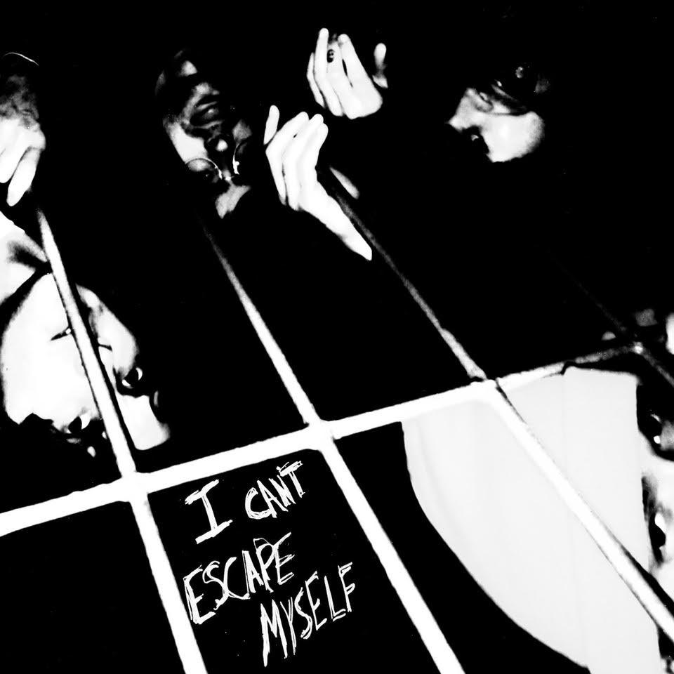

About White Reaper
Comprised of Tony Esposito (guitar / vocals), Ryan Hater (keyboards), Sam Wilkerson (bass), Nick Wilkerson (drums), and Hunter Thompson (guitar), Asking for a Ride followed White Reaper’s 2019 album You Deserve Love, which marked a new career peak for the Louisville band. The collection was led by the number one alternative radio hit, “Might Be Right,” which the band later made their network TV debut performing on ABC’s Jimmy Kimmel LIVE!. A collection of smart, sharply-written songs of doubt, dislocation, and elusive and often complicated love, The New York Times observed, “The Kentucky quintet White Reaper blends the winking gravitas of ‘70s arena rock with garage-y power pop… enjoy the trip back,” while GQ applauded the release as “the perfect companion for all your nice weather fun.” Equal parts glam and grit, You Deserve Love found the band expanding on the songcraft laid down on 2017’s critically acclaimed The World’s Best American Band, which landed on Noisey’s “100 Best Albums of 2017” and Pitchfork’s “20 Best Rock Albums of 2017,” earning an 8.0 album score.

Connect with White Reaper:
WEBSITE / FACEBOOK / TWITTER / INSTAGRAM / YOUTUBE

White Reaper Press Contacts:
Ross Anderson / Ross.Anderson@300elektra.com
Collin Citron / Collin.Citron@300elektra.com

