FOR IMMEDIATE RELEASE
March 22, 2024

3X GRAMMY AWARD WINNERS PHIL AND TIM HANSEROTH
SIGN TO ELEKTRA AS THE HANSEROTH TWINS

LONGTIME BRANDI CARLILE COLLABORATORS RELEASE DEBUT SINGLE “REMEMBER ME”

LISTEN HERE | WATCH HERE

Photo credit: Hanna Hanseroth

Seattle, WA duo The Hanseroth Twins have announced their signing to Elektra and released their debut single “Remember Me”. The song is available on all streaming platforms beginning today HERE. It is accompanied by a lyric video streaming on the band’s official YouTube channel. Watch HERE.

As Brandi Carlile’s longtime songwriting partners and bandmates, the duo of identical twin brothers Phil and Tim Hanseroth have notably each received three GRAMMY Awards to go along with their 10 nominations, and performed sold out shows at legendary venues such Madison Square Garden and the Hollywood Bowl. While still remaining Carlile’s creative collaborators, with “Remember Me,” the brothers step into the forefront to share another side of their artistry with audiences everywhere. They personally wrote, produced, and performed the song, which was recorded by Nathan Yaccino with additional engineering by Jerry Streeter, mixed by Brandon Bell, and mastered by Pete Lyman with assistance from Dan Bacigalupi.

The pair recorded “Remember Me” live, huddled around a microphone with an acoustic guitar. The track preserves this intimacy as sparse production draws attention to loose guitar and their inimitable brotherly harmonies. Anchored by vulnerable strumming, cinematic strings, and airy piano, they deliver a message to their kids straight from the heart. Emotion practically overflows from the heartfelt chorus, “Remember me gentle. Remember me strong and free and wild as a river running.”

About the launch of The Hanseroth Twins, Tim said, “By writing songs for as long as we have, we’re definitely part of the heart and soul of our band, but we’re not necessarily the mouth. Brandi is the voice, and we love that. As The Hanseroth Twins, we have a voice that we can use. It’s awesome to take something personal and move it out of your body and into somebody else’s brain and heart. Now, we’ve got an avenue to be our own mouthpiece in this project.”

“Remember Me” marks the first single off a larger project slated to arrive later this year. The Hanseroth Twins just performed an opening set before joining Carlile for the first of two intimate headline shows in Washington, D.C.

Be on the lookout for more from The Hanseroth Twins soon.

THE HANSEROTH TWINS - “REMEMBER ME”
LISTEN HERE | WATCH HERE

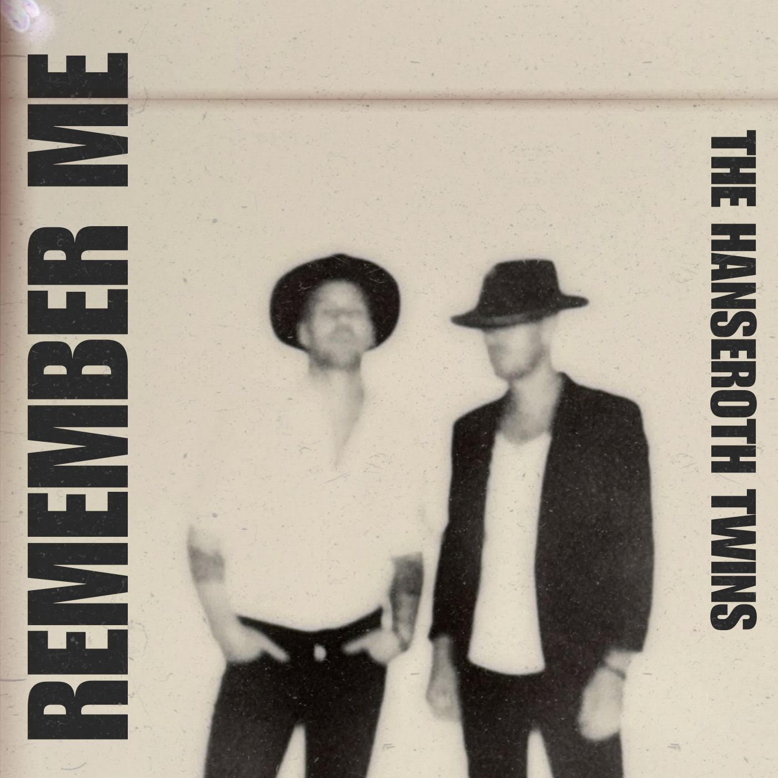

ABOUT THE HANSEROTH TWINS:
The music of Tim and Phil Hanseroth remains forever threaded into the fabric of the 21st century American songbook and culture at large. The identical twins have co-written dozens of songs in the studio, co-produced Top 10 albums, performed thousands of gigs on stage, and reached towering heights as Brandi Carlile’s most trusted songwriting partners and creative confidants. Along the way, they’ve each garnered three GRAMMY® Awards out of 10 nominations, played for sold out crowds in legendary venues like Madison Square Garden and The Hollywood Bowl, and actualized seemingly impossible childhood dreams. Growing up outside of Seattle, WA, countless hours jamming together as teens primed them for a life in music. Their band The Fighting Machinists emerged at the tail end of the nineties grunge revolution, landing a major label deal and recording at the legendary London Bridge Studio with the late Rick Parashar [Nirvana, Alice In Chains]. It would be Parashar who introduced them to Carlile in 1999. Over the next two decades, their catalog blossomed across styles with staples alongside Carlile such as the GRAMMY® Award-winning “The Joke” (Best American Roots Song), “Bring My Flowers Now” (Best Country Song), and “Broken Horses” (Best Rock Song) as well as the gold-certified “The Story.” Dolly Parton notably covered the latter, while Adele even cut her own rendition of “Hiding My Heart.” Plus, they penned music for the likes of Tanya Tucker, Zac Brown Band, and The Highwomen, to name a few. Now, they step into the light like never before as The Hanseroth Twins, with their debut single “Remember Me” on Elektra.

https://www.thehanserothtwins.com/
Instagram | Facebook | TikTok | YouTube | X

The Hanseroth Twins Press Contacts:
Glenn Fukushima / Glenn.Fukushima@300elektra.com
Collin Citron / Collin.Citron@300elektra.com

