FOR IMMEDIATE RELEASE
March 22, 2024

BENDIGO FLETCHER UNVEIL SOPHOMORE ALBUM TWO THINGS AT ONCE
LISTEN HERE

33-CITY NORTH AMERICAN TOUR CURRENTLY UNDERWAY
TICKETS AVAILABLE HERE

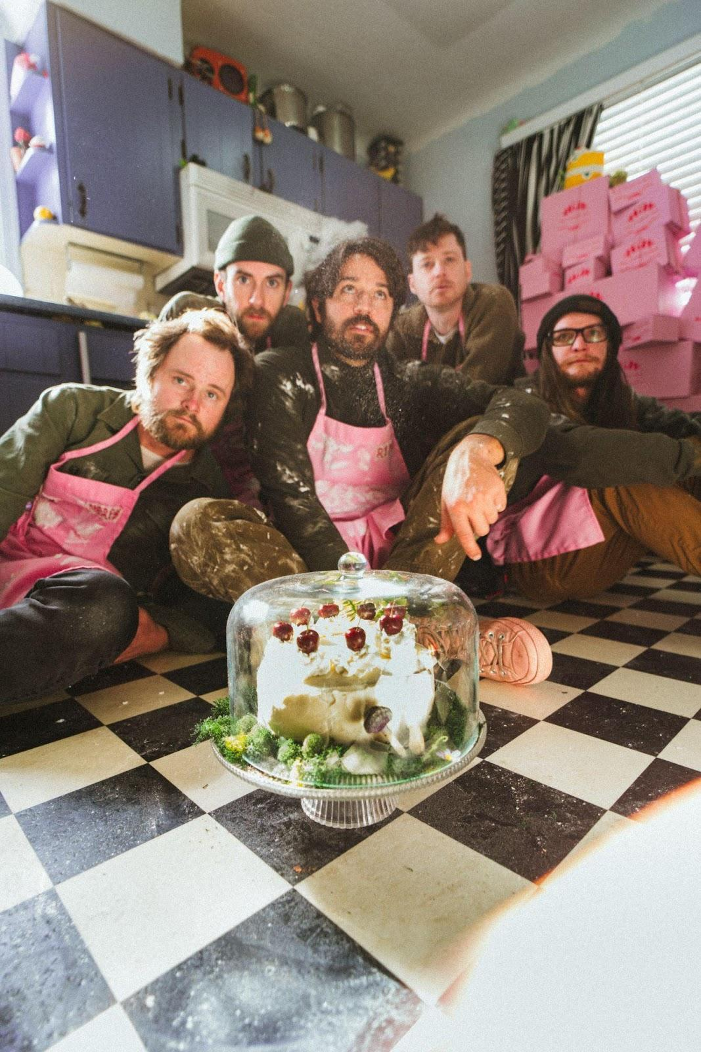
Photo Credit: Ben Baptist

Louisville, KY’s Bendigo Fletcher have unveiled their eagerly anticipated sophomore album Two Things At Once. The album is available on all streaming platforms now HERE via Elektra. Additionally, the band has dropped the latest episode of their "Top of the Rock Sessions," which is now available on YouTube. Check it out HERE.

About the release, lead vocalist/guitarist Ryan Anderson shares, “Two Things at Once reflects a personal journey embracing the dual nature of complementary occurrences, like experiencing love and letting go during a teary-eyed motorcycle ride, sweet words and false promises like a moldy dessert, or particle wave forms, like laughter swirling around a theme park on a beautiful summer day. Writing and making this album has been a journey in vulnerability and one of great fun. Hopefully, in turn, the album can offer some sense of comfort.”

Two Things At Once pulls together threads of folk, psychedelia, indie, alt-country, and rock into a charcuterie board of vibrant characters, vivid memories, and vital moments. It’s a recipe for 11 intoxicating and irresistible anthems earmarked by American Songbook-worthy storytelling and elevated songcraft. For the album, they notably reteamed with producer Ken Coomer [a founding member of Wilco and Uncle Tupelo], recording at Cartoon Moon Recording in Nashville and at Southern Grooves in Memphis joined by GRAMMY® Award-winning engineer Matt Ross-Spang [Jason Isbell, John Prine, Margo Price].

Bendigo Fletcher ushered in Two Things At Once with the singles "Upcountry Lemonade" and "Sweet Tooth," which garnered praise from Ones To Watch and Atwood Magazine and more. Before its official release, Bendigo Fletcher personally showcased Two Things At Once to a select group of 20 fans at a secluded hideaway in the woods outside of Louisville. This group of fans accompanied the band on a hike to the residence where they experienced the entire album with an unforgettable intimate live performance. Now, Bendigo Fletcher is ready to share these special moments through their "Top of the Rock Sessions" on YouTube. Check out the sessions HERE.

Bendigo Fletcher embarked on a North American headline tour in support of Two Things at Once. This 33-city tour spans major markets across the country and will conclude on May 11 in Cincinnati. Get tickets HERE. Last year, Bendigo Fletcher toured as support for The Backseat Lovers during their Waiting To Spill Summer Tour. Additionally, they joined The Brook & The Bluff for a 7-week run, entertaining sold-out crowds across North America. Renowned for their dynamic live performances, Bendigo Fletcher has previously toured in support of acts such as Caamp, Mt. Joy, Rainbow Kitten Surprise, Shakey Graves, Madison Cunningham, and more.

Last fall, Bendigo Fletcher surprised fans with a cover of Cults’ 2011 classic “Go Outside”. “Go Outside (From Natural Bridge State Resort Park)” is available to stream and download HERE via Elektra. Recorded live at Slade, KY’s Natural Bridge State Resort Park, the release was accompanied by a stunning visual of the band performing the song in the picturesque location. Watch HERE. Bendigo Fletcher encourages fans to support the Kentucky State Parks Foundation, a non-profit organization aimed at connecting residents and guests to the outdoors. The band also partnered with Kentucky Parks Club on a limited edition t-shirt, designed by frontman Ryan Anderson. The shirt is available now HERE.

"Go Outside (From Natural Bridge State Resort Park)" marked Bendigo Fletcher’s first new music since the 2023 Fourth of July single ”Uncle Mick’s Fireworks Extravaganza" and their 2022 Wingding EP. Praised for their blend of folk-rock and psychedelic twang, the band garnered acclaim from publications like MUD and Consequence. Their debut album, Fits Of Laughter, released in 2021, featured hits like "Sugar In The Creek" and "Evergreen," earning accolades from FLOOD Magazine, Music Connection, American Songwriter, and Atwood Magazine for its unique blend of alt-rock and folk-Americana roots.

BENDIGO FLETCHER - TWO THINGS AT ONCE
STREAM NOW

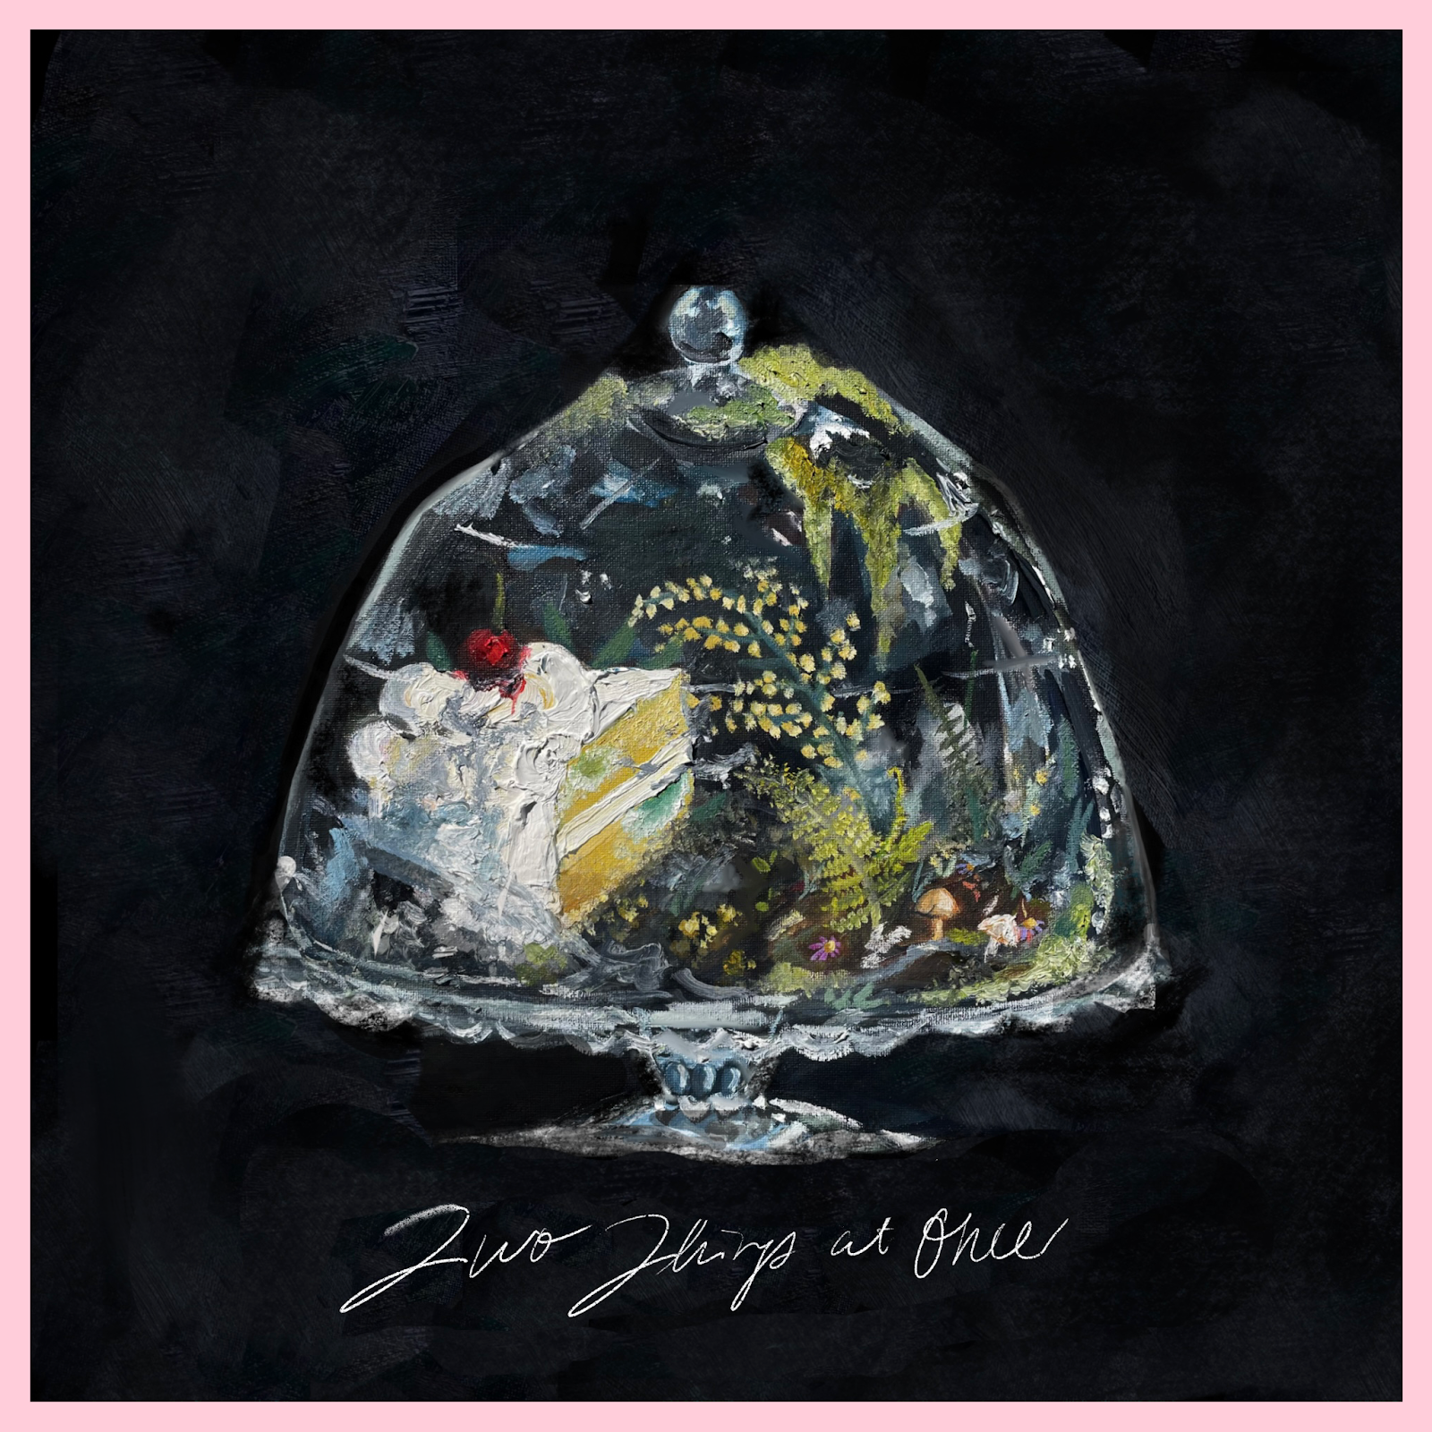

Two Things at Once Album Tracklist
1. Upcountry Lemonade
2. Tough Season
3. Ought Not
4. Liquor Store
5. Real 2 Me
6. Sweet Tooth
7. Useful 4 U
8. Babushka Dolls
9. Plaster Moon (Blow Me Away)
10. Two Things at Once
11. Rental Skates

Bendigo Fletcher Tour Dates
March 22, 2024 - Atlanta, GA - Masquerade (Purgatory)
March 23, 2024 - Asheville, NC - Grey Eagle
March 24, 2024 - Carrboro, NC - Cat’s Cradle Backroom
March 26, 2024 - Washington, DC - DC9
March 28, 2024 - Asbury, NJ - Wonder Bar
March 29, 2024 - New York, NY - Sultan Room
March 30, 2024 - Boston, MA - Cafe 939
March 31, 2024 - Portland, ME - Portland House of Music
April 02, 2024 - Toronto, ON - The Garrison
April 04, 2024 - Columbus, OH - Woodlands
April 05, 2024 - Louisville, KY - Headliners Music Hall
April 06, 2024 - Chicago, IL - Lincoln Hall
April 08, 2024 - Madison, WI - High Noon Saloon
April 09, 2024 - Minneapolis, MN - Amsterdam
April 12, 2024 - Billings, MT - Pub Station
April 15, 2024 - Boise, ID - Shrine Social Club
April 16, 2024 - Salt Lake City, UT - Kilby Court
April 18, 2024 - Denver, CO - Bluebird Theater
April 20, 2024 - Boulder, CO - Bluebird Music Festival*
April 21, 2024 - Fort Collins, CO - Aggie Theatre
April 23, 2024 - Great Falls, MT - The Newberry
April 25, 2024 - Seattle, WA - Barboza
April 26, 2024 - Portland, OR - Doug Fir
April 28, 2024 - San Francisco, CA - Bottom of the Hill
May 01, 2024 - Los Angeles, CA - Moroccan Lounge
May 02, 2024 - San Diego, CA - Soda Bar
May 04, 2024 - Santa Fe, NM - Meow Wolf
May 07, 2024 - Oklahoma City, OK - Ponyboy OKC
May 11, 2024 - Newport, KY - Southgate House Revival
*Festival Appearance

Bendigo Fletcher is: Ryan Anderson (lead vocals, guitar, banjo) - Andrew Shupert (backing vocals, lead guitar) - Evan Wagner (backing vocals, keys, guitar, auxiliary percussion) - Conner Powell (bass) - Chris Weis (drums).

BendigoFletcher.com
Facebook | Instagram | Twitter | YouTube

Bendigo Fletcher press contact:
Collin Citron | collin.citron@300elektra.com
Destiny Dominguez | destiny.dominguez@300elektra.com

