QUARTERS OF CHANGE TO EMBARK ON
THE PORTRAITS TOUR (PART ONE) THIS SPRING
TICKETS ON SALE THIS FRIDAY HERE

BRAND NEW SOPHOMORE ALBUM PORTRAITS AVAILABLE NOW HERE

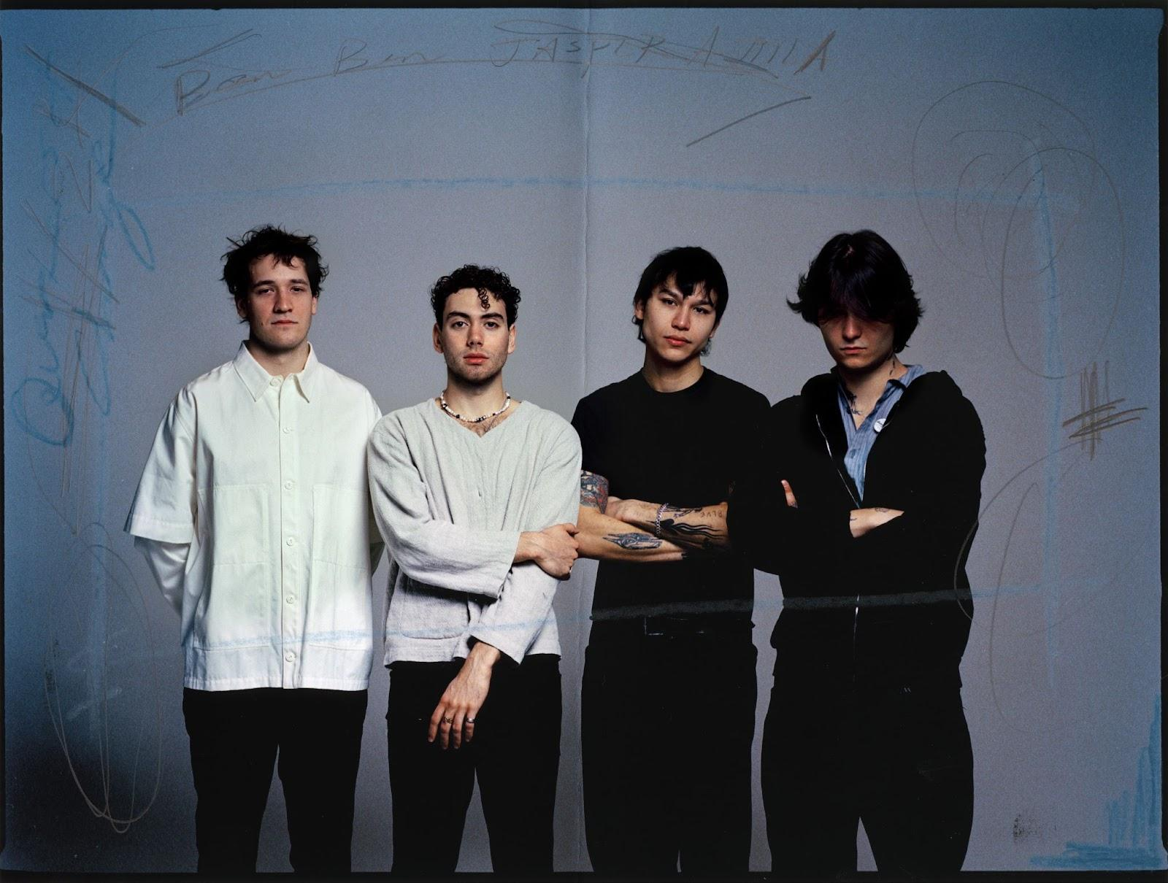
Press photo by Anna Henderson [Download]

“…the depths of the group’s range as musicians. Ben Roter delivers the lyrics with a languid flair that builds to a euphoric crescendo…” - BILLBOARD
“New York's Quarters of Change douse listeners with their aggressively vulnerable storytelling…alluring and bold…” - ONES TO WATCH

“Their best work to date.” - LOCAL WOLVES
“..their music unfailingly reaches into the pit of your stomach — an act demonstrated by Roter’s vocals but owed to the four of them as a whole.” - THE LUNA COLLECTIVE

One of New York City’s fastest rising rock bands, Quarters of Change, have announced plans for a North American headline tour in support of their brand new sophomore studio album Portraits. The Portraits Tour will kick off on April 7 in Boston, MA, visit major markets coast-to-coast, and wrap on April 29 in Phoenix, AZ. Notably, this tour will be the band’s first time performing outside the US, with scheduled shows in Montreal and Toronto. Pre-sale tickets for the tour will be available beginning Wednesday, February 7th at 10:am local and general on-sale begins Friday, February 9th at 10:00am local time. Tickets for the tour will be available HERE. Additionally, Quarters of Change are scheduled to appear at major US festivals including Shaky Knees, Governors Ball, and more.

Portraits was released in January and is available HERE via 300 Entertainment. The album arrived to widespread critical acclaim, with UPROXX declaring, “With electrifying chords and resounding guitars, Quarters Of Change is bringing rock music to a whole new generation." Local Wolves dubbed it their best work to date, leading New York's alt-rock resurgence. Silent Radio also praised the band's aggressively vulnerable storytelling, and Disaster Magazine hailed "Portraits" as an unparalleled sonic experience, exceeding all expectations.

After decamping to Woodstock, NY, for two weeks, the band left with their most collaborative, exposed-nerve writing to date; something with a piece of each of them etched into it. Where their last album Into The Rift was staring into the dark tunnel ahead, Portraits is close to the other side, with the band surfacing for some light. The band continued to put themselves to the test by self-producing this body of work back in NYC, joined by a handful of collaborators including GRAMMY® Award winning producers Mikey Freedom Hart (Jon Batiste, Taylor Swift, Bleachers, Lana Del Rey) and Dave Tozer (John Legend, JAY-Z), in addition to fellow artist Charlie Burg and producer Brandon Shoop.

“The album is made up of individualized fragments that provide different perspectives and create their own little vignettes,” shares frontman Ben Roter. “I think of each fragment as a portrait, reflecting a separate emotion or moment. Overall, it dives into themes of addiction, isolation and exploration.”

To celebrate the release of Portraits, Quarters of Change hosted an event at Fotografiska Museum in New York with fans, their team, and everyone else who helped bring Portraits to life. At the party, the band premiered their album documentary, Portraits of a New York City Rock Band. Directed by longtime creative collaborator Amyas Ryan, the documentary shows the behind the scenes of the 14 days in the woods writing, 47 shows, 26 states, 3 festivals, and 10,000 miles that led to this album — Watch.

The band also just unveiled an official visual for “Tightrope.” Directed by Oliver Pearson across Manhattan and Brooklyn, Quarters of Change don’t pull their punches in this blow-by-blow cut. Training in the streets and taking it to the ring, the visual matches the song’s intensity and combativeness — Watch.

In the tailend of last year, Quarters of Change sold out their headline tour while releasing singles from the album. In December, the band played to a sold out NYC crowd at their Webster Hall homecoming show. Live performance videos can be watched here of “Heaven Bound” and “What I Wanted.” At their Albany arena show, the Jonas Brothers brought Quarters of Change out to perform “T Love,” introducing the band to a whole new, ravenous fanbase.

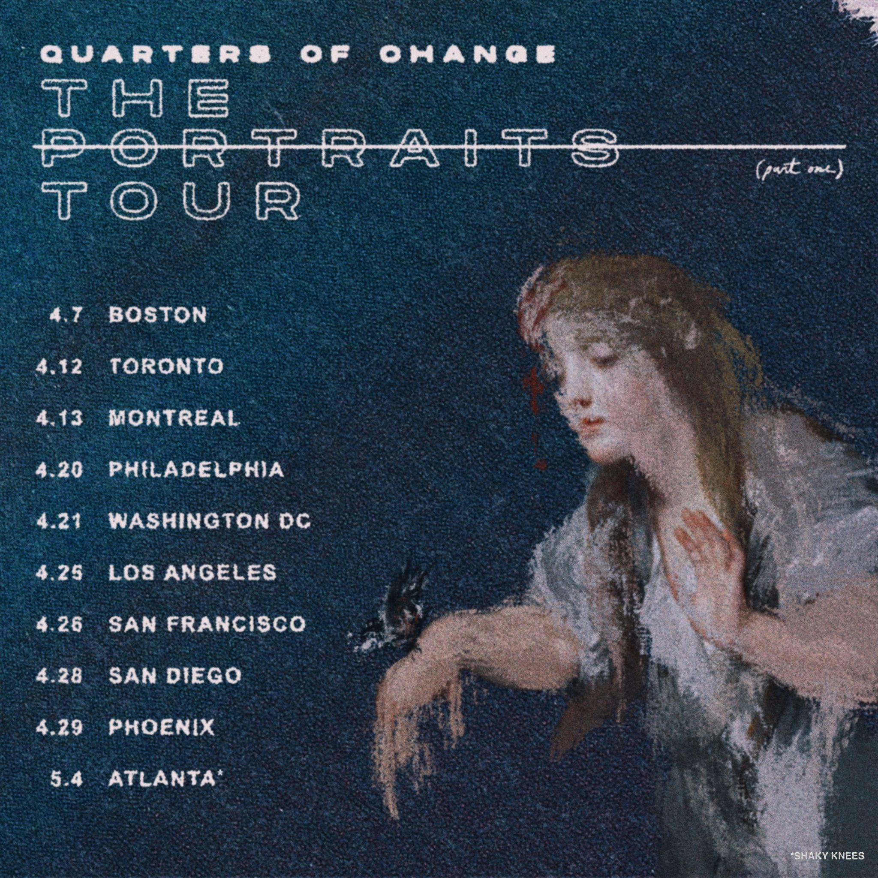

Quarters of Change Tour Dates
April 07, 2024 - Boston, MA - Paradise Rock Club
April 12, 2024 - Toronto, ON - Velvet Underground
April 13, 2024 - Montreal, QC - Le Ministère
April 20, 2024 - Philadelphia, PA - Foundry
April 21, 2024 - Washington, DC - Atlantis
April 25, 2024 - Los Angeles, CA - El Rey
April 26, 2024 - San Francisco, CA - Independent
April 28, 2024 - San Diego, CA - Soma Sidestage
April 29, 2024 - Phoenix, AZ - Walter Studios
May 04, 2024 - Atlanta, GA - Shaky Knees Music Festival *
June 08, 2024 - New York, NY - Governors Ball Music Festival*

*Festival appearance

ABOUT QUARTERS OF CHANGE
Anchored by a mutual predisposition for unpredictability, Quarters of Change fuse together a signature hybrid of nineties-style alternative hooks, crunchy space rock soundscapes, and strutting seventies grooves. After piling up millions of streams, selling out shows, and inciting critical applause, the New York City quartet — Ben Acker (guitar, bass, synths), Attila Anrather (drums), Jasper Harris (guitars, bass, synths), and Ben Roter (vocals, guitar).

Leaning on an unspoken musical language of their own, forged by years of cutting their teeth together, sneaking into shows they were once too young to play and practicing in the basement of their old high school, Quarters of Change very clearly have a lifelong bond that has created their own breed of alternative rock with stadium scope.

Initially gaining traction with a handful of independent EPs as the fan favorite “Kiwi” reeled in over 10 million streams, they continued to hone this signature style on their 2022 full-length debut, Into The Rift. Highlighted by fan-favorite tracks “T Love,” “Jaded,” and “Dead,” they made enamored notable fans out of Joe Jonas, Lewis Capaldi, Chad Smith, and Fred Durst, to name a few.

Quarters of Change simultaneously emerged as a live force, supporting Bad Suns and selling out their first-ever US headline tour. The Aquarian hailed them as “reviving alt rock,” and Sheesh professed, “Quarters of Change has mastered the New York rock resurgence in a way that is resonating with even the best of the best.” In 2023 the band made their SXSW debut, sold out a headline tour run that ended with a momentous performance at Austin City Limits, and began rolling out the singles from the newest body of work. Doubling down on amplifying the energy, and turning up the distortion, Quarters of Change have quietly emerged as a phenomenon, and maintain this momentum with the release of their new album Portraits, available everywhere now.

###

For more information on Quarters of Change, please visit:
Instagram | Twitter | TikTok | YouTube | Spotify | Apple Music | Website

For Quarters of Change press materials and inquiries, please contact:
Collin Citron | Collin.Citron@300elektra.com
Destiny Dominguez | Destiny.Dominguez@300elektra.com

