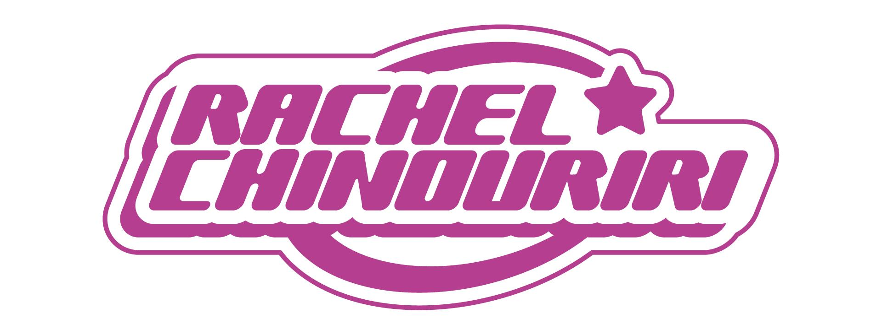
RACHEL CHINOURIRI ANNOUNCES DEBUT ALBUM
WHAT A DEVASTATING TURN OF EVENTS
OUT MAY 3RD VIA ELEKTRA

SHARES NEW SINGLE “NEVER NEED ME”
WITH OFFICIAL VIDEO STARRING FLORENCE PUGH
WATCH HERE

ANNOUNCES FIRST-EVER U.S. HEADLINE TOUR DATES
TICKETS ON SALE THIS FRIDAY

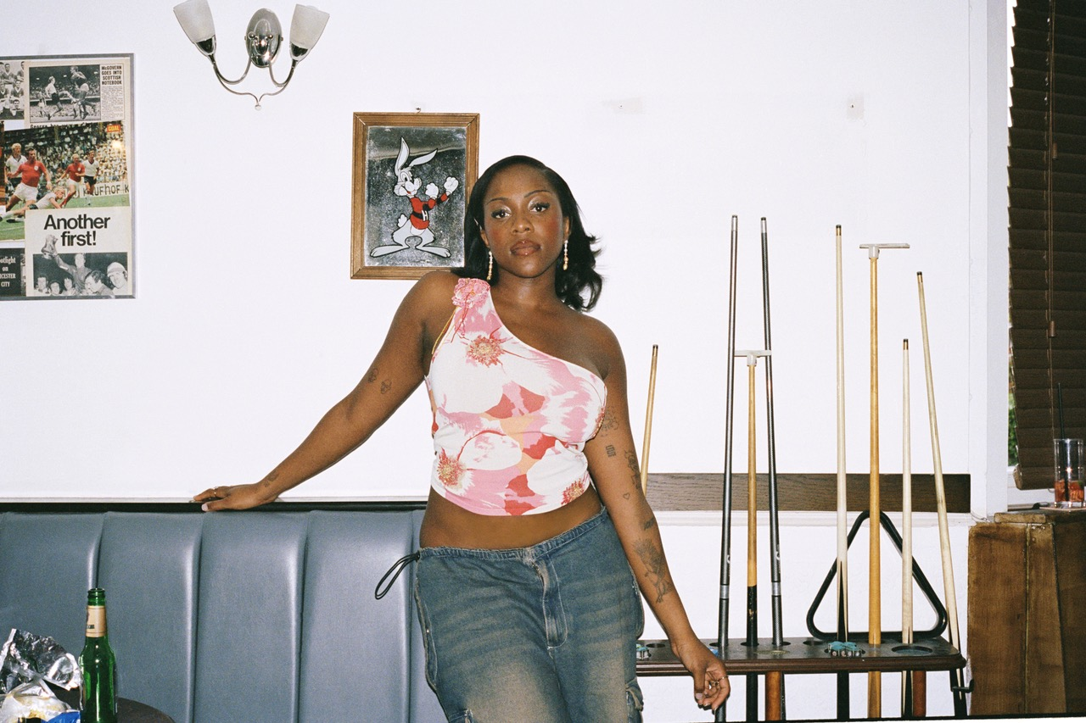
HI-RES PRESS ASSETS HERE
PHOTO CREDIT: LAUREN HARRIS
“Responsible for one of the most delightful pop singles of 2022 in ‘All I Ever Asked’”
“…one of the warmest, fully enveloping pop introductions in recent memory”
- BILLBOARD

“Chinouriri’s glowing voice and wistful lyrics create a sonically boundless landscape” - CONSEQUENCE

“…honest lyrics and enchanting vocals” – NYLON
“If you’ve ever had a secret crush, obsessed or felt utter despair over someone, Chinouriri’s direct way of discussing love and loss will resonate with you” – THE OBSERVER
"A glorious throwback of a track, the London singer's new song is a break-up beauty awash in the sonic tics and tricks of mid-Eighties new wave and soft-pop" – THE TIMES
JANUARY 18, 2023 - LOS ANGELES, CA - Alternative indie pop artist Rachel Chinouriri has announced details of her long-awaited debut album What A Devastating Turn Of Events, arriving May 3rd, 2024 via Elektra. The album is available for pre-save HERE.

What A Devastating Turn Of Events is a culmination of the experiences, challenges and joys of Chinouriri’s life so far, explored through the prism of musical stylings honed through years of experimentation and creation. Ever-eclectic and brutally honest, the album traverses life’s light and shade, the writing and sharing a healing process for Rachel, and she hopes, her listeners.

Rachel comments, “It’s finally here. The moment most musicians dream of when they’re a child. I can’t believe it’s real in a way, but I’m proud of it. What A Devastating Turn Of Events should feel like discovering a personal journey of all the hardship and struggles that have ultimately made me the person I am today. I was lost when I first made this album, when I felt so lost within myself but also in London. I was on a search to find myself and I can say I’ve managed to do that by the end of this process and have found a love for myself that I never thought was possible. I feel fortunate enough to be able to document that process and have it in physical form and sound. Hopefully it’ll help other people realize that it takes tough times, self accountability, betrayal and uncomfortable moments to finally get to a point of true self love. I’m more than ready for the next chapter.”

Following the album’s lead single “The Hills,” Rachel has also shared the soaring indie pop anthem “Never Need Me,” a bittersweet and empowering ode to putting yourself first despite caring deeply about another person. She shares: “I made this song with a sense of heartbreak but empowerment. It’s about taking your power back the moment you realize that helping someone is actually hurting you because they aren’t willing to change. Sometimes you end up enabling someone instead of actually helping them and carrying their load is tough. ‘Never Need Me’ is the moment you wish them well but can’t continue to harm yourself by helping them. It’s always a tough decision to make but once you make it, it’s a weight lifted off your shoulders for sure.”

“Never Need Me” comes complete with an official music video directed by Jake Erland and starring Academy Award nominated actress Florence Pugh who features as Rachel’s supportive bestie. Of coming together to work with Rachel on the “Never Need Me” video, Pugh shares: “Recently I was in LA and I was listening to a few of her songs and I thought, you know what, I’m actually going to reach out to this amazing artist and I just said ‘Thank you for making my day today’ and then she replied and was also a fan and then this idea came that I was in her music video!”

WATCH THE "NEVER NEED ME" VIDEO HERE

Rachel will play her biggest sold-out headline show to date at London’s KOKO on March 6th. In celebration of the announcement of her debut album, Rachel also announced her first-ever U.S. headline dates for this spring, stopping in NY and LA. Pre-sale tickets are available now while general on-sale begins this Friday at 10am local. For tickets and more information, please visit www.rachelchinouriri.com.

RACHEL CHINOURIRI
2024 U.S. HEADLINE TOUR DATES

March 12 Baby's All Right Brooklyn, NY
March 20 The Echo Los Angeles, CA

RACHEL CHINOURIRI
What A Devastating Turn Of Events - OUT MAY 3RD
PRESAVE NOW
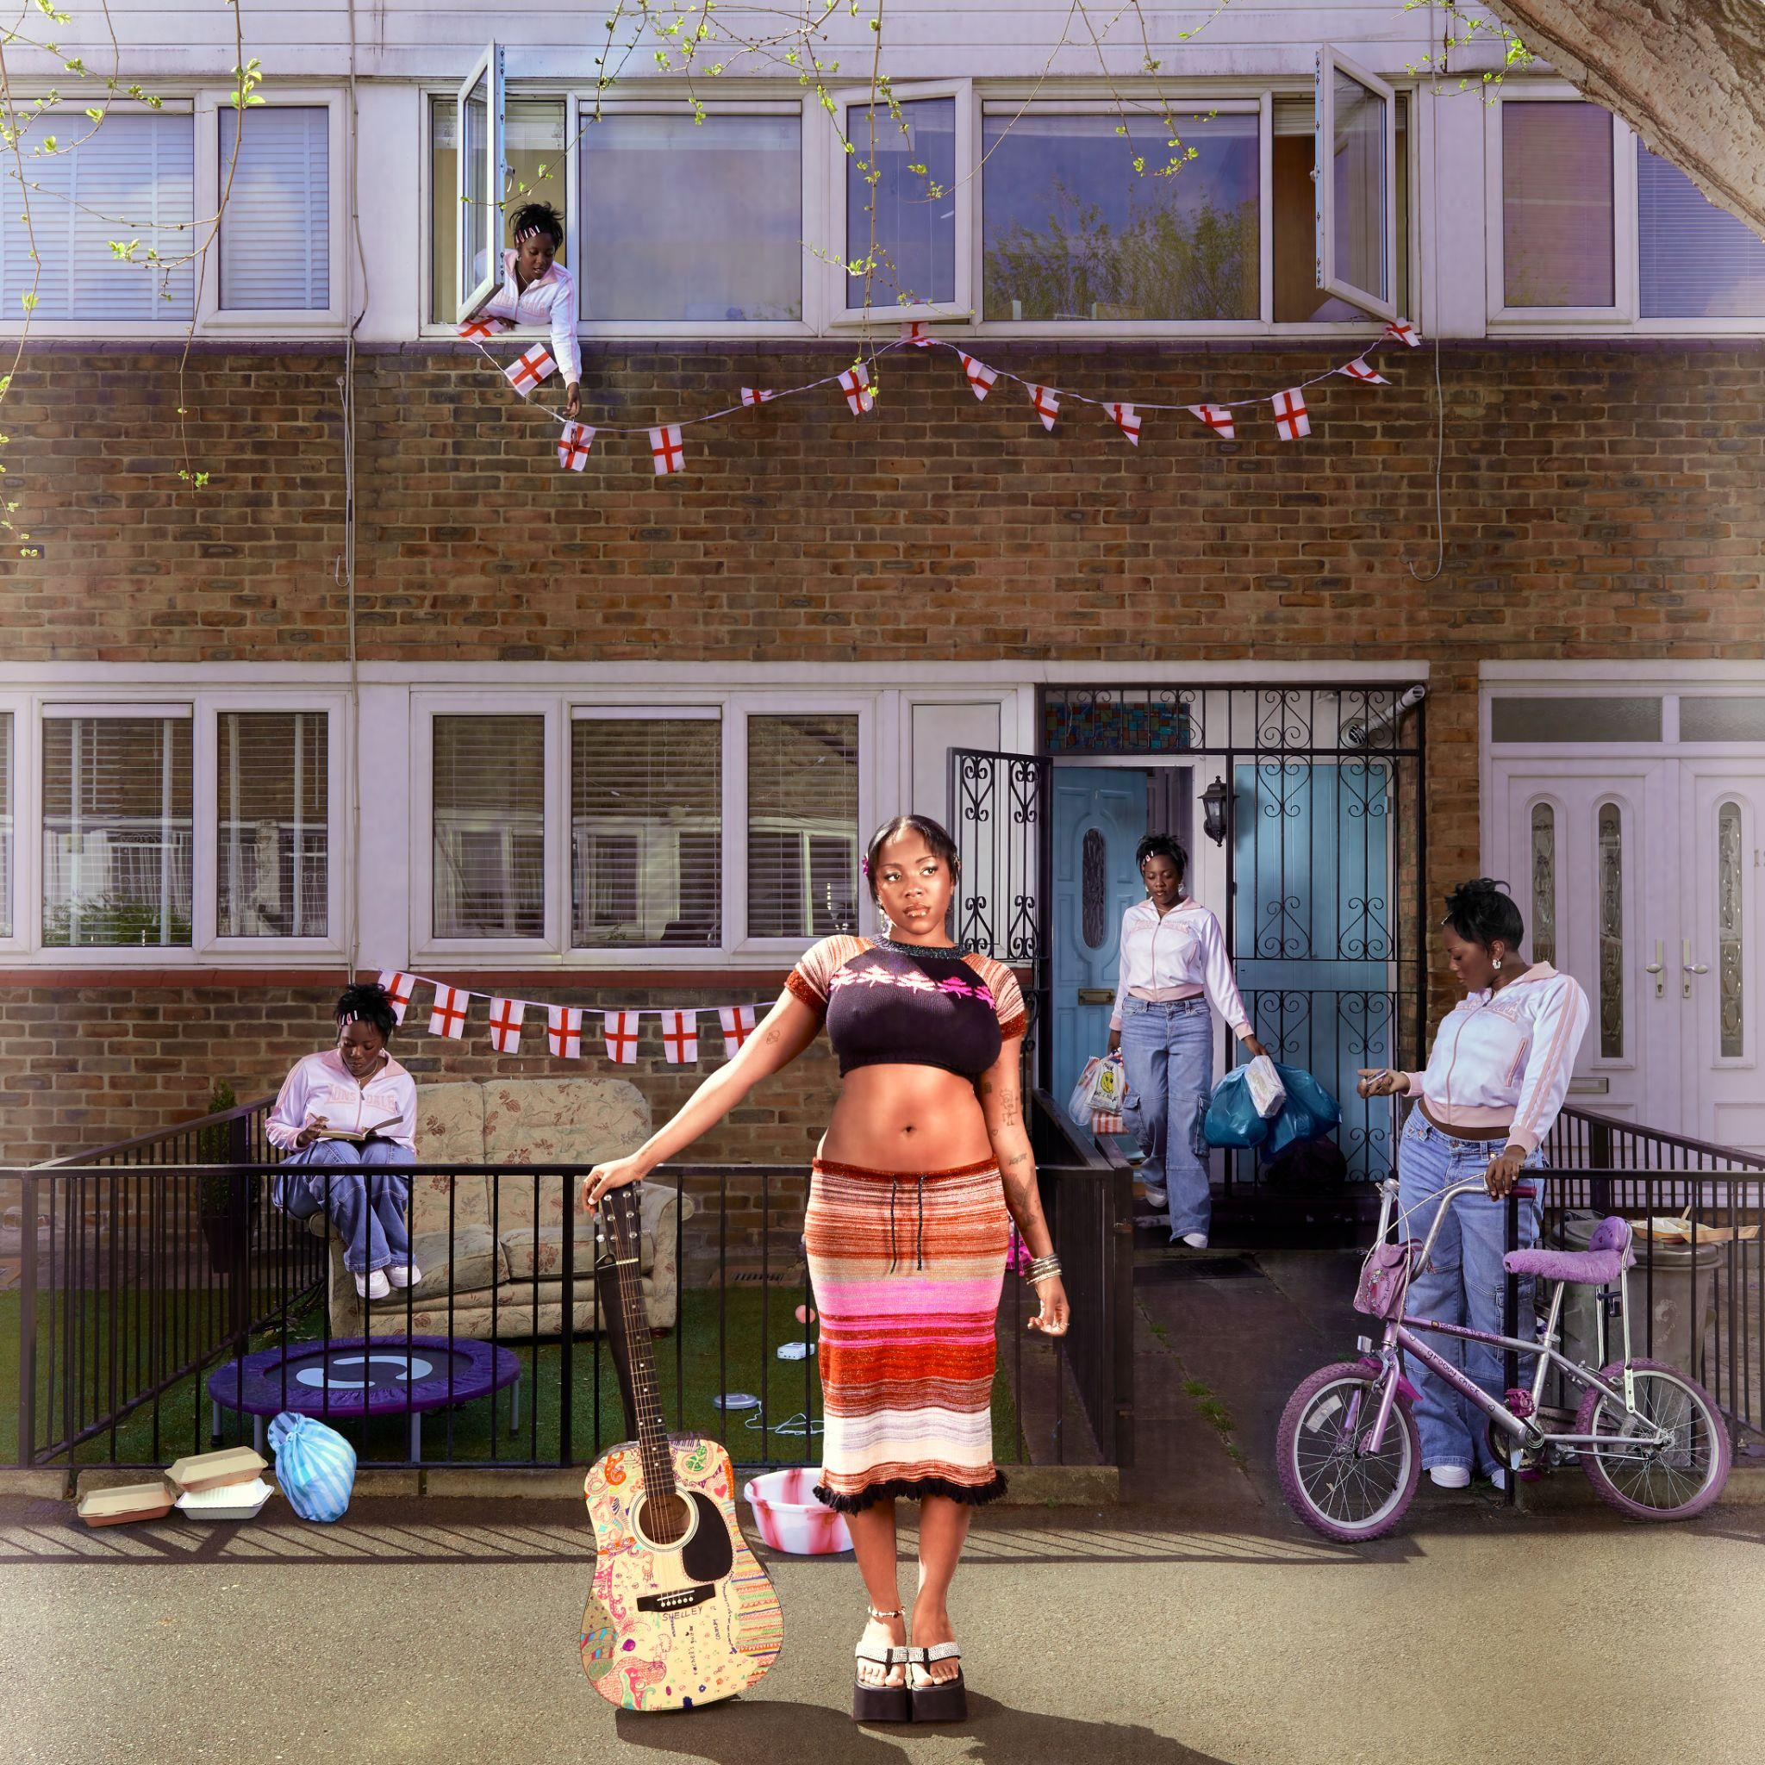
HI-RES ALBUM ART HERE

TRACKLISTING
- Garden Of Eden
- The Hills
- Never Need Me
- My Everything
- All I Ever Asked
- It Is What It Is
- Dumb Bitch Juice
- What A Devastating Turn Of Events
- My Blood
- Robbed
- Cold Call
- I Hate Myself
- Pocket
- So My Darling

On What A Devastating Turn of Events, Rachel Chinouriri is unflinching and mesmerizing as she invites us into her world and the experiences that have shaped her to become the person she is today. Despite facing up to the darkest parts of herself and her life - relationships, loneliness, regret, abuse, unconditional freedom, self harm, alcohol abuse and ultimately, death - Rachel asks us to consider the beauty amongst it all too.

The record examines the thoughts that had been swirling around her head: there are more long-standing themes of love, self-deprecation, unworthy exes and finding her boundaries in the album’s first half, but then in the second half, things get heavier.

“It’s a turning point,” she says, “Each song represents how you deal with trauma, but on the second half it’s when you get bad news and your world turns upside down.” This is an album which deals with grief, heartache, hurt, and what she calls the “worst-case scenarios” when these things are left unspoken for too long.

“I’m a lot better now,” she smiles, “And all of these topics don’t hurt me anymore, to a degree, but they shaped me and made me the person I am. When these things happen, you will never be the person you were before then, you adapt; and I think this album reflects that. It’s a healing tool, and I’m hoping people listening to it might feel less alone.”

In the process of learning to collaborate with other writers and producers in the creation of her debut album, Rachel was able to create the sonic world that she’d long been searching for. From soft acoustics to shiny indie pop to roaring scuzz, there’s her mellifluous vocal, the sumptuous harmonies, and even occasional bouts of cheeky, chatty speak-singing à la Kate Nash and Lily Allen, through which she builds upon her penchant for candid, lyrical songwriting.

What A Devastating Turn Of Events’ expansive palette was fleshed out with executive producer Rich Turvey (Blossoms, The Courteeners, The Coral), and co-credits include hip-hop behemoth Kenny Beats, and writers like Aaron “Apob” Paul O’Brien, Glen Roberts, Mary Weitz, and her long-term collaborator Daniel Hylton-Nuamah.

About Rachel Chinouriri

Rachel Chinouriri is one of the most exciting rising alternative indie pop talents who made a name for herself as a leading ambassador of captivating and heartfelt songwriting. The London singer-songwriter has amassed over 120 million streams to date and has been marked out as a true one to watch by being shortlisted for the BBC’s Sound of 2023 and the Ivor Novello Rising Star Award.

With her 2022 EP Better Off Without, Rachel marked a return to her first genre love of indie, balancing the sadness of heartbreak with summery choruses of hope. Rachel also made her COLORS session debut, sharing her vulnerable single ‘Thank You For Nothing’, exploring the topic of alcohol abuse.

The critical success of 2021’s Four° in Winter EP marked out her capabilities as a stylistic amalgamator, praised across the likes of BBC Radio 1, The Guardian, Dazed, NME, and theneedledrop’s Anthony Fantano who named the EP his #1 project of 2021.

Over the past few years Rachel has sold out numerous headline shows, supported the likes of Lewis Capaldi, Sam Fender, Celeste, Tems and Kojey Radical, drawn adoring crowds at festivals including Glastonbury, Latitude, The Great Escape, Boardmasters, Cross The Tracks and more. With a fiercely loyal fanbase by her side, Rachel turns her attention to her debut album: the truest expression of her musical journey to date, she’s ready to share her realest, rawest self.

CONNECT WITH RACHEL CHINOURIRI
Instagram | Facebook | Twitter | TikTok | YouTube

For US media inquiries, please contact:
Sarah Goldstein - sarahgoldstein@elektra.com
Sydney Worden - sydneyworden@elektra.com

