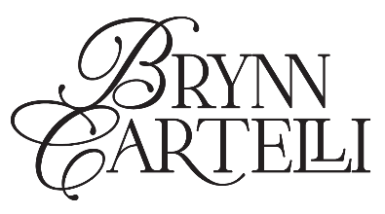

BRYNN CARTELLI ANNOUNCES DEBUT ALBUM OUT OF THE BLUE
PRE-SAVE/PRE-ORDER HERE

SHARES NEW SINGLE “BOY FROM HOME”
LISTEN HERE | WATCH OFFICIAL MUSIC VIDEO HERE

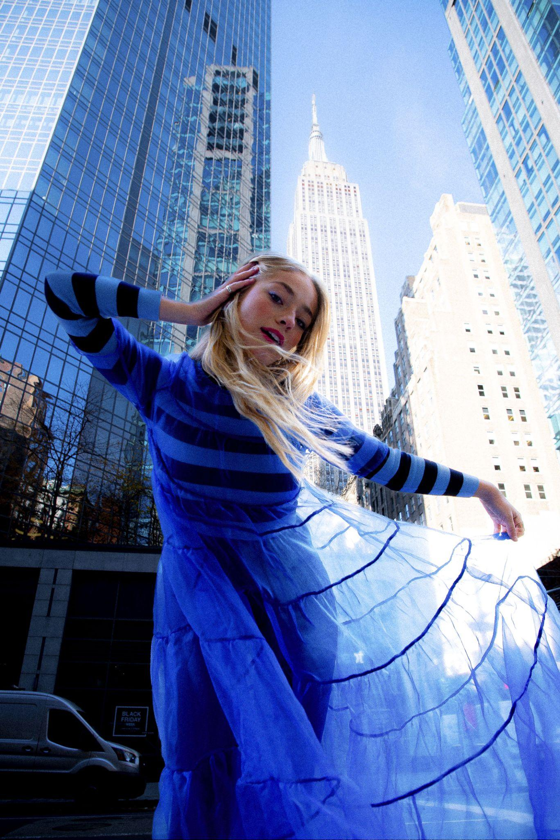
PHOTO CREDIT: SOPHIA BELLA CUCCI
HI-RES PRESS ASSETS HERE

“an indisputable titan of pop” – EUPHORIA MAGAZINE

“ethereal… floaty vocals” – V MAGAZINE

“…with a maturity far beyond her years” – PEOPLE

“…marvelous debut” – AMERICAN SONGWRITER

“Cartelli’s voice is wildly impressive” – THE WASHINGTON POST

“… radiates both youthfulness and maturity.” – LA MAGAZINE

(JANUARY 19, 2024) – LOS ANGELES, CA – Acclaimed 20-year-old singer-songwriter Brynn Cartelli has announced plans for her debut album OUT OF THE BLUE, arriving March 1st via Elektra. The album is available to pre-order and pre-save HERE. To celebrate the announcement, Cartelli also shared her new single “Boy From Home,” which arrives alongside an official music video co-directed by Cartelli and Martín Blanco. Watch the video HERE.

Cartelli explains, “Writing ‘Boy From Home’ was my personal call to action to surrender to the process of healing from past experiences. To then create a music video telling the story from my perspective allowed me to regain power over a situation that had haunted me for a while. I couldn’t be more excited for people to hear this song in the greater context of OUT OF THE BLUE.”

The announcement follows Cartelli’s recent singles “Secondhand Smoke” and “Lucky To Love You,” the latter of which figured prominently in NETFLIX’s Love Is Blind. “Secondhand Smoke” was released alongside a stunning self-directed music video, and saw a powerful performance on The Kelly Clarkson Show, as well as praise from PEOPLE, EUPHORIA and more. Cartelli paved the way for OUT OF THE BLUE with other fan favorites such as “Gemini,” “Girl Code,” and “Convertible in theRain.”

On OUT OF THE BLUE, Cartelli vividly depicts the complexities of relationships, leaving home, and finding purpose while standing on the precipice of adulthood. Crucial life events bookended its creation as she started the process during high school and finished by the time she settled into her life in New York, where she’s now attending college. For Cartelli, blue embodies a myriad of meanings and emotions, running the gamut from sadness, sympathy, and sensitivity to inspiration, intuition, and imagination.

OUT OF THE BLUE follows Cartelli’s debut EP Based On A True Story which arrived to widespread acclaim in 2021. American Songwriter hailed it as a “marvelous debut,” and UNCLEAR christened it “a perfect collection of songs for your story arc.” Sweety High raved, “The collection of six raw, personal and stunning songs shows Brynn and her talents at their very best.” Both projects showcase Cartelli’s remarkable vocal range that impressed viewers nationwide when she was crowned the winner of Season 14 of NBC’s The Voice. She emerged as the youngest champion in the show’s history, and still holds this title to date. Along with garnering a subsequent nomination at the People’s Choice Awards, Cartelli captivated audiences with performances on the TODAY Show, Macy’s Thanksgiving Day Parade, The Kelly Clarkson Show, and more.

In 2023 Cartelli played a series of headline shows in New York and Los Angeles, and supported select dates on Adam Melchor’s U.S. tour. She’s previously shared stages with Kelly Clarkson, OneRepublic, Maroon 5, and labelmate Jake Scott.

Be on the lookout for more from Brynn Cartelli soon.

BRYNN CARTELLI - OUT OF THE BLUE
DOWNLOAD HI-RES ALBUM ART HERE

TRACKLISTING
1. Beginning Of The End
2. Gemini
3. Watching My Friends Fall In Love
4. The Blue
5. Secondhand Smoke
6. Running In Place
7. Girl Code
8. Convertible In The Rain
9. Lucky To Love You
10. Fine Line
11. Boy From Home
12. Darker Days
13. Play With Fire
14. Leader

CONNECT WITH BRYNN CARTELLI:
Website | Facebook | X | Instagram | TikTok | YouTube
# # #
PRESS CONTACTS:
Glenn Fukushima | Glenn.Fukushima@300Elektra.com
Sydney Worden | Sydney.Worden@300Elektra.com
Destiny Dominguez | Destiny.Dominguez@300Elektra.com

