ALEC BENJAMIN
“PICK ME”
NEW SINGLE & VIDEO OUT NOW
WATCH THE MUSIC VIDEO HERE

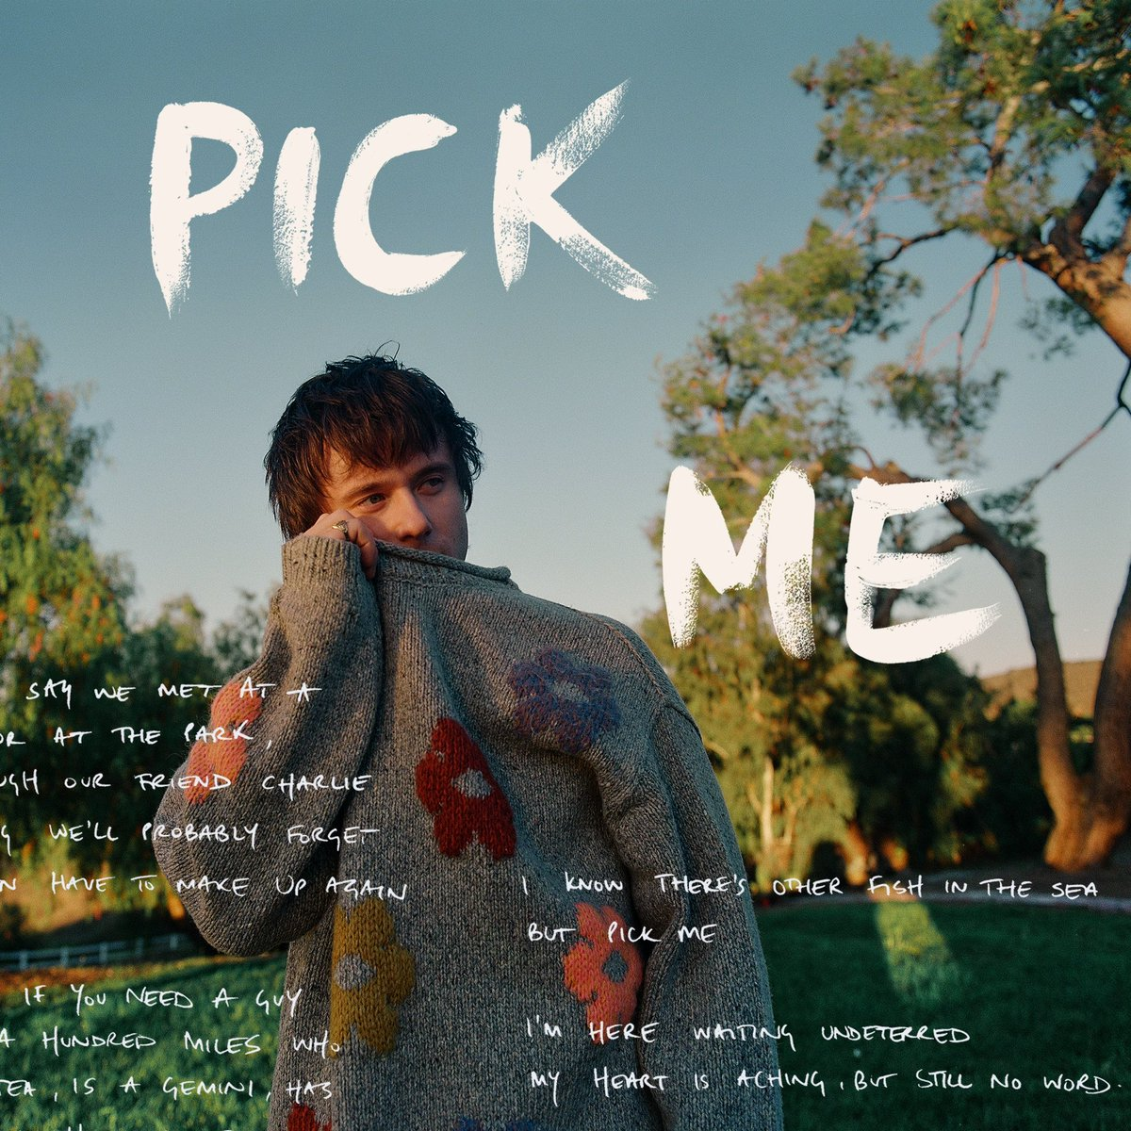

JANUARY 26, 2024, LOS ANGELES - Multiplatinum singer-songwriter Alec Benjamin takes center stage with his latest release, "Pick Me," the latest offering from his upcoming third studio album, slated for release later this year via Elektra Entertainment. Infused with enchanting guitar melodies and Benjamin’s signature introspective lyricism, he crafts a compelling narrative of desire and recognition within the expansive landscape of relationships, delving fearlessly into the digital dance of online dating. Listen to the track HERE.

Shot in Los Angeles, the accompanying music video reunites Benjamin with director Matt Trainor (who lensed Benjamin’s last video, “I Sent My Therapist To Therapy”). Set against the backdrop of a charming diner, the visual mirrors the essence of "Pick Me," emphasizing the search for an authentic connection in a world dominated by digital facades. Watch the video HERE.

Benjamin shares, “This song is about the way we represent ourselves - and the lies we sometimes tell - on dating apps to seem more appealing to other people. At the end of the day, we often discover that the best version of ourselves is the real version, and sharing our authentic selves with others is what creates meaningful connections.”

Benjamin recently gave a captivating performance of his recent single, “I Sent My Therapist To Therapy,” on The Tonight Show Starring Jimmy Fallon. Watch the performance HERE. Upon its release, Rolling Stone exclusively premiered the track hailing it “a wild self help yarn.” The song has since garnered over 16 million streams to date.

Closing out the previous year, Benjamin graced the stage on Jimmy Kimmel Live! with a debut performance of the album’s first single, “Different Kind Of Beautiful." Check out the performance HERE. The track was highlighted by UPROXX as "a love song in the purest form," and highlighted in Billboard’s Cool New Pop Songs. The track has amassed over 24 million streams to date.

Benjamin continues his emergence as a standout artist. Since his debut in 2018, Benjamin has been celebrated by both fans and critics for his exceptional narration. With the release of his sophomore album (Un)Commentary in 2022 Benjamin took to the road to connect with fans captivating audiences across the United States, Asia, Australia, and Europe as well as a debut performance at Coachella Valley Arts and Music Festival. Alec’s impressive resume includes 9B+ global streams, 10M+ social media followers across his platforms, 123M+ in playlist reach, and 1.6B+ YouTube views on his channel. An illustration of the connection Alec has forged with audiences worldwide.
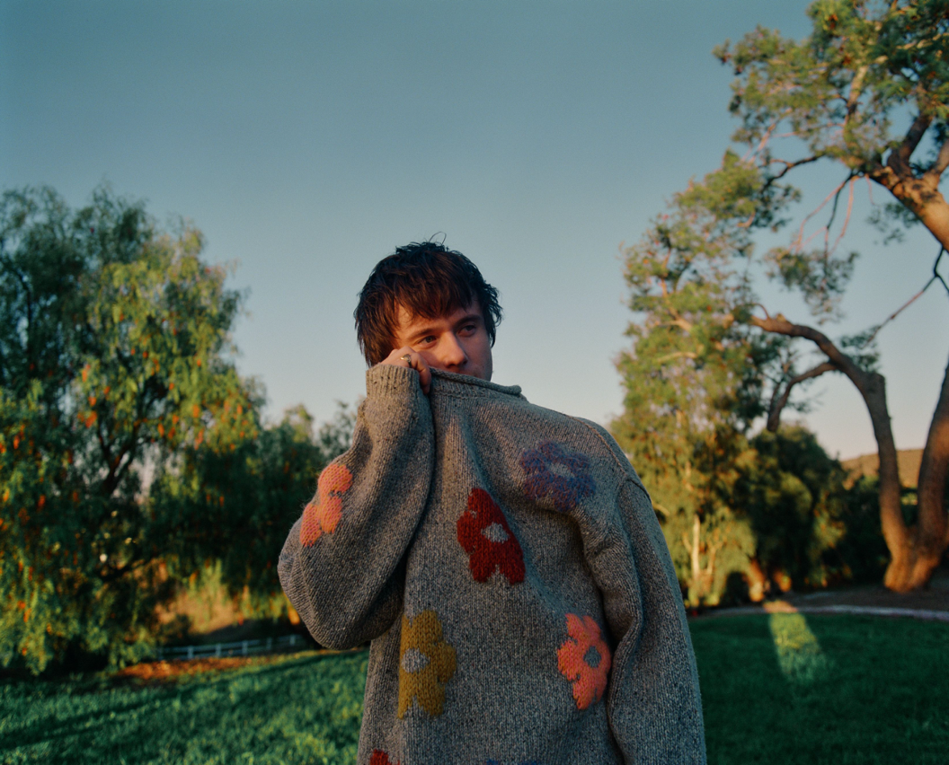
Photo Credit: Louis Browne
Download high-res art HERE.

CONNECT:
Website | Facebook | Twitter | Instagram | YouTube

For media inquiries, please contact:

﻿BT PR
Benny Tarantini | Benny@BTPR.biz
Moya Crowley | Moya@BTPR.biz

Elektra Entertainment
Glenn Fukushima | GlennFukushima@elektra.com
Collin Citron | CollinCitron@elektra.com

