SYDNEY ROSE SHARES NEW SINGLE “THE NEW KID”
OFFICIAL VISUALIZER STREAMING NOW
WATCH HERE

TOUR DATES SUPPORTING LEANNA FIRESTONE KICK OFF
NOVEMBER 24 IN DURHAM, NC

DEBUT ALBUM ONE SIDED
ARRIVING NOVEMBER 10 VIA PUBLIC CONSUMPTION
Download Press Assets HERE
OCTOBER 13, 2023 – 20-year-old singer/songwriter Sydney Rose has shared wistful new single "The New Kid," the second offering from her upcoming debut album One Sided. The track touches on the distance between friends and explores the idea of turning the page to a pending chapter of life: Rose asks, without an answer, “Am I lonely, or am I free?” “The New Kid” arrives alongside an official visualizer, which is streaming now on Rose’s official YouTube channel.
Sydney expanded on the track: “‘The New Kid’ is really special to me. I wrote it in a time where I was growing up, where I was getting ready to move, and where I felt the most lonely I’ve ever felt in my life. Growing up, I always felt like the new kid. As I continue to grow, no matter where I go or what I do, I still feel like that little kid. However, being that little kid has taught me to appreciate learning new experiences and growing up and changing to be a better person.”
Next month, Sydney will kick off tour dates supporting Leanna Firestone’s “Least Favorite Only Child Tour.” The dates kick off November 24 in Durham, NC, hitting New York City’s Gramercy Theatre on December 6 before wrapping up in Boston, MA on December 7. Tickets for all dates are on sale now. For up-to-date ticketing information, please visit www.sydneyrosemusic.com.
In September, Sydney announced her debut album One Sided, set for release on November 10th via Public Consumption. The news arrived alongside new single and video “You’d Be Stars (feat. chloe moriondo),” which premiered via FLOOD Magazine who celebrated the "breezy, late-summer exhalation." Written solely by Rose, “You’d Be Stars” lovingly explores the small, shared moments of friendship that create a lasting bond. One Sided is available for presave now via Public Consumption.
In 2022, her debut EP You Never Met Me and its follow-up This Kind of Thing Doesn’t Last showcased intimate lyricism and a knack for candid honesty, with the help of understated synths, muted drum machines, and stacked harmonies. Now, with her debut album One Sided, Rose returns to her stripped-back acoustic roots, offering tenderhearted meditations on childhood, love, and the evolution of friendship, with a guitar in hand.
The album announcement follows a slew of 2023 singles, including an intimate cover of The Killers’ iconic track “Mr. Brightside.” Spring release “I can’t live without you (feat. Charlie Oriain),” was coined by Sweety High as “a whispery, gorgeous ballad straight from the heart,” while Stereogum praised “Tell Him I Miss Him” as “lovely and delicate,” noting, “[the] achingly spare song … slowly layers on more instruments and effects without losing any heart.”
Sydney shared her latest EP This Kind Of Thing Doesn’t Last in November, which arrived alongside a self-directed official music video for focus track “Too Fast.” Last summer, the artist shared her debut EP You Never Met Me, which included previously released singles “Phoebe Told Me,” “Things That Don’t Exist (feat. Zachary Knowles),” and “I’ll Never Get Over It” and arrived to critical acclaim, with PEOPLE Magazine naming her one of their Emerging Artists To Watch and Under The Radar attesting, “‘You Never Met Me’ is the sound of Rose finding herself in her music and introducing herself to the world, tracing all of the messy contours of teenage heartbreak in the process.” Amplify Her Voice also celebrated the effort, stating “Rose re-discovers different parts of herself on her own, presenting her real self through a delicately honest six-song collection.”
(Album Art + Tracklisting Below)
SYDNEY ROSE 2024 TOUR DATES
All dates supporting Leanna Firestone

November 24 Durham, NC Motorco
November 25 Asheville, NC Grey Eagle
November 26 Charleston, SC Music Farm
November 28 Tampa, FL Crowbar
November 29 Orlando The Abbey
December 1 Pensacola, FL Handlebar
December 2 Birmingham, AL Saturn
December 3 Nashville, TN Eastside Bowl
December 6 New York NY Gramercy Theater
December 7 Boston, MA Paradise
SYDNEY ROSE
One Sided – OUT NOVEMBER 10TH
PRESAVE NOW
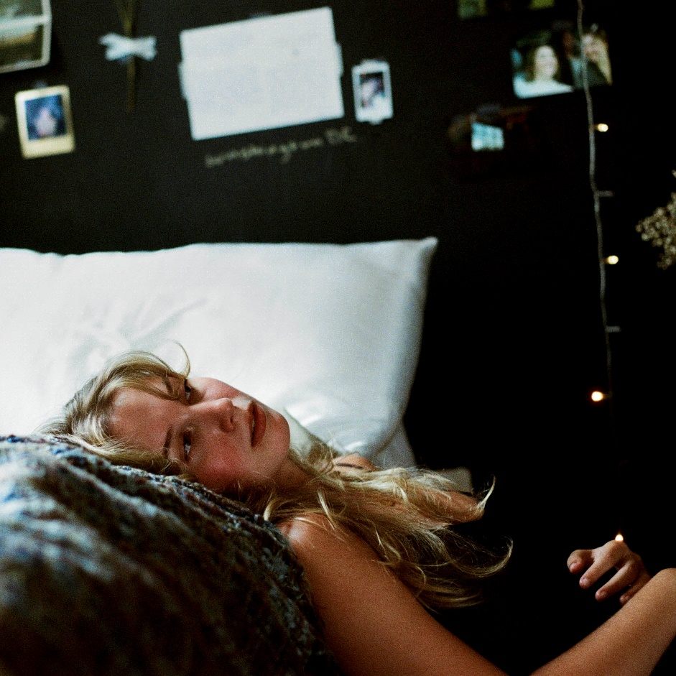
- Filing Our Papers
- Unmade Bed
- I Think of How It Ends
- The New Kid
- You’d Be Stars (feat. chloe moriondo)
- Pretty Words
- The House I Grew Up In
- Growing
- Same Car
- Cool Girl
- What Kind Of Winner
- Out Of Service
- Throwing Rocks

CONNECT WITH Sydney Rose
TIKTOK
YOUTUBE
INSTAGRAM

CONTACT:
Sarah Goldstein
SarahGoldstein@elektra.com

