QUARTERS OF CHANGE UNVEIL NEW SINGLE ”HEAVEN BOUND”
FROM UPCOMING SOPHOMORE STUDIO ALBUM PORTRAITS

LISTEN HERE | WATCH HERE

HIGHLY ANTICIPATED LP PORTRAITS SET TO DROP ON JANUARY 26, 2024 VIA ELEKTRA

PRE-ORDER / PRE-SAVE PORTRAITS HERE

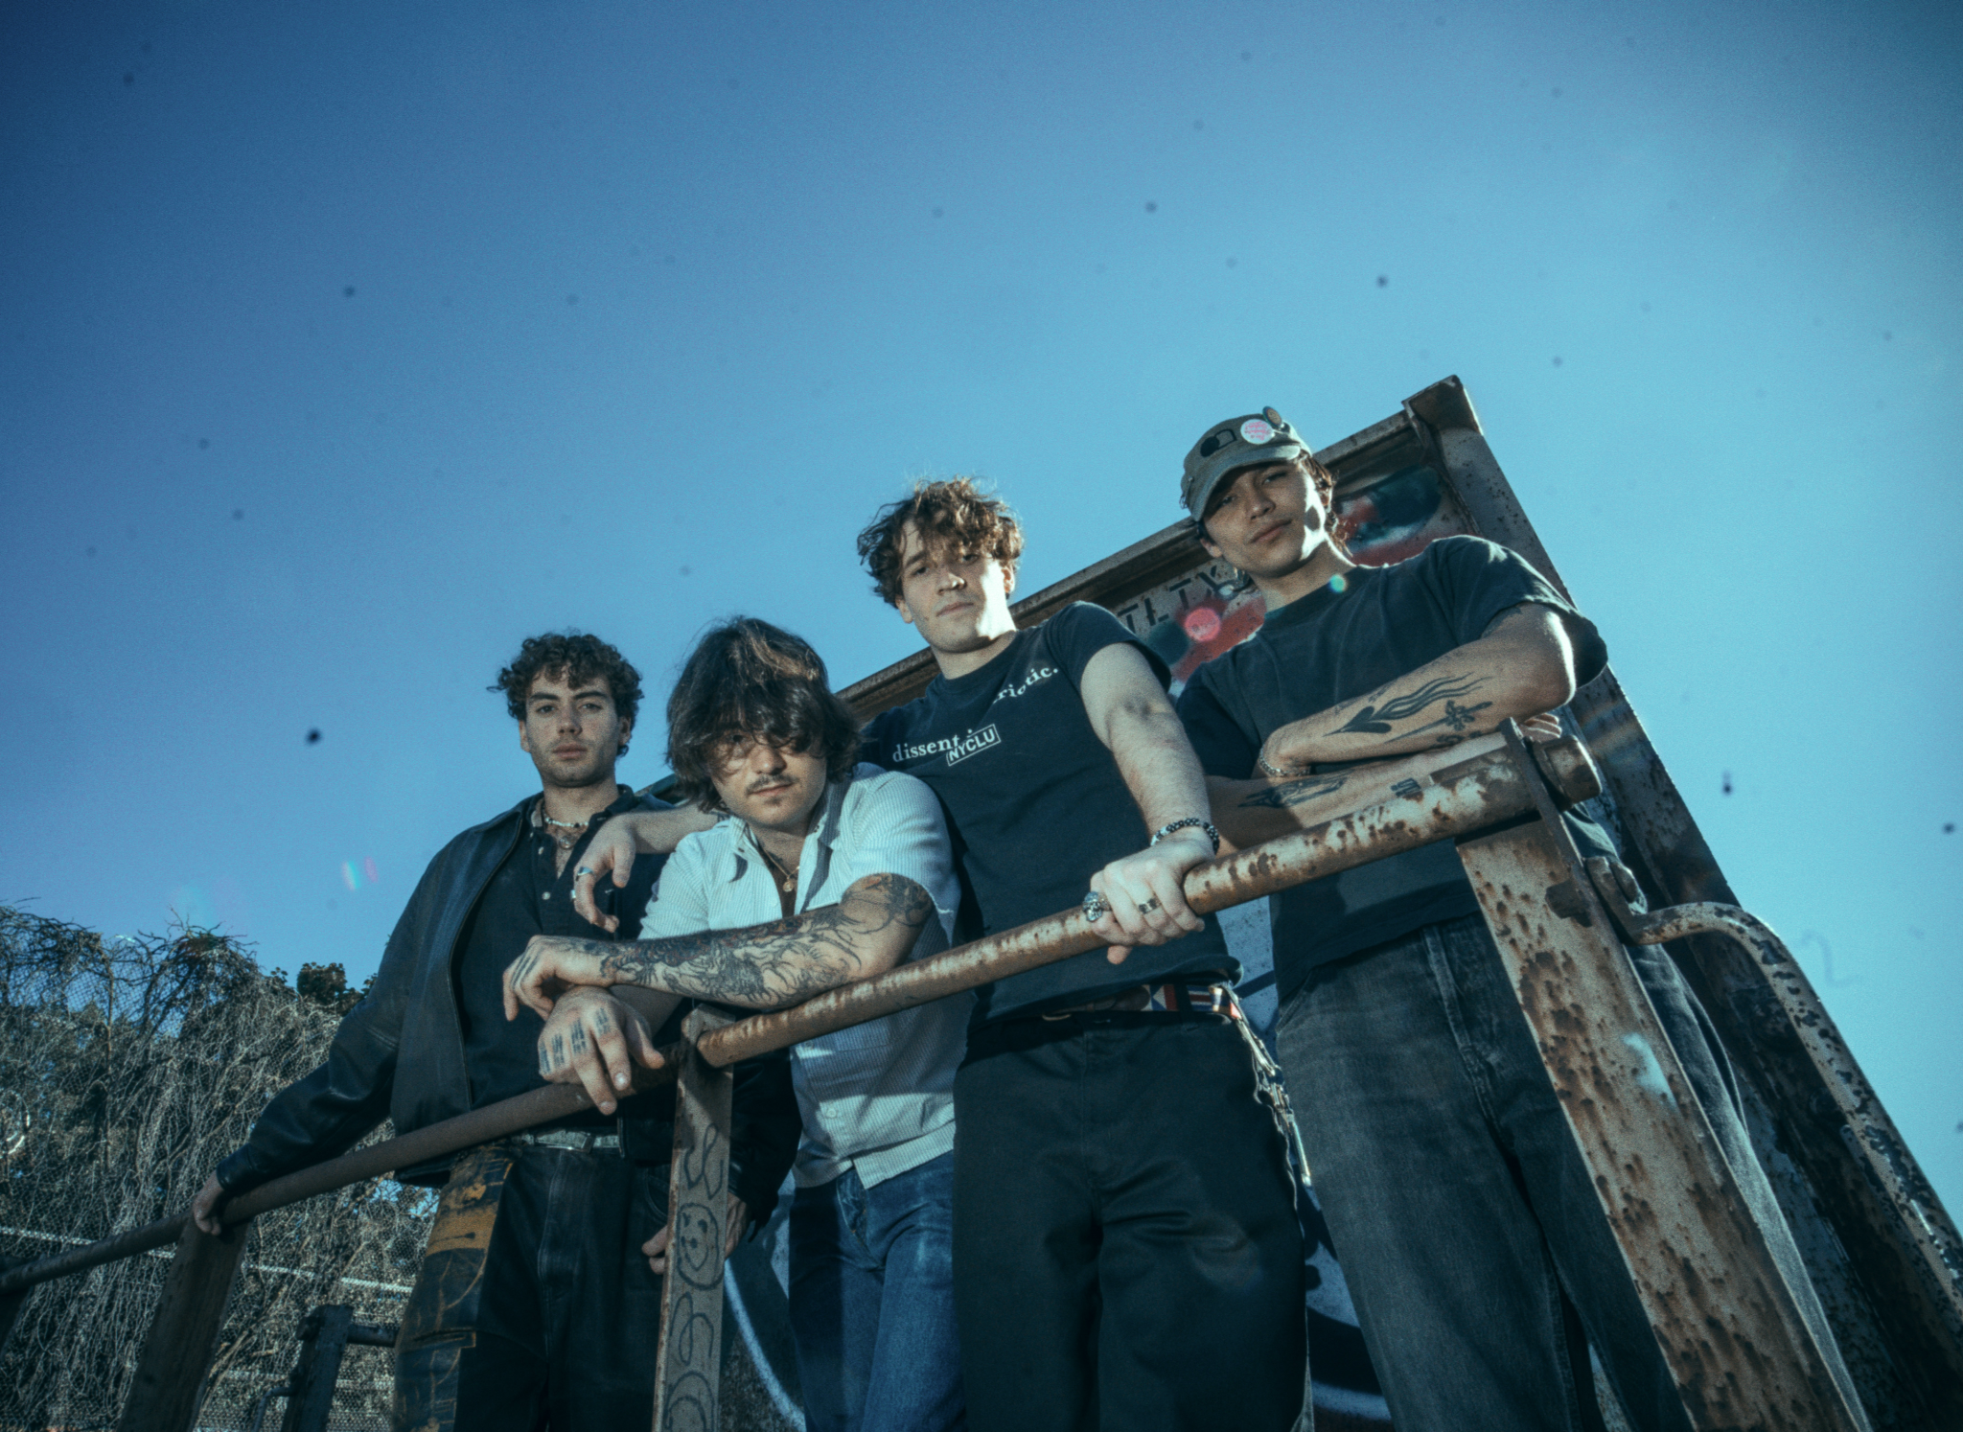
PRESS ASSETS AVAILABLE HERE | PHOTO CREDIT: AMYAS RYAN

OCTOBER 27, 2023 - Quarters of Change, an emerging force in the alternative music scene, have unveiled “Heaven Bound,” the latest single from their eagerly awaited sophomore studio album, Portraits, set to release on Friday, January 26, 2024, via Elektra. The new track encapsulates emotions of solitude, an intense yearning for escape, and inner self-doubt, harmonizing with late 2000s rock and dream pop influences. Frontman Ben Roter's candid lyrics delve into themes of addiction and the recurring cycles of life, crafting a deeply introspective reflection. Listen to “Heaven Bound” HERE. Watch the accompanying visualizer HERE.

“'Heaven Bound' is about a period of nihilism, isolation, and addiction. Specifically using addiction to cope. It’s about feeling detached from the world, and searching for meaning,” shares Quarters of Change frontman Ben Roter. “In the end, it’s an anthem of acceptance - and realizing that we all have a beautiful, inevitable fate. We’re all truly ‘Heaven sent; heaven bound.’”

The track follows critically acclaimed singles “Do or Die,” "What I Wanted," and "Hollywood Baby," all of which arrived to rave reviews and secured spots on major DSP playlists. Adding an artistic touch to their album, each single is paired with artwork that also serves as a portrait of a specific Quarters of Change member (Jasper Harris for 'What I Wanted,' Attila Anrather for 'Hollywood Baby,' Ben Acker for 'Do or Die,' and Ben Roter for 'Heaven Bound'). This unique approach turns every track into an individual work of art which takes you on a visual journey through the band's unique individuality.

Quarters of Change recently concluded their successful 'The Quarters of Change Show,' which took them to 20 major cities across the United States. The band will perform their largest hometown performance to date at the renowned Webster Hall in New York City on December 9, with support The Backfires. The band just delivered an unforgettable performance at Austin City Limits and are expected to make additional festival appearances in 2024.
Portraits follows the deluxe edition of Quarters of Change’s debut studio album Into The Rift. Released last year, the 14-track collection boasts three new songs, including “To Let Go,” “T Love – Extended,” and “Blue Copper.” Into The Rift (Deluxe) is available to stream and download HERE. Originally released in July of 2022, the album introduced and solidified Quarters of Change as a standout quartet going beyond the typical conventions and traditional boundaries of genre to take the rock scene by storm. Fan-favorite tracks, including “Jaded,” “T Love,” and “Dead”, and shoutouts from celebrity fans such as Joe Jonas, Fred Durst, and Lewis Capaldi have also helped catapult the group into the limelight. Following the LP’s release, they hit the road with Bad Suns and sold out their first-ever US headline tour. Earning tastemaker praise, The Aquarian hailed them as “reviving alt rock,” and Sheesh professed, “Quarters of Change has mastered the New York rock resurgence in a way that is resonating with even the best of the best.”
QUARTERS OF CHANGE - PORTRAITS
PRE-ORDER HERE | STREAM “HEAVEN BOUND” HERE
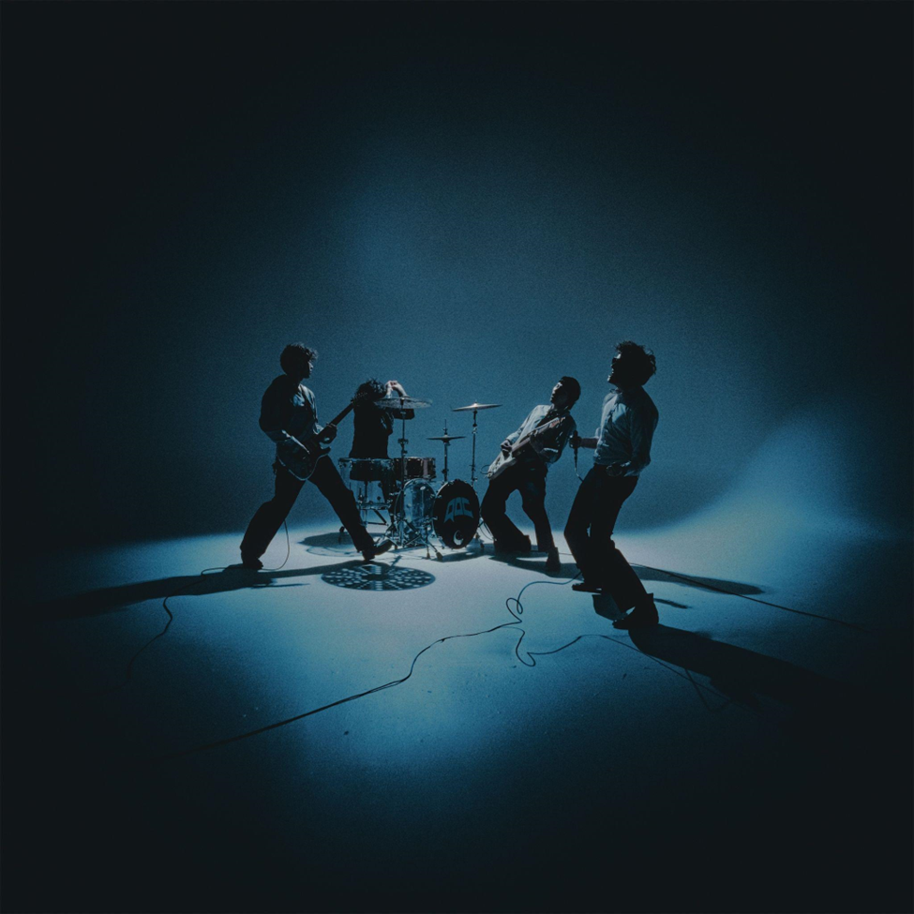
Portraits Tracklisting
1. What I Wanted
2. Depression II
3. Heaven Bound
4. Turn It Away
5. Tightrope
6. Cherry Tree
7. Do or Die
8. Time Before Mourning
9. Hollywood Baby
10. Illogical Decisions
11. Keep My Blood

ABOUT QUARTERS OF CHANGE
Quarters of Change channel the shared energy of a lifelong bond as friends into emotionally charged and ethereal alternative rock with stadium scope. The New York City quartet—Ben Acker [guitar, bass, synths], Attila Anrather [drums], Jasper Harris [guitars, bass, synths], and Ben Roter [vocals, guitar]—lean on an unspoken musical language of their own, writing face-to-face and recording together. They initially gained traction with a handful of independent EPs as the fan favorite “Kiwi” reeled in over 10 million streams. They continued to hone this signature style on their 2022 full-length debut, Into The Rift, which is highlighted by fan-favorite tracks “T Love,” “Jaded,” and “Dead.” The band also unveiled a deluxe edition of the LP featuring three new songs. Quarters of Change simultaneously emerged as a live force, supporting Bad Suns and selling out their first-ever US headline tour. The Aquarian hailed them as “reviving alt rock,” and Sheesh professed, “Quarters of Change has mastered the New York rock resurgence in a way that is resonating with even the best of the best.” The group has also amassed high-profile fans including Joe Jonas, Lewis Capaldi, Chad Smith, Fred Durst, and more. Doubling down on amplifying the energy, and turning up the distortion, Quarters of Change have quietly emerged as a phenomenon, and maintain this momentum with their forthcoming album Portraits (due out January 26, 2024 via Elektra).
CONNECT WITH QUARTERS OF CHANGE
TikTok | Instagram | Twitter

Quarters of Change Press Contacts
Collin Citron / Collin.Citron@300elektra.com
Destiny Dominguez / Destiny.Dominguez@300elektra.com

