Fall Out Boy Announces So Much For (2our) Dust

Worldwide Headline Tour Continues Across United States with 23 New Dates Beginning February 2024 Due to Overwhelming Demand

General Tickets On Sale Starting Friday, September 15

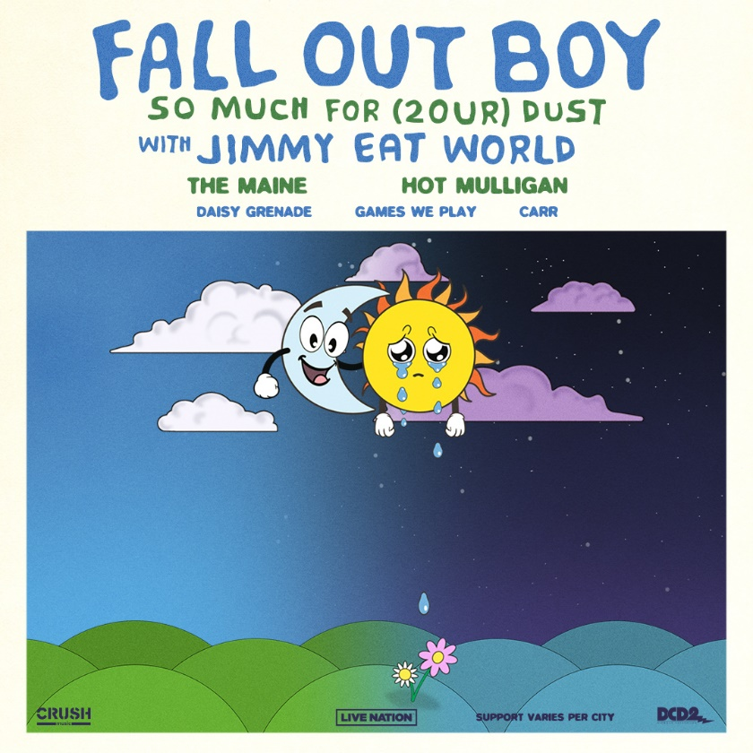
So Much For (2our) Dust Admat: Download Here
Fall Out Boy press image (credit Pamela Littky): Download Here
So Much (For) Stardust Album Art: Download Here

September 7, 2023 – Due to overwhelming demand, GRAMMY Award-nominated and multi-platinum selling rock band Fall Out Boy’s worldwide So Much For (Tour) Dust tour will continue next year with the announcement of So Much For (2our) Dust, a 20+ date run across the United States.

So Much For (2our) Dust, presented by Live Nation, will kick off February 28, 2024 in Portland, OR and travel through cities including Seattle, Austin, Orlando, Baltimore, and Nashville before concluding April 6, 2024 in Minneapolis, MN. The trek also includes a stop at New York City’s famed Madison Square Garden on March 22, 2024.

Jimmy Eat World will join So Much For (2our) Dust on all dates as special guests; The Maine, Hot Mulligan, Daisy Grenade, Games We Play and CARR will join the tour on select shows throughout the run.

Ticket pre-sales for So Much For (2our) Dust begin Wednesday, September 13 at 9:30am local time. General tickets will be available beginning Friday, September 15 at 10am local time. For all dates and details, please visit www.falloutboy.com/tour.

The news follows the August 6 conclusion of So Much For (Tour) Dust’s initial North American run, which kicked off June 21 with a sold out, epic hometown show at Wrigley Field in Chicago, IL and was dubbed “the loudest concert Wrigley’s ever had” by the Chicago Sun-Times.

Each show also included the use of a Magic 8 Ball to surprise fans with a performance of a Fall Out Boy song that had never played live before, which became one of the most buzzed about topics of the summer, igniting fans across social media – and spawning a trend on TikTok, with hundreds of thousands of views – to determine what songs might be coming next.

So Much For (Tour) Dust has proven to be another career display of Fall Out Boy’s undeniable and renowned live performance prowess, featuring multiple sold-out dates; four stadiums shows (Fenway Park in Boston, Forest Hills Stadium in Queens, two nights at BMO Stadium in Los Angeles); special guests (Mikey Way in San Diego, Travie McCoy in Queens); unforgettable production, visual effects and pyrotechnics; and widespread praise from fans and critics alike:

“In a dazzling concert packed with Fall Out Boy songs new and old, the band proved why they still have the hearts of pop-punk lovers of all ages.” – Tampa Bay Times

“At Fenway, Fall Out Boy bring the fireworks” – Boston Globe

“When they took the stage, Fall Out Boy immediately showed they’re in the upper echelon of modern rock performers alongside the likes of Weezer, Green Day and Foo Fighters.” – Exclaim!

“Fall Out Boy gave us more than we bargained for with a genre-defying, sensational show… The highlight of the evening came when the stage was stripped down, the backdrop dimmed and the lighting rigs lowered, creating the illusion of an intimate club reminiscent of the ones where Fall Out Boy played during their formative years. Fall Out Boy’s flawless performance of their timeless anthem, “Grand Theft Autumn,” reminded us of the lasting impact of their music.” – Dallas Observer

“Patrick Stump, Pete Wentz, Andy Hurley, and Joe Trohman let it all hang out on stage after going through their extensive catalog of tunes that helped shape a generation of millennials who grew up choosing to proudly showcase the pop rock genre on their thoughtfully curated Myspace profile pages. The sold out crowd flooded merchandise lines that stretched around the sunny field before the beginning of the event to show fierce loyalty and dedication to a group that continues to not only stand the test of time, but swiftly adapt in the ever changing scene known as the music industry.” – The Queens Gazette

“In addition to delivering a great set of music, Fall Out Boy lit up the night with a pyrotechnics display worthy of a July 4 celebration.” – Cleveland Plain-Dealer

“Fall Out Boy burn bright at Michigan’s Pine Knob Music Theatre… the pop-punk titans still have plenty of sway in the area…With the combination of classics and recent hits, sparks flew at the concert (literally and figuratively).” – Glide Magazine

“We’re all united in this moment. We’re here for the same reason: to forget the woes of the real world and to be transported through the decades of the storylines that Fall Out Boy has so graciously given us over the past 20 years.” – Cincinnati CityBeat

The UK and European leg of So Much For (Tour) Dust kicks off October 17 in Warsaw, Poland and concludes November 8 in Berlin, Germany, with multiple dates (Munich, Paris, Amsterdam, Leeds, Manchester, Cardiff) already sold out. The band will continue performing for fans around the world this year with a recently announced December 6 date in Bangkok as well as multiple cities (Melbourne, Sydney, Brisbane) across Australia as part of the Good Things Festival from December 1-3. In August, the band performed at Summer Sonic in both Tokyo and Osaka.

So Much For (2our) Dust is in support of Fall Out Boy’s most recent, critically acclaimed 8th studio album So Much (For) Stardust, which debuted as the No. 1 rock album upon its March 24 release on Fueled By Ramen/Elektra/DCD2 Records and features the global smash single “Love From The Other Side.”

The album has also garnered Fall Out Boy two current nominations for the 2023 MTV Video Music Awards – Best Alternative (“Hold Me Like A Grudge”) and Best Visual Effects (“Love From The Other Side”).

Additionally, the band currently stars in NBC Sports’ B1G Saturday Night show open this season. The show open – with a chorus of “Here Comes Saturday Night” – debuted on September 2 ahead of the season-opening West Virginia-Penn State game. Fall Out Boy also headlines the NBC Sports and Peacock Big Ten Football promotional campaign, appearing across NBCUniversal platforms throughout the summer and fall.

# # #

Fall Out Boy – So Much For (2our) Dust – 2024 Dates
*Jimmy Eat World to support on all dates
Date | City | Venue
Wednesday, February 28 | Portland, OR | Moda Center
Friday, March 1 | Seattle, WA | Climate Pledge Arena
Sunday, March 3 | Sacramento, CA | Golden 1 Center
Monday, March 4 | Anaheim, CA | Honda Center
Thursday, March 7 | Fort Worth, TX | Dickies Arena
Friday, March 8 | Austin, TX | Moody Center
Monday, March 11 | Oklahoma City, OK | Paycom Center
Wednesday, March 13 | Birmingham, AL | Legacy Arena at The BJCC
Friday, March 15 | Orlando, FL | Amway Center
Saturday, March 16 | Jacksonville, FL | VyStar Veterans Memorial Arena
Tuesday, March 19 | Raleigh, NC | PNC Arena
Wednesday, March 20 | Baltimore, MD | CFG Bank Arena
Friday, March 22 | New York, NY | Madison Square Garden
Sunday, March 24 | Albany, NY | MVP Arena
Tuesday, March 26 | Grand Rapids, MI | Van Andel Arena
Wednesday, March 27 | Pittsburgh, PA | PPG Paints Arena
Friday, March 29 | Columbus, OH | Schottenstein Center
Saturday, March 30 | Lexington, KY | Rupp Arena
Sunday, March 31 | Nashville, TN | Bridgestone Arena
Tuesday, April 2 | Milwaukee, WI | Fiserv Forum
Wednesday, April 3 | Des Moines, IA | Wells Fargo Arena
Friday. April 5 | Omaha, NE | CHI Health Center Arena
Saturday, April 6 | Minneapolis, MN | Target Center

Fall Out Boy – 2023 Live Dates
Date | City | Venue
Tuesday, October 17 | Warsaw, Poland | COS Torwar
Wednesday, October 18 | Prague, Czech Republic | Sportovni Hala Fortuna
Friday, October 20 | Milan, Italy | Mediolanum Forum
Saturday, October 21 (SOLD OUT) | Munich, Germany | Zenith
Monday, October 23 (SOLD OUT) | Paris, France | Zénith
Tuesday, October 24 (SOLD OUT) | Amsterdam, Netherlands | AFAS Live
Wednesday, October 25 | Brussels, Belgium | Forest National
Friday, October 27 (SOLD OUT) | Leeds, UK | First Direct Arena
Saturday, October 28 | Glasgow, UK | OVO Hydro
Sunday, October 29 (SOLD OUT) | Manchester, UK | AO Arena
Tuesday, October 31 | Birmingham, UK | Utilita Arena Birmingham
Thursday, November 2 | London, UK | The O2
Friday, November 3 | London, UK | The O2
Saturday, November 4 (SOLD OUT) | Cardiff, UK | Cardiff International Arena
Monday, November 6 | Oberhausen, Germany | Rudolf Weber-Arena
Tuesday, November 7 | Hamburg, Germany | Barclays Arena
Wednesday, November 8 | Berlin, Germany | Max-Schmeling-Halle
Friday, December 1 | Melbourne, Australia | Flemington Racecourse
Saturday, December 2 | Sydney, Australia | Centennial Park
Sunday, December 3 | Brisbane, Australia | Brisbane Showgrounds
Wednesday, December 6 | Bangkok, Thailand | Thunder Dome

About Live Nation Entertainment
Live Nation Entertainment (NYSE: LYV) is the world’s leading live entertainment company comprised of global market leaders: Ticketmaster, Live Nation Concerts, and Live Nation Sponsorship. For additional information, visit www.livenationentertainment.com.

