CHLOE MORIONDO TAKES ON “AMERICA’S SCARIEST MOTEL”
IN “HOTEL FOR CLOWNS” OFFICIAL MUSIC VIDEO
WATCH HERE

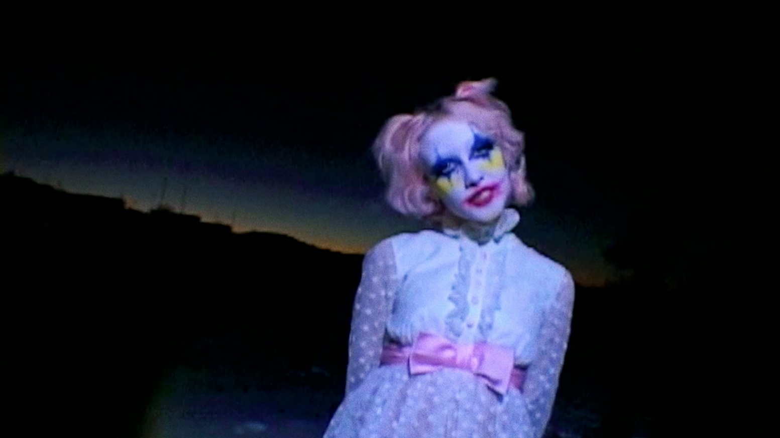
DOWNLOAD PRESS ASSETS HERE

OCTOBER 5, 2023 – Indie-pop starlet Chloe Moriondo has revealed an official music video for SUCKERPUNCH track, “Hotel For Clowns.” Filmed at The Clown Motel in Tonopa, Nevada (dubbed “America’s Scariest Motel”), the glitchy visual follows Moriondo as she spends a nightmare-fueled evening among the motel’s vast clown collection and adjoining cemetery. The video arrives on the cusp of the one-year anniversary of her critically acclaimed album, SUCKERPUNCH, and is streaming now on Moriondo’s official YouTube channel.

Earlier this year, Moriondo shared the Split Decision double single, which featured genre-swapped versions of Blood Bunny breakout hit “I Want To Be With You (SUCKERPUNCH Version)” and standout track “Celebrity (Blood Bunny Version)” from Moriondo’s 2022 album, SUCKERPUNCH. The artist has also featured on a slew of recent releases, including tracks from Cavetown, Pierce The Veil, Sydney Rose and more.

Last fall, Moriondo unleashed her new album SUCKERPUNCH which arrived to critical acclaim from The New York Times, PAPER, Billboard, NYLON, Consequence, Alternative Press, FLOOD Magazine and more. The New York Times raved, “SUCKERPUNCH is jubilantly chaotic … It’s astute pop, and also an astute read on the state of contemporary pop,” while PAPER praised the “…untamed, imaginative new album.” Billboard attested, “On her new record, she flies full force into hyperpop, drum ‘n’ bass, and an exuberant electronic palette,” while Consequence lauded the music as “some of her most gripping to date.”

SUCKERPUNCH was preceded by singles “Cdbaby<3” and “Fruity.” The artist was featured on the cover of DORK Magazine, which arrived alongside a five-star review of SUCKERPUNCH, praising the record as “bold and extravagant with a refreshing dose of silliness.” The drum-and-bass-inspired “Cdbaby<3” was celebrated by Teen Vogue, who touted, “…the thumping, hypnotic track perfectly showcases why Chloe is one of indie pop's brightest rising stars.” Billboard raved, “Lots of modern pop artists aspire to evoke the highs of top-quality drum-and-bass, but Chloe Moriondo actually gets there,” while NYLON praised the “…delirious new drum ‘n’ bass jam.”
The sticky-sweet summer anthem “Fruity” racked up praise from The New York Times, Pitchfork, Billboard, V Magazine, UPROXX, Alternative Press and more. The New York Times applauded the “relentless catchy” track as “an exhilarating pivot to hyperpop,” while UPROXX raved “It’s skittish, explosive, and enthused.” FLOOD Magazine crowned “Fruity” as “a sugar-rush anthem for the end of summer,” while V Magazine agreed, “…it’s time to unwrap the singer’s latest treat and take a bite—It’s going to be one sweet season.”
Working with producers/co-writers including Oscar Scheller (Rina Sawayama, PinkPantheress, Charli XCX), David Pramik (Machine Gun Kelly, Oliver Tree), and Teddy Geiger (Caroline Polachek, Olivia O’Brien), SUCKERPUNCH marks a bold leap forward from the understated indie-pop and jittery pop-punk of her 2021 offering, Blood Bunny.
[Album Art/Tracklisting below]
###
Chloe Moriondo
SUCKERPUNCH
AVAILABLE NOW

Tracklisting:
- Popstar
- Fruity
- Trophy
- Knockout
- Hell Hounds
- Hotel For Clowns
- DRESS UP
- Plastic Purse
- Celebrity
- Cdbaby<3
- Hearteyes
- Diet Heartbreak
- Cry

CONNECT WITH Chloe Moriondo
www.chloemoriondo.com
YOUTUBE
INSTAGRAM
TWITTER
FACEBOOK

CONTACT:
Sarah Goldstein
SarahGoldstein@elektra.com

