RYAN BEATTY DELIVERS “WHITE TEETH” LIVE PERFORMANCE VIDEO

SOLD-OUT NORTH AMERICAN HEADLINE SHOWS
KICK OFF SEPTEMBER 13 IN SAN FRANCISCO

STUNNING NEW ALBUM CALICO OUT NOW
LISTEN HERE

DOWNLOAD PRESS ASSETS HERE

“… finger-picked folk-pop, incisive lyrics and carefully rendered melodies.” – BILLBOARD

“…built to stand the test of time.” – V MAGAZINE

“a sobering snapshot of a late night in California … built around an airy piano melody” – ROLLING STONE

“…the most beautiful song of the year so far” – i-D

“…a poetic album that perfectly epitomizes Beatty as an artist.” – FLAUNT

“Every once in a while you hear a song that seems to land at the perfect moment, capturing an ephemeral and unknowable emotion, and ‘Ribbons’ by Los Angeles singer-songwriter Ryan Beatty is just that song.” – THEM

MAY 19, 2023 – Following the release of his third-studio album Calico, critically acclaimed singer/songwriter Ryan Beatty has unveiled a live performance video for his latest single, “Bruises Off The Peach,” which is streaming now on Ryan’s official YouTube channel. The intimate performance showcases an exceptional and moving vocal performance from the LA-based artist.

Earlier this month, the artist announced the “California In Every Color” tour, a limited run of North American headline shows beginning this fall. The five-date run marks the artist’s first return to the stage in over four years, kicking off September 13th in San Francisco and hitting major markets including Los Angeles, Chicago, New York City, and Toronto. Tickets for all dates are on sale now. For up-to-date ticketing information, please visit www.ryanbeatty.com.

In April, Beatty unveiled his long-awaited third studio album, Calico. The record arrived alongside a visual accompaniment directed by revered Belgian artist Peter De Potter, which is streaming now on Ryan’s official YouTube channel. Calico is available now via Elektra US/Atlantic Records UK.

Co-produced by Ryan and Ethan Gruska, Ryan shares the endless nuances of his interior life across the album’s nine seamless tracks, quietly exploring the tension between protecting our hearts and longing for connection that can only come from true vulnerability. The album was heralded by first single, “Ribbons,” a sublimely wistful piece rooted in Gruska’s delicate piano work alongside strings, celestial synth, and hypnotic steel guitar melodies, courtesy of Bon Iver’s Justin Vernon. The song is laced with lovingly rendered images of lonesome sunrises and California freeways. “What I love about ‘Ribbons’ is that the music says so much on its own,” Ryan points out. “Especially in the last minute, it feels like finally exhaling after holding something in for so long.”

Recorded at the historic Valentine Recording Studios and Rick Rubin’s Shangri-La, Ryan with an impressive line-up of musicians, including guitarist Dylan Day (Jenny Lewis, Laura Veirs), drummer Matt Chamberlain (Lorde, Brandi Carlile), saxophonist Sam Gendel (Sylvan Esso, Perfume Genius), string arranger Rob Moose (FKA twigs, Laura Marling), and Bon Iver’s Justin Vernon, who contributed additional production and instrumentation. Mixed by Shawn Everett (The War on Drugs, HAIM), Calico moves further into the free-form yet gracefully sculpted sound Ryan explored on 2020’s Dreaming of David.

Embracing a deliberately slow-paced and often meditative process throughout the making of Calico, Ryan made his way to the kind of confidence and conviction that leaves a profound imprint on audiences and artist alike. The result is a timeless and transportive body of work, providing abundant space for the transformation and healing that led to its creation.

RYAN BEATTY “CALIFORNIA IN EVERY COLOR” TOUR
2023 NORTH AMERICAN HEADLINE DATES
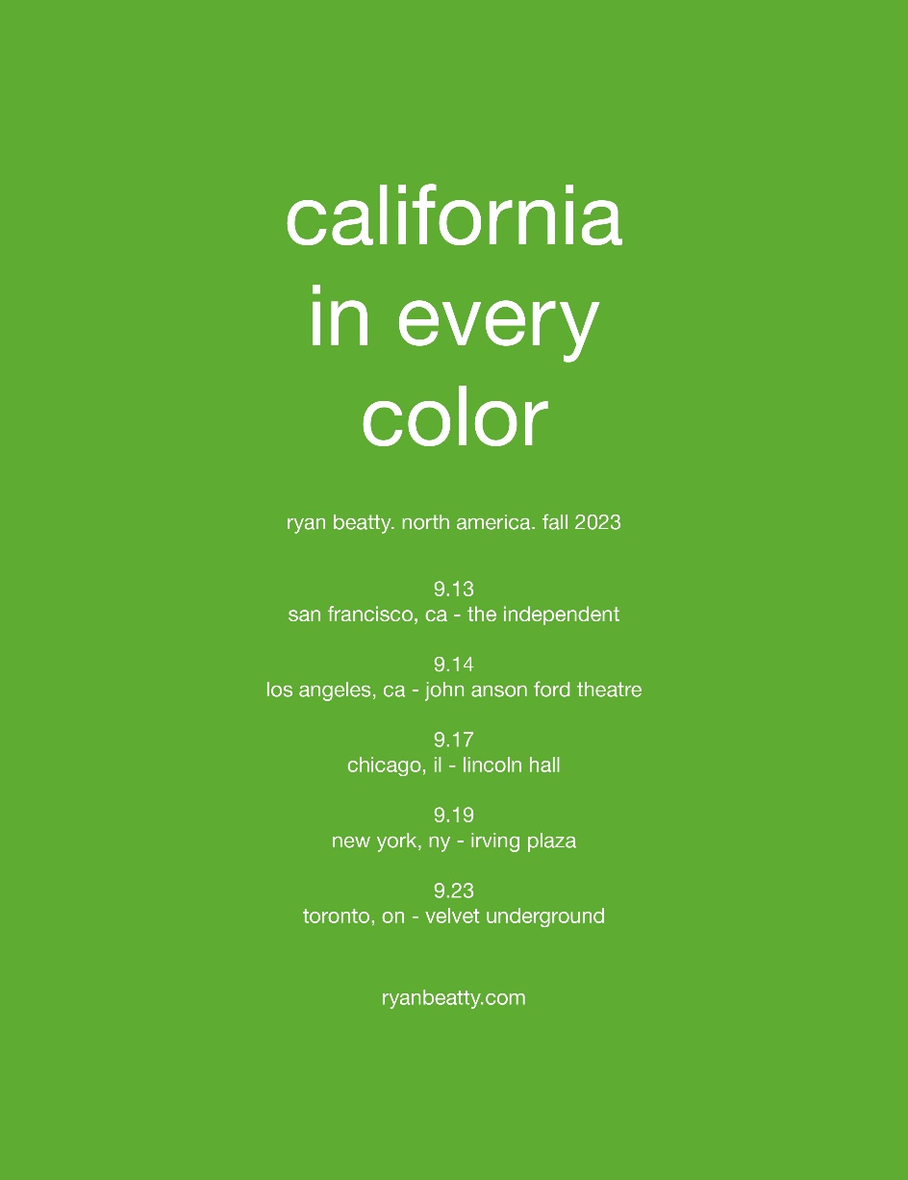

September 13 San Francisco, CA The Independent
September 14 Los Angeles, CA John Anson Ford Theatre
September 17 Chicago, IL Lincoln Hall
September 19 New York, NY Irving Plaza
September 23 Toronto, ON Velvet Underground – SOLD OUT

RYAN BEATTY
CALICO
AVAILABLE NOW
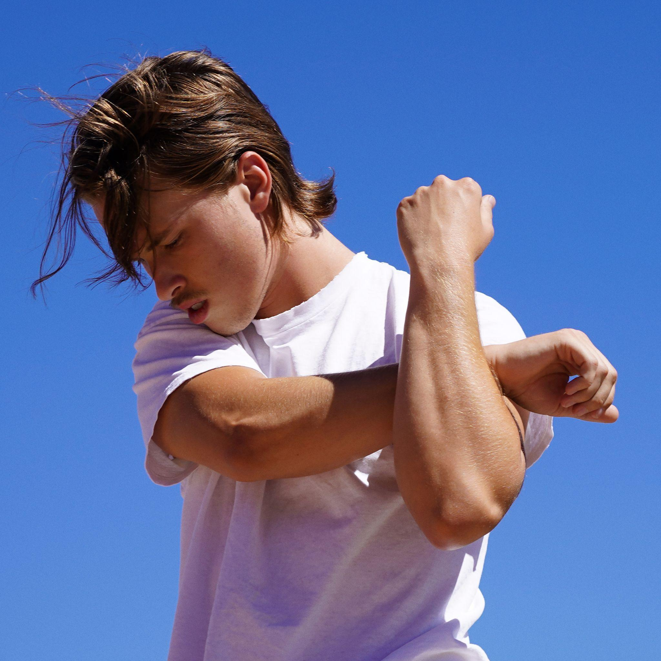

Tracklist:
- Ribbons
- Bruises Off The Peach
- Cinnamon Bread
- Andromeda
- Bright Red
- Hunter
- White Teeth
- Multiple Endings
- Little Faith

FOLLOW RYAN BEATTY
OFFICIAL SITE | INSTAGRAM | FACEBOOK | YOUTUBE

For US press inquiries, please contact:
Sarah Goldstein / sarahgoldstein@elektra.com
Glenn Fukushima / glennfukushima@elektra.com

