GAMES WE PLAY ANNOUNCES FULL-LENGTH DEBUT ALBUM
LIFE’S GOING GREAT OUT OCTOBER 6TH

PRE-ORDER/PRE-SAVE HERE

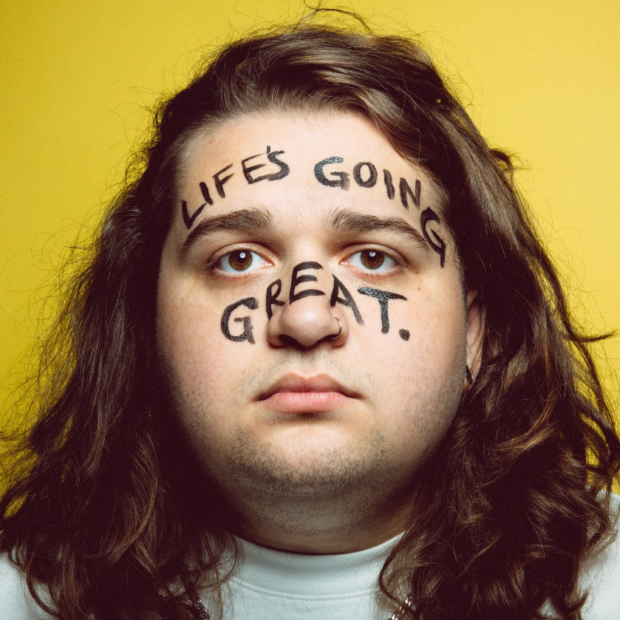
DOWNLOAD HI-RES PRESS ASSETS HERE

SHARES EMOTIONALLY CHARGED NEW SINGLE “TOO YOUNG.”

LISTEN HERE | WATCH MUSIC VIDEO HERE

SET TO LAUNCH FIRST-EVER NORTH AMERICAN HEADLINE RUN
THE LIFE’S GOING GREAT TOUR THIS FALL

“The one-man pop-punk powerhouse Games We Play produces nothing but feel-good pop-punk anthems” Alternative Press
“Big, catchy hooks and lyrics that are equal parts spiteful and playful” Consequence

“Emotionally self-aware lyrics, big heavy riffs and a brilliantly fun attitude” Rock Sound

“Radiating pop-punk-esque melodies that provide a mesmerizing atmosphere paired with glowing crisp vocals” New Noise

“Games We Play is going to be massive. Just a talented musician who has it all — catchy music, fun lyrics and an amazing stage presence.” LOUDWIRE

August 8th, 2023 - Singer, songwriter, multi-instrumentalist, producer, and pop-punk provocateur Games We Play (a.k.a Emmyn Calleiro) will unveil his anxiously awaited full-length debut album, Life’s Going Great, on October 6, 2023 via DCD2 / Fueled By Ramen. It is available for pre-order/pre-save HERE. To herald the release of the record, he has shared his vulnerable new single “too young.”—available now on all streaming platforms HERE. The song is accompanied by an emotionally charged music video—now streaming on the official Fueled By Ramen YouTube Channel HERE.

On Life’s Going Great, Emmyn shares, “The record is a snapshot of how my life has been for the past year. I’ve gotten to do things I’ve only ever DREAMED of doing while simultaneously going through the hardest challenges I’ve ever had.”
“‘too young.’ is the most important song I’ve ever made. I’ve never made anything that makes me feel like this; honest and vulnerable. I’m really excited for you to hear this, but also very very nervous,” he adds on the new single.
Games We Play initially teased “too young.” on social media with a series of snippets. Inciting anticipation from fans worldwide, it generated 1 million-plus cumulative views in advance of its arrival highlighted by this preview post. The track illuminates yet another side of this multi-faceted phenom. Airy clean guitar underlines confessional verses as he paints a picture of a breakup’s aftermath with the utmost sincerity and no holds-barred. He barely clenches back tears and regret on a disarmingly unforgettable refrain, “Swore to God it would never be us saying, ‘We were too young’.” Meanwhile, the video projects these feelings on screen with an equally evocative and arresting narrative. It intercuts live performance footage with vignettes of a relationship that’s growing apart.

In support of the LP, Games We Play will embark on his first-ever North American headline run, the Life’s Going Great Tour. It kicks off on October 13 in Vancouver, BC at Fortune Sound Club, rolls through major markets coast-to-coast, stops at When We Were Young Festival in Las Vegas, NV on October 21-22, and concludes on November 18 in Austin, TX at Scoot Inn. Additionally, JUTES and Ultra Q join the tour as support. Pre-sale tickets are available today beginning at 10am ET. General on-sale begins Friday August 11 at 10am ET. A complete list of upcoming tour dates can be found below. For tickets and more information on Games We Play’s upcoming tour dates visit gamesweplay.co.

Emmyn paved the way for the album with the hyper catchy “All My Untalented Friends (Ooo La La),” available now on all streaming platforms HERE. Beyond plugs from the likes of Substream Magazine and more, KERRANG! hailed it as “infectious,” and Rock Sound dubbed it “catchy.”

Last year, Games We Play released his major label debut EP Get A Job, followed by the official video for the wildly chantable title track “Get A Job.” Inspired by the legendary “What The Fuck Is Up Denny’s?” clip, the video was filmed at Emmyn’s first-ever Los Angeles show at America’s beloved diner Denny’s in Hollywood, CA. The epic performance sees Emmyn start a mosh pit in the middle of the restaurant and features Fall Out Boy bassist/Emmyn’s DCD2 Records label boss Pete Wentz crowd surfing. Watch the video on Fueled By Ramen’s official YouTube channel HERE.

The Get A Job EP was introduced with viral breakout single “I Hope You’re Happy” and anthemic track “St. Girlfriend.” In May of last year, Games We Play announced his Fueled By Ramen/DCD2 Records signing in an exclusive interview with Consequence. Watch how Games We Play signed featuring DCD2 Records Founder and Fall Out Boy bassist and visionary Pete Wentz HERE. To herald the announcement, Games We Play unveiled an official music video for his viral breakout single “I Hope You’re Happy”. Watch it on Fueled By Ramen’s official YouTube channel HERE. In the clip, Emmyn’s contagious enthusiasm, bold personality, and hilarious sense of humor come to life on screen as the magnetic pop-punk refrain resounds with chantable turn-of-the-century bliss.

Be on the lookout for more from Games We Play soon.

“Life’s Going Great” Album Track List
1. The End
2. Oh So Blue
3. Pretty Boy
4. Girl Shaped Crater
5. All My Untalented Friends (Ooo La La)
6. Interlude
7. Naked
8. Round & Round
9. So Bad
10. too young.

Games We Play Tour Dates
Life’s Going Great Tour
with support from JUTES and Ultra Q
October 13, 2023 - Vancouver, BC - Fortune Sound Club
October 14, 2023 - Seattle, WA - Neumos
October 15, 2023 - Portland, OR - Hawthorne Theatre
October 18, 2023 - Los Angeles, CA - El Rey
October 21, 2023 - Las Vegas, NV - When We Were Young*
October 22, 2023 - Las Vegas, NV - When We Were Young*
October 24, 2023 - Salt Lake City, UT - Soundwell
October 25, 2023 - Denver, CO - Meow Wolf
October 27, 2023 - Minneapolis, MN - Fine Line
October 28, 2023 - Chicago, IL - Bottom Lounge
October 29, 2023 - Detroit, MI - Shelter
October 31, 2023 - Toronto, ON - Axis Club
November 01, 2023 - Columbus, OH - Newport Music Hall
November 03, 2023 - Washington, DC - Atlantis
November 04, 2023 - Philadelphia, PA - Union Transfer
November 05, 2023 - Boston, MA - Brighton Music Hall
November 07, 2023 - New York, NY - Irving Plaza
November 09, 2023 - Raleigh, NC - Lincoln Theatre
November 10, 2023 - Atlanta, GA - The Loft
November 11, 2023 - Orlando, FL - Beacham
November 14, 2023 - St. Louis, MO - Old Rockhouse
November 15, 2023 - Nashville, TN - Eastside Bowl
November 17, 2023 - Dallas, TX - The Echo Lounge & Music Hall
November 18, 2023 - Austin, TX - Scoot Inn

*Festival Appearance

ABOUT GAMES WE PLAY:
Games We Play a.k.a. Emmyn Calleiro brings pop punk back to the people. You could think of him as the pop punk everyman—kinda like Springsteen if he was weaned on blink-182. He writes about breakups, awkwardness, growing up, and living his dream with wide-eyed enthusiasm through the perspective of a seasoned pro. For as sharp as his hooks are, he’s also gleefully self-effacing (which makes him even more likable!). Moreover, he’ll play a Denny’s with just as much bombast and bravado as he would an arena (and he’s actually done both!). The Florida-born singer, songwriter, multi-instrumentalist, and producer relocated to Nashville in his teens and served up the independent Senior Year EP in 2018. Simultaneously, his sense of humor, relatability, and sharp songcraft endeared him to a rabid fan base on TikTok as “I Hope You’re Happy” caught fire. He wound up signing to Fueled By Ramen/DCD2 Records and dropped his major label debut EP, Get A Job, in 2022. Beyond reeling in tens of millions of streams, he incited the applause of Consequence, Alternative Press, Loudwire, Rock Sound, The Honey Pop, and more. Renowned for his live energy, he notably toured alongside everyone from All Time Low, The Band CAMINO, and State Champs to YUNGBLUD and Fall Out Boy. Now, he’s serving up a batch of undeniable and unforgettable anthems on his full-length debut, Life’s Going Great, introduced by “All My Untalented Friends (Ooo La La)” and “too young.” Get ready to sing along to Games We Play.

Instagram | Twitter | Facebook | YouTube | TikTok

Press contacts:
Collin Citron / collin.citron@300elektra.com
Sydney Worden / sydney.worden@300elektra.com

