A DAY TO REMEMBER
RETURN WITH BRAND NEW SINGLE “MIRACLE”

OFFICIAL MUSIC VIDEO STREAMING NOW

NORTH AMERICAN LIVE DATES
“JUST SOME SHOWS” & “JUST SOME MORE SHOWS” BEGIN JULY 27TH
WITH SPECIAL GUESTS THE USED, THE GHOST INSIDE, BEARTOOTH, BAD OMENS, MOVEMENTS, & MAGNOLIA PARK ON SELECT DATES

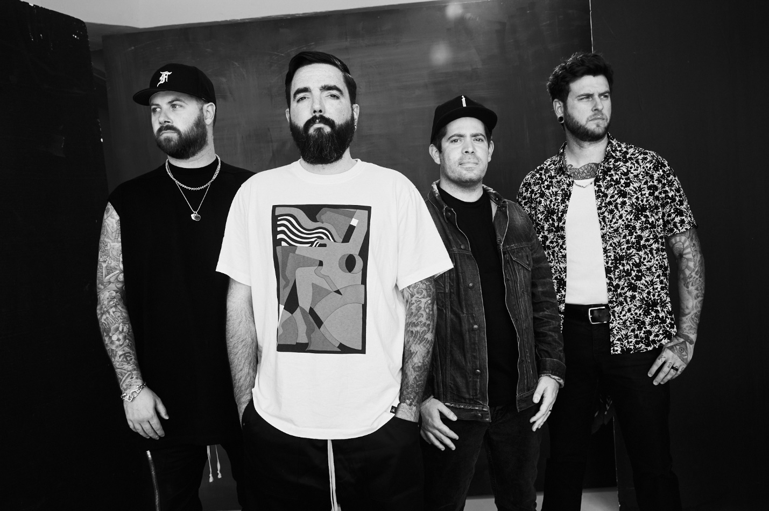
PHOTO CREDIT: JAMES HARTLEY

JULY 21, 2022 - A Day To Remember have unveiled a brand new single entitled “Miracle,” which is available on all streaming platforms and accompanied by a cinematic and emotionally charged music video streaming on the band’s official YouTube channel. The song marks the band’s first new music since their critically acclaimed 2021 album, You’re Welcome.

Earlier this summer, A Day To Remember concluded a string of sold out of tour dates and festival appearances throughout Europe and the UK. Next week, they’ll embark on an epic run of new North American tour dates featuring special guests The Used, The Ghost Inside (on select dates), Beartooth, Bad Omens, Movements, and Magnolia Park. “Just Some Shows” and “Just Some More Shows” will kick off July 27th in Baltimore, MD and traverse the country through a performance on October 28th in Irvine, CA [tour itinerary below]. For tickets and more information on A Day To Remember’s upcoming live dates, visit www.adtr.com.

Earlier this year, A Day To Remember reignited their single “Re-Entry” with a new version featuring Mark Hoppus of Blink-182. Consequence of Sound noted, “Having Hoppus on the track is a perfect fit, since Blink-182 was a significant inspiration for the song.” It also received plugs from NME, Rock Sound, and more. LISTEN HERE

“Re-Entry” originally appeared on A Day To Remember’s latest studio album You’re Welcome. Available on all streaming platforms, You’re Welcome is largely produced by Colin “DOC” Brittain and the band’s own Jeremy McKinnon. The 14-track collection represents another major step forward for the acclaimed quintet, and is highlighted by singles “Brick Wall,” “Degenerates,” “Resentment,” “Mindreader” and the #1 Active Rock hit single “Everything We Need.”

Having amassed over 1.6 billion global streams to date, A Day To Remember incited critical praise with You’re Welcome. Revolver declared, “[Brick Wall] showcases the group's signature mix of post-hardcore heaviness and pop-rock hooks,” while Consequence of Sound declared, “the Florida rockers’ new LP will continue their wide-ranging sound that ranges from infectious pop-punk to crushing metalcore.” Forbes put it simply, “It seems A Day To Remember are only just getting started,” and Billboard praised the band’s “anthemic hybrid of post-hardcore and pop.” Popdust avowed A Day To Remember “have all but mastered their niche melding of pop melodies with hardcore music,” while Kerrang! attested, “‘You’re Welcome’ is the perfect soundtrack to this strange and uncertain world that we live in.”

Last year, A Day To Remember also unveiled their first-ever acoustic livestream event, “A Day To Remember: Live at The Audio Compound.” After premiering the stream on their official YouTube channel, the band surprised audiences everywhere by releasing the career-spanning nine-song performance as an acoustic live album, Live At The Audio Compound, which is available now on all DSPs.

A DAY TO REMEMBER
“MIRACLE” SINGLE ARTWORK

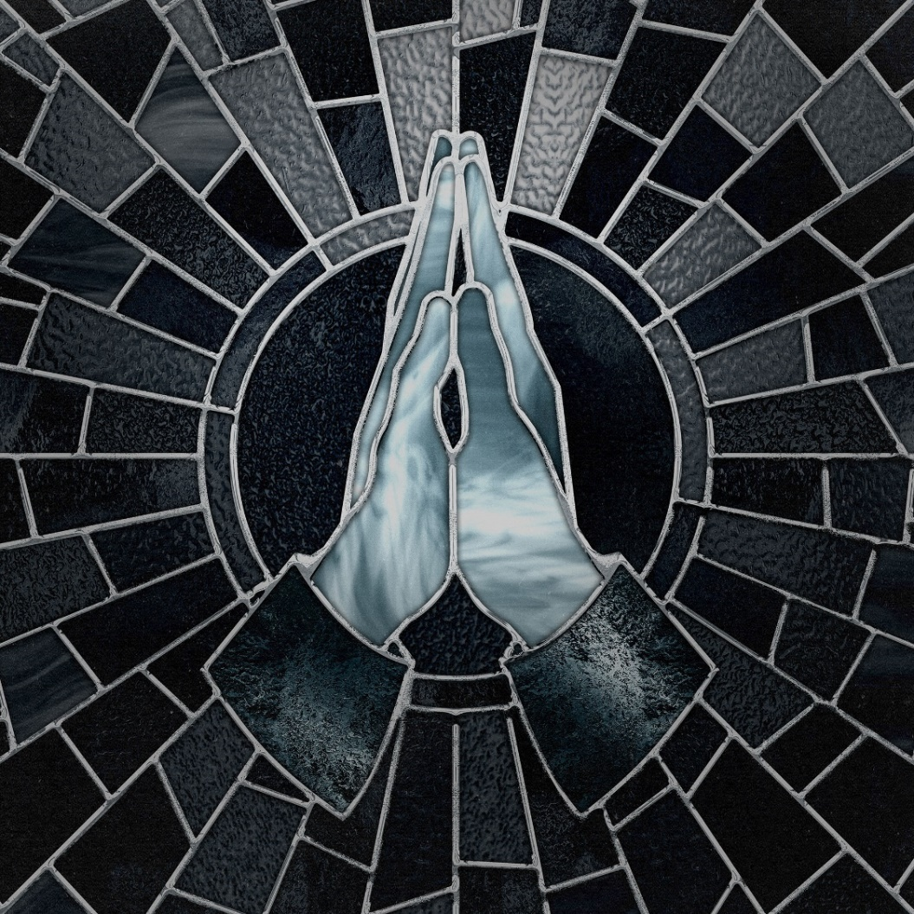

A DAY TO REMEMBER
“JUST SOME SHOWS” & “JUST SOME MORE SHOWS”
WITH SUPPORT FROM THE USED, THE GHOST INSIDE (SELECT DATES), BEARTOOTH, BAD OMENS, MOVEMENTS, AND MAGNOLIA PARK
~The Used | ^The Ghost Inside |*Beartooth | #Bad Omens | @Movements | %Magnolia Park | +Non Live Nation Dates

July 27 - Baltimore, MD - Pier SixPavilion *#
July 29 - Cleveland, OH - Jacobs Pavilion at Nautica +^*#
July 30 - Toronto, ON - RBC Echo Beach ^*#
July 31 - Quebec City, QC - Agora du Vieux-Port ^*#
August 2 - Providence, RI - Bold Point Park *#
August 3 - Bangor, ME - Maine Savings Amphitheater *#
August 5 - Bridgeport, CT - Hartford HealthCare Amphitheater ^#
August 6 - Reading, PA - Santander Arena ^#
August 7 - Asbury Park, NJ - Stone Pony Summer Stage ^*#
August 9 - Pittsburgh, PA - Stage AE +*#
August 11 - Chattanooga, TN - Soldiers & Sailors Memorial Auditorium *#
August 12 - Maryland Heights, MO - Saint Louis Music Park *#
August 14 - Council Bluffs, IA - Harrah’s Stir Cove *#
August 16 - Cedar Rapids, IA - McGrath Amphitheatre *#
August 17 - Oshkosh, WI - Oshkosh Arena +*#
August 20 - Wichita, KS - The Wave (Outdoors) +*#
August 21 - Bonner Springs, KS - Azura Amphitheater +^*#
August 23 - Indianapolis, IN - TCU Amphitheater at White River State Park *#
August 24 - Pikeville, KY - Appalachian Wireless Arena *#
August 26 - Simpsonville, SC - CCNB Amphitheatre at Heritage Park *#
August 27 - Portsmouth, VA - Atlantic Union Bank Pavilion *#
October 1 - Pensacola, FL - Pensacola Bay Center +~@%
October 2 - Birmingham, AL - Legacy Arena at The BJCC ~%
October 4 - Oklahoma City, OK – The Zoo Amphitheatre @%
October 7 - San Diego, CA - Gallagher Square at Petco Park @%
October 8 - Sacramento, CA - Aftershock Festival
October 10 - Portland, OR - Theater of the Clouds +~@%
October 11 - Seattle, WA - WAMU +~@%
October 13 - Calgary, AB - Grey Eagle Resort & Casino +~@%
October 14 - Spokane, WA - TBA ~@%
October 16 - Grand Junction, CO - Amphitheatre at Las Colonias Park +~@%
October 18 - Austin, TX - Moody Amphitheater @%
October 22 - Las Vegas, NV - When We Were Young Festival
October 23 - Las Vegas, NV - When We Were Young Festival
October 25 - Lubbock, TX - Lonestar Amphitheater ~@%
October 27 - Mesa, AZ - Mesa Amphitheater +~@%
October 28 - Irvine, CA - FivePoint Amphitheatre ^@%
October 29 - Las Vegas, NV - When We Were Young Festival

ABOUT A DAY TO REMEMBER:
Since their formation in 2003, A Day To Remember quietly emerged as arguably the biggest underground band in the world. The Florida group affirmed this status by achieving one platinum album, one gold album, one platinum single, and four gold singles. Not to mention, each full-length record ascended to #1 on the Billboard Rock, Indie, and/or Alternative Charts with 2016’s Bad Vibrations bowing at #2 on the Billboard Top 200. They’ve put up unprecedented numbers for a rock act in the 21st century, generating 850 million Spotify streams, 500 million YouTube views, and sales of three million-plus units. They’ve also packed arenas on continental tours and attracted a worldwide audience consisting of millions. Additionally, A Day To Remember successfully launched their own Self Help Festival in 2014, which continues going strong. Plus, everyone from Marshmello to Pierce The Veil has sought them out for collaborations. All of which explains why Rolling Stone called them “An Artist You Need To Know.”

A Day To Remember is: Jeremy McKinnon (vocals), Alex Shelnutt (drums), Kevin Skaff (guitar, vocals), and Neil Westfall (guitar, vocals).

Connect with A Day To Remember:
WEBSITE
FACEBOOK
TWITTER
INSTAGRAM
YOUTUBE
SPOTIFY
APPLE MUSIC

MEDIA CONTACT:

A Day To Remember
Ross Anderson | rossanderson@elektra.com

