FOR IMMEDIATE RELEASE
AUGUST 12, 2021

TRIVIUM ANNOUNCE NEW ALBUM IN THE COURT OF THE DRAGON

BAND SHARES OFFICIAL VIDEO FOR NEW SONG "FEAST OF FIRE," WHICH IS STREAMING NOW — WATCH
BAND TOURING WITH MEGADETH & LAMB OF GOD THIS SUMMER
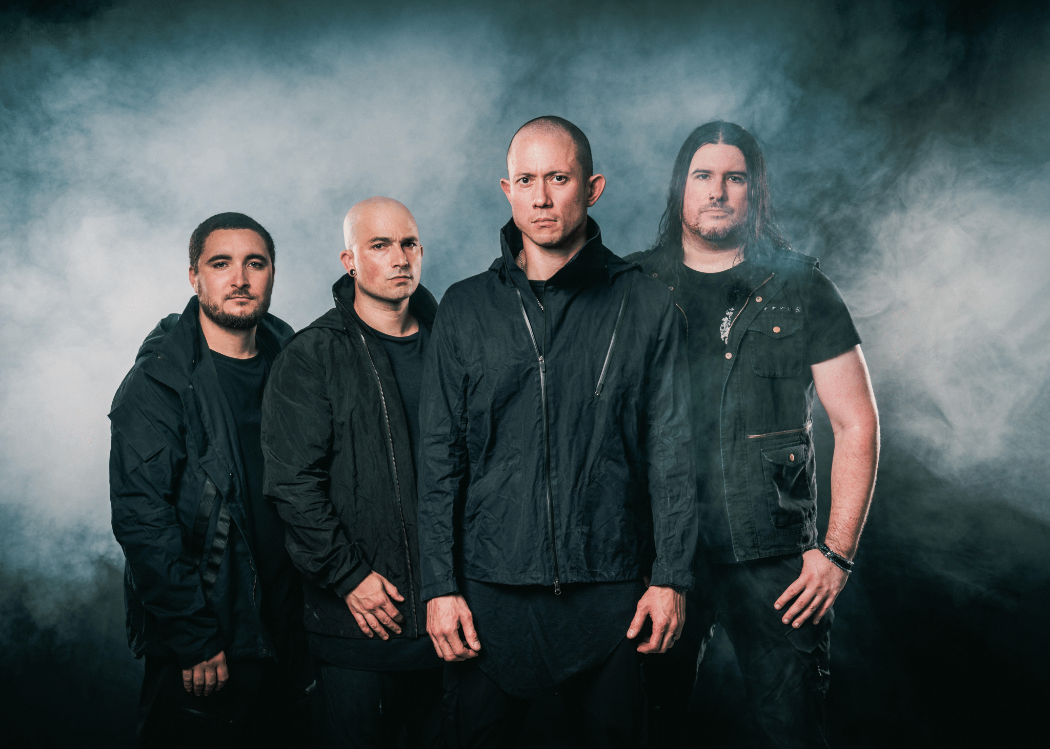

Grammy-nominated band TRIVIUM — Matt Heafy [vocals, guitar], Corey Beaulieu [guitar], Paolo Gregoletto [bass], and Alex Bent [drums] — has announced that it will release its tenth album, titled In The Court of The Dragon, on October 8 via longtime label Roadrunner Records. The record was produced and mixed by Josh Wilbur and recorded in the Fall of 2020 at Full Sail University in Orlando.

Pre-orders are live here

The band has also shared the new song "Feast of Fire," which is joined by an official music video. Watch it here.

The footage was filmed at the band’s HQ — The Hangar in Orlando. It was shot by director John Deeb.

"There's always that one song you aren't expecting when you begin writing a new album," says Gregoletto about the song and, in turn, sharing an inside look at the band's songwriting process. "It could be a riff written on the spot in the rehearsal space, a lyric that pairs just right with a melody, or in the case of 'Feast of Fire,' sitting right there in front of us in the middle of a demo that Corey brought in. We were well into pre-production at Full Sail when we all decided that something about the demo we had tracked was good but could be even better. Our producer Josh Wilbur even had in his notes: 'Bridge is special, maybe so special it needs its own song.' We tore the song apart and began again on the spot."

He continues, "We went into this album knowing we had time to consider everything and anything that came about during this period, and if need be, we could start again if it didn’t feel right given that no touring was on the horizon."

Further pulling back the curtain, he says, "I had the words 'Feast of Fire' written in my running list of notes for lyric ideas that I try to amass before we record. Something about the phrase stuck out to me. It felt like the missing piece of the story we were trying to tell with this album, a climactic moment and a real centerpiece for the narrative."

He finishes, "After all these years I’m still blown away at how a song can really appear out of thin air and take the album to a place you weren’t expecting. Those are the moments we are always looking for when making a record."

The album cover is an original oil painting by French artist Mathieu Nozieres (@mathieunozieres on Instagram)

"While the music of In The Court Of The Dragon was taking shape, we knew we needed epic artwork of the type that you might see on the wall of an important museum from a long dead renaissance master," says Heafy. "After extensive research, we found one of the few living artists who is capable of creating artwork like Caravaggio and Gentileschi — painter Mathieu Nozieres. Mathieu took our song title and created an original oil painting on canvas unlike anything we could have ever imagined. It's so staggeringly breathtaking and epic and it looks like what the song and album sounds like."

The oil painting, which is also featured in both videos, will be on display at the Bloodstock Festival from August 11 through 15 at the on site RAM Art Gallery. This marks the painting's first public showing. The first 100 fans to view it in the gallery will receive a free poster of the image.

Last month Trivium shared the album’s title track, "In The Court of The Dragon," which featured an epic intro composed and orchestrated by Ihsahn (Emperor) and was accompanied by an official short film music video directed by Ryan Mackfall. Loudwire called out the song as "a skillful blend of dynamics. And blast beats just sound really, really good beneath Matt Heafy's soothing clean singing" while Revolver labeled it "epic."
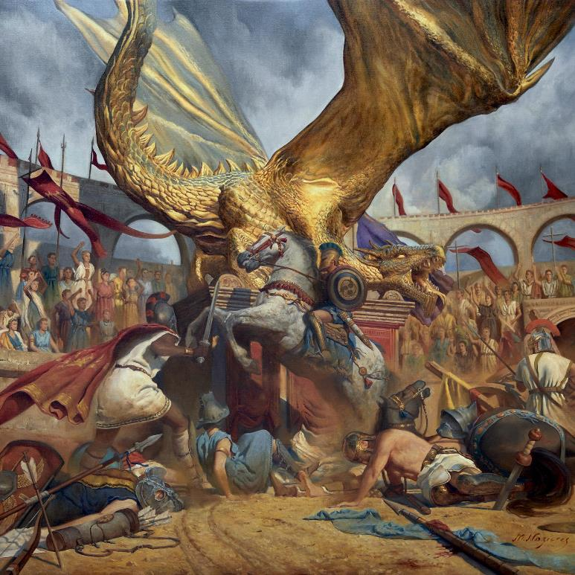
IN THE COURT OF THE DRAGON TRACK LISTING:
"X"
"In The Court Of The Dragon"
"Like A Sword Over Damocles"
"Feast Of Fire"
"A Crisis Of Revelation"
"The Shadow Of The Abattoir"
"No Way Back Just Through"
"Fall Into Your Hands"
"From Dawn To Decadence"
"The Phalanx"

In other Trivium news, the band will make its long-awaited return to the road this summer with Megadeth, Lamb of God, and In Flames. All dates are below.

TRIVIUM ON TOUR:
8/20 — Austin, TX — Germania Insurance Amphitheater
8/21 — Irving, TX — The Pavilion at Toyota Music Factory
8/22 — Woodlands, TX — The Cynthia Woods Mitchell Pavilion presented by Huntsman
8/24 — El Paso, TX — Don Haskins Center
8/25 — Albuquerque, NM — Isleta Amphitheater
8/26 - Wichita, KS - Cotillion Ballroom (headline)
8/27 — Denver, CO — Ball Arena
8/29 — Phoenix, AZ — Arizona Federal Theatre
8/31 — Reno, NV — Reno Events Center
9/1 — Irvine, CA — FivePoint Amphitheatre
9/2 — Concord, CA — Concord Pavilion
9/4 — Portland, OR — Moda Center
9/5 — Auburn, WA — White River Amphitheatre
9/6 - Boise, ID, Revolution Concert House (headline)
9/9 — Tinley Park, IL — Hollywood Casino Amphitheatre - Chicago
9/10 - Pittsburgh, PA — Roxian Theater (headline)
9/11 — Danville, VA — Blue Ridge Festival*
9/12 — Wantagh, NY — Northwell Health at Jones Beach Theater
9/13 — Boston, MA — Leader Bank Pavilion
9/15 — Camden, NJ — BB&T Pavilion
9/16 — Holmdel, NJ — PNC Bank Arts Center
9/18 — Noblesville, IN — Ruoff Music Center
9/19 — Clarkston, MI — DTE Energy Music Theatre
9/20 — Cincinnati, OH — PNC Pavilion
9/22 — Rogers, AR — Walmart AMP
9/24 — Mount Pleasant, MI — Soaring Eagle Casino Amphitheatre
9/25 - Des Moines, IA - Knotfest Iowa*
9/26 — St. Louis, MO — Hollywood Casino Amphitheatre - St. Louis
9/28 — Minneapolis, MN — Armory
9/30 — Toronto, ON — Budweiser Stage
10/1 — Laval, QC — Place Bell
10/2 — Quebec City, QC — Centre Videotron
*Festival Date featuring all 4 bands.

ABOUT TRIVIUM:
Trivium released their ninth full-length, What The Dead Men Say, through Roadrunner Records in 2020. The album was produced by Trivium and Josh Wilbur and debuted at #35 on the Billboard Top 200; at #2 on the Top Current Albums Chart, and at #3 on both the Hard Rock Albums Chart and Top Rock Albums Chart. The band and album were praised by and featured in mainstream outlets like The New York Times, NPR, Forbes, Billboard, TechCrunch, and Kotaku, as well as Guitar World, Revolver, Alternative Press, and more.
Trivium released its now-canonical album Ascendancy in 2005. It was recognized as KERRANG!’s "Album of the Year," achieved a gold certification in the UK, and eclipsed sales of 500,000 worldwide. Metal Hammer placed it in the Top 15 of "The 100 Greatest Metal Albums of the 21st Century." It ignited a string of six consecutive Top 25 debuts on the Billboard Top 200 and five straight Top 3 debuts on the Top Hard Rock Albums Chart, culminating on 2017's benchmark The Sin And The Sentence. That album elevated the group's total stream tally past a quarter-of-a-billion. Additionally, "Betrayer" received a GRAMMY® Award nomination in the category of "Best Metal Performance." Unanimous acclaim followed from Decibel, Loudwire, Ultimate Guitar, MetalSucks, and Metal Hammer who dubbed them, "quite simply one of the best bands in modern metal." Not to mention, they performed alongside Metallica, Black Sabbath, Iron Maiden, and many others and graced the main stages of Download, Bloodstock, KNOTFEST, and more. After two decades, eight albums, and hundreds of sold out shows, Trivium actualize the all-encompassing ambition they first set in motion back in 1999.
TRIVIUM ONLINE:
https://www.facebook.com/Trivium
https://twitter.com/TriviumOfficial
http://www.trivium.org
https://www.instagram.com/triviumband/
https://www.youtube.com/user/trivium
https://open.spotify.com/artist/278ZYwGhdK6QTzE3MFePnP

FOR MORE INFORMATION, PLEASE CONTACT:
Amy Sciarretto | amy@atomsplitterpr.com
Mike Colantuoni | mike@atomsplitterpr.com
Tim Tatulli | tim@atomsplitterpr.com
Ross Anderson | ross.anderson@roadrunnerrecords.com

